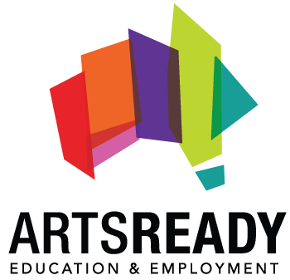
Sydney Festival – Administration Traineeship (Indigenous)

About ArtsReady
ArtsReady is a national, not-for-profit employment and education company. We deliver support, training and education through traineeships, resulting in quality employment opportunities for young Australians.
About the opportunity
We currently have a full-time Administration traineeship with the team at Sydney Festival. Traineeships are exciting opportunities that give people the chance to learn on-the-job skills and be mentored by industry experts. At the end of the program, trainees receive a nationally recognised Certificate III in Business qualification. Each of our roles provide an ideal launching pad for a fulfilling career within NSW’s arts and cultural sector.
About the Sydney Festival:
Every January, Sydney Festival enlivens and transforms Sydney with a bold cultural celebration based on the highest quality art and big ideas.
The program is kaleidoscopic in its diversity, from burlesque, cheeky cabaret and circus, to high energy jazz, indie rock and theatre; from contemporary dance to family programs to Indigenous arts practice. In 2017, Sydney Festival's program presented over 450 performances and 150 events performed by over 1,000 artists at more than 46 venues across theatre, dance, music, circus and art. Inclusive programming, a broad range of free events and accessible pricing policies for the ticketed shows meant that Sydney Festival was open to all, welcoming Sydneysiders and visitors from wherever they live.

Administration Trainee (Indigenous) - The Administration Trainee reports to the Executive Assistant and plays a vital role in assisting in the efficient running of the Sydney Festival office. This role will provide support across general office administration, front of house, and customer service
SELECTION CRITERIA

- Desire to provide administrative support in a busy professional environment.
- Demonstrated interest in working in an event or festival environment.
- A positive, energetic, proactive disposition and responsible approach to managing multiple tasks on competing deadlines.
- Ability to develop skills to work efficiently under pressure while maintaining attention to detail.
- Be an experienced user of email and the Internet and undertake regular use of programs such as MS Word, MS Excel and or similar programs.
- High level of competency in data entry with speed and accuracy.
- Excellent interpersonal and communication skills including an impeccable phone manner, professional personal presentation, and confidence in developing the ability to communicate with a range of stakeholders at various levels.
- Self-motivated and an ability to work both under direction and independently in a team environment and a strong willingness to learn.
- Experience in the use of a database system, or the capacity to quickly obtain these skills.
Other Requirements

- This traineeship is open to Aboriginal and Torres Strait islander candidates only.
- Willingness to work outside regular work hours [There is sometimes a requirement to work outside of regular office hours in the lead up to and during the Festival. These extra hours are compensated by time off in lieu after the Festival]

SALARY
The successful candidate will receive:
- National Training Wage Award + 9.5% Superannuation
- Fully funded qualification

As these are traineeship positions, applicants with tertiary qualifications will not be considered.

Only Aboriginal and/or Torres Strait Islander people are eligible to apply for this position. This action is by virtue of a section 126 exemption granted by the Anti-Discrimination Board of NSW

For more information on these positions or any other opportunities at ArtsReady, please contact:
Rog Chhabra
ArtsReady Program Manager – NSW/ACT
P: 02 8333 8013
E: Rog.Chhabra@artsready.com.au

To apply please forward your current/ updated resume and a tailored cover letter to Rog Chhabra at Rog.Chhabra@artsready.com.au

