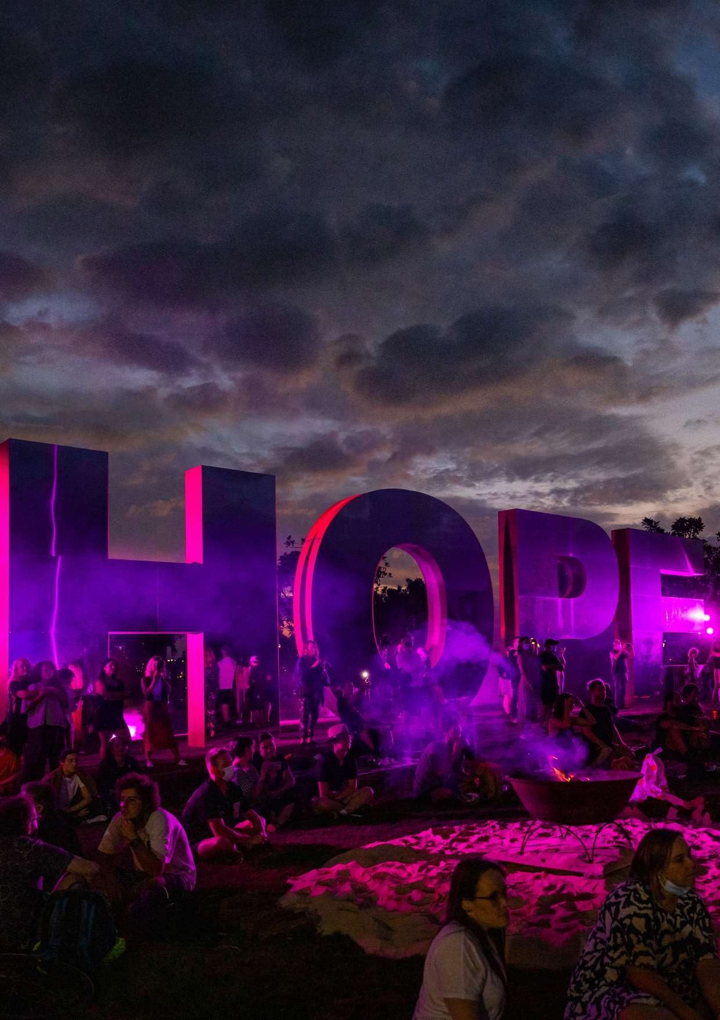RECONCILIATION
ACTION PLAN
DRAFT

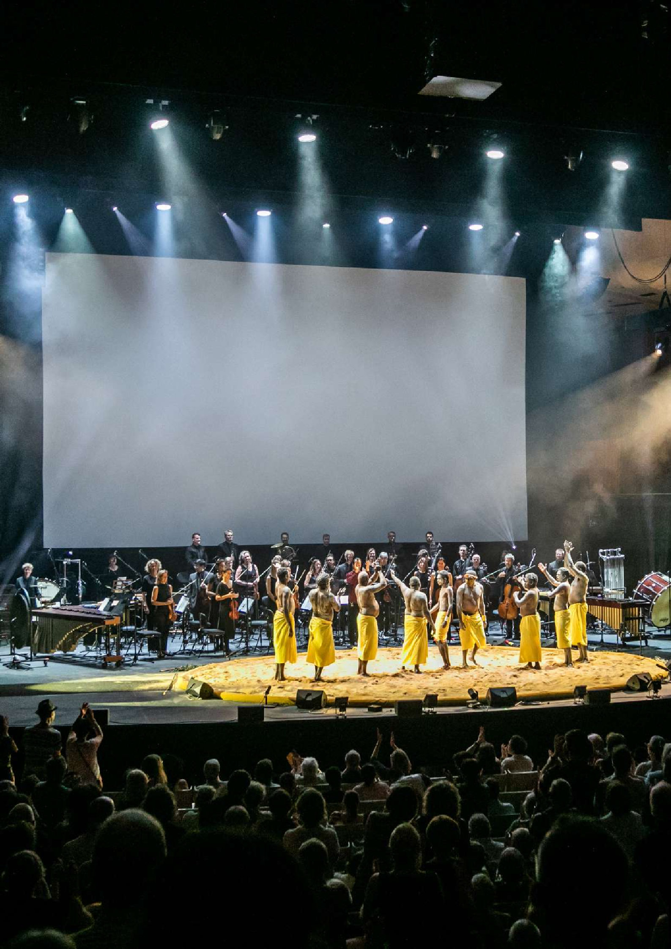Buŋgul

Sydney Festival 2020
Photo credit: Victor Frankowski

2

INTRODUCTION

Access and Inclusion Advisory Panel
Sydney Festival would like to acknowledge the Traditional Owners of the land on which the Festival takes place, and pay respect to the 29 clans of the Eora Nation. We acknowledge that this land falls within the boundaries of the Metropolitan Local Aboriginal Land Council. We would also like to acknowledge our Darug neighbours
in Parramatta. We pay respect to Elders both past and present, and all Aboriginal and Torres Strait Islander peoples whichever Aboriginal and Torres Strait Islander nation they come from.

Originally launched in 2013, our Reconciliation Action Plan (RAP) outlines our commitment towards improving outcomes for Aboriginal and Torres Strait Islander peoples by creating and fostering an organisational environment that cherishes respect, creates opportunity and builds cultural awareness.

Sydney Festival recognises that Sydney is a vast, complex and exuberant city of cultural contrasts and social diversity, that Sydney’s Aboriginal and Torres Strait Islander heritage and contemporary cultures lie deep within the city’s identity and are key to an enlightened and progressive festival.

COVER IMAGE:
Vigil: Songs for Tomorrow
Sydney Festival 2022
Photo credit: Jackie Manning 1

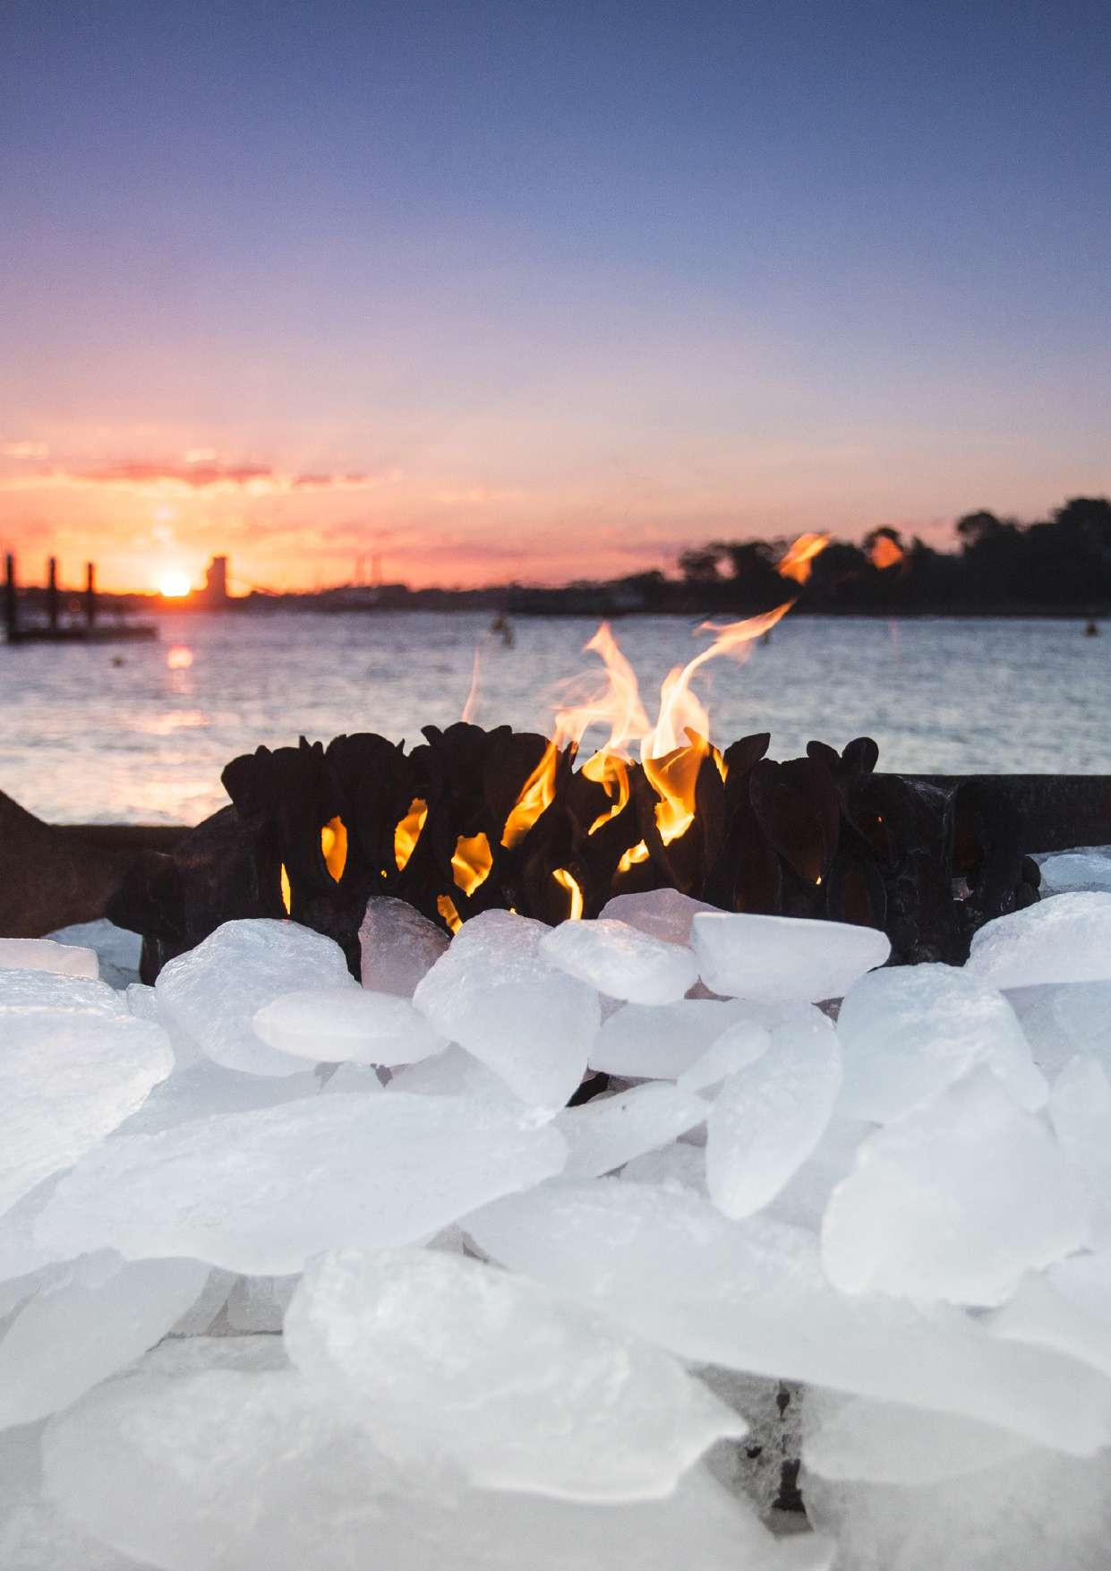Four Thousand Fish

Sydney Festival 2018
Photo credit: Jamie Williams

2

A MESSAGE FROM THE EXECUTIVE
DIRECTOR

The Sydney Festival Reconciliation Action Plan remains our organisation's commitment to ensure that we keep moving forward on this vital issue for our nation.

We are committed to working towards improving outcomes for Aboriginal and Torres Strait Islander peoples by creating and fostering an organisational environment that cherishes respect, creates opportunity and builds cultural awareness.

We will continue to set ourselves new measurable goals, at the same time as maintaining ongoing successful initiatives as part of the ongoing journey for this organisation and our community.

Christopher Tooher

Executive Director

3

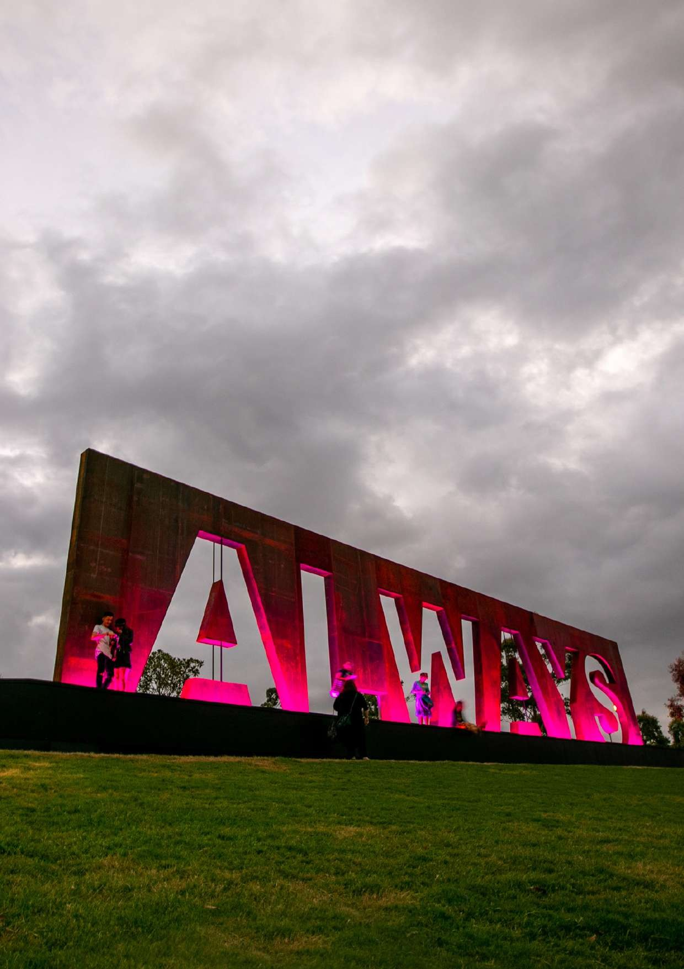ALWAYS
V

Sydney Festival 2020
Photo credit: Jackie Manning

4

OUR
VISION FOR RECONCILIATION

Sydney Festival’s vision for reconciliation is to formally and informally engage with Aboriginal and Torres Strait Islander artists and communities and to positively contribute to closing the gap between Indigenous and other Australians.

We do this by committing to:

- Respect Aboriginal and Torres Strait Islander people and cultures

- Offer employment opportunities to Aboriginal and Torres Strait Islander people

- Offer development and presentation opportunities to Aboriginal and Torres Strait Islander artists and arts workers

- Build cultural awareness and understanding among our staff, stakeholders and audiences of the diversity of Aboriginal and Torres Strait Islander stories.

- Live and breathe an inclusive and accessible organisational culture.

5

OUR
BUSINESS
The biggest event in the city’s cultural calendar, Sydney Festival is a unique and playful celebration of Sydney in summer. Every January it transforms our city with a kaleidoscopic program of performance, art and big ideas.

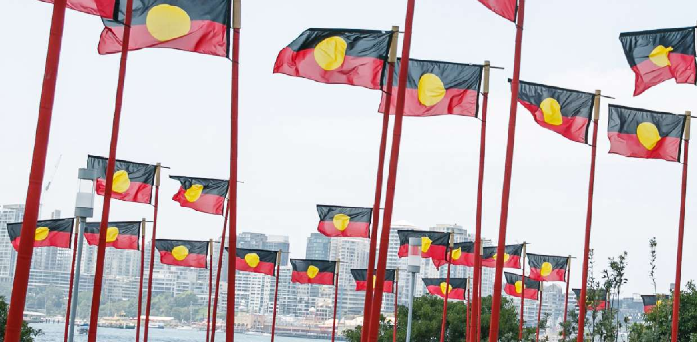Our free and ticketed events span a multitude of genres, ranging from
burlesque circus to New York rap and Russian theatre to traditional Aboriginal and Torres Strait Islander arts practice. For four decades the Festival has brought to Sydney outstanding artists like Björk, Brian Wilson, David Byrne, Elvis Costello, Grace Jones, Geoffrey Gurrumul Yunupingu, Robert Lepage, Sir Ian McKellen, Archie Roach and Peter Sellars alongside some of the world's great companies – The Wooster Group, Complicite, Cheek by Jowl,
Royal Shakespeare Company, and the Schaubühne Berlin to name only a few – to share the Festival with the
most exciting artists and companies in Australia.
6
Aboriginal and Torres Strait Islander art and cultures have always held
a special place within the Sydney Festival program. Over the years, the Festival has celebrated and profiled the talents of respected artists, leaders and companies, including Ilbijerri Theatre Company, Black Arm Band,
Moogahlin Performing Arts, Marrugeku, The Pigram Brothers, Archie Roach, Wesley Enoch, Rachael Maza, Geoffrey Gurrumul Yunupingu, Kev Carmody, Rhoda Roberts, Richard Bell, Gerry Bostock, Kelton Pell, Brook Andrew, Frank Yaama, Dan Sultan, Dr Anita Heiss, Professor Larissa Behrendt, Lily Shearer, Mark Howett, Rachel Perkins, Jacob Nash, the Hon. Linda Burney, Jocob Boehme, Nathan Maynard,

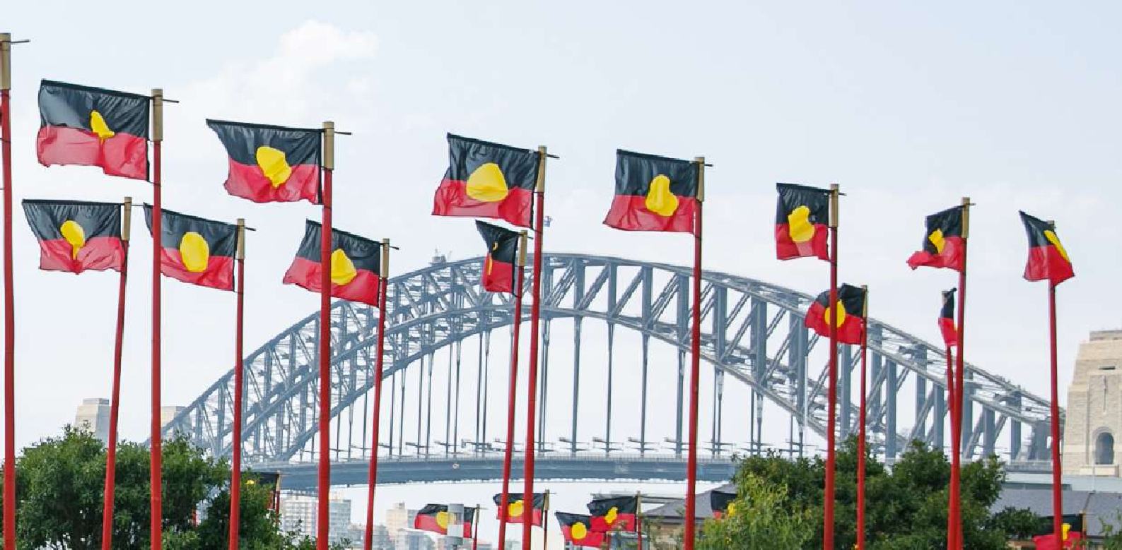Uncle Jack Charles, Stephen Page, Bart Willoughby, Gary Foley, Professor Shane Houston, Ernie Dingo, Ursula Yovich, Last Kinection, Emma Donovan, William Barton, Ghenoa Gela, Trevor Jamieson, Roger Knox and many more.

Proclamation
Sydney Festival 2020
Photo credit: Yaya Stempler
Telling Australian First Nations stories is an extension of our dedication to reflecting the stories of our country.
In 2012, with Festival Director Lindy Hume, Sydney Festival heralded a significant shift in its commitment to its programming of contemporary Aboriginal and Torres Strait Islander work by presenting Black Capital,
a ground-breaking contemporary program of diverse Aboriginal and Torres Strait Islander works and ideas, emerging as one of the Festival’s most ambitious projects ever – in scale, scope and in its transformative potential and momentum. During the
three-year development period leading to the presentation of Black Capital, Sydney Festival launched longer term strategies to encourage productive partnerships with Aboriginal and Torres Strait Islander artists and organisations: to develop new Aboriginal and
Torres Strait Islander audiences; to commission new work; and to discover and present emerging and established Aboriginal and Torres Strait Islander artists and their work.
Lieven Bertels was appointed Festival Director in 2012 with his tenure running from 2013 to 2016. As an international visitor Mr Bertels embraced the
opportunity provided by Black Capital to ensure Aboriginal and Torres Strait Islander arts practice were at the core of his four festivals.
Our Reconciliation Action Plan started in 2013 and has provided us with clear objectives to support our strategy and develop employment opportunities for Aboriginal and Torres Strait Islander people across all facets of the Festival. The Festival continues to consult with local organisations such as Sydney’s Metropolitan Local Aboriginal Land Council, the City of Sydney Aboriginal
and Torres Strait Islander Advisory Panel and specific project-based reference groups and cultural consultants.
In 2015 Sydney Festival was delighted to appoint to its Board of Directors Professor Larissa Behrendt OA Director of Research at the Jumbunna Indigenous House of Learning at
the University of Technology Sydney and Darren Dale Managing Director Blackfella Films.
In the same year Wesley Enoch was appointed Festival Director with his tenure running across five Festivals from 2017 to 2021. Hailing from Stradbroke Island (Minjeribah) and a proud Noonuccal Nuugi man, Wesley’s unprecedented focus on Australian stories, artists and new work resulted in the most expansive Aboriginal and Torres Strait Islander art and cultural program to date across his five Festivals.
In 2020, Olivia Ansell was appointed Festival Director for 2022 to 2024. As the organisation develops strategic plans for this period, an ongoing commitment to Aboriginal and Torres Strait Islander arts practice will be a core driver.
Sydney Festival has a full time equivalent of 50–60 staff in any given year. The team curates, plans and presents the annual three- week program of events focused on venues and audiences in Sydney and Parramatta. The organisational structure of the permanent team promotes good communication,
effective ownership by staff members over their areas of responsibility, active support among team members and a flexible and questioning environment where open discussion is encouraged.
Sydney Festival's audacious contemporary programming position is at the forefront of arts practice in Australia and up there as one of the most wonderful festivals in the world. Sydney Festival relies on a mix of government funding; corporate, media and production partnerships; as well as philanthropic giving. Accessibility
is central to the Sydney Festival ethos, which is reflected in a commitment to free events, geographic reach
to Parramatta and Western Sydney audiences, disability access and the Festival’s ongoing commitment to reconciliation.

7

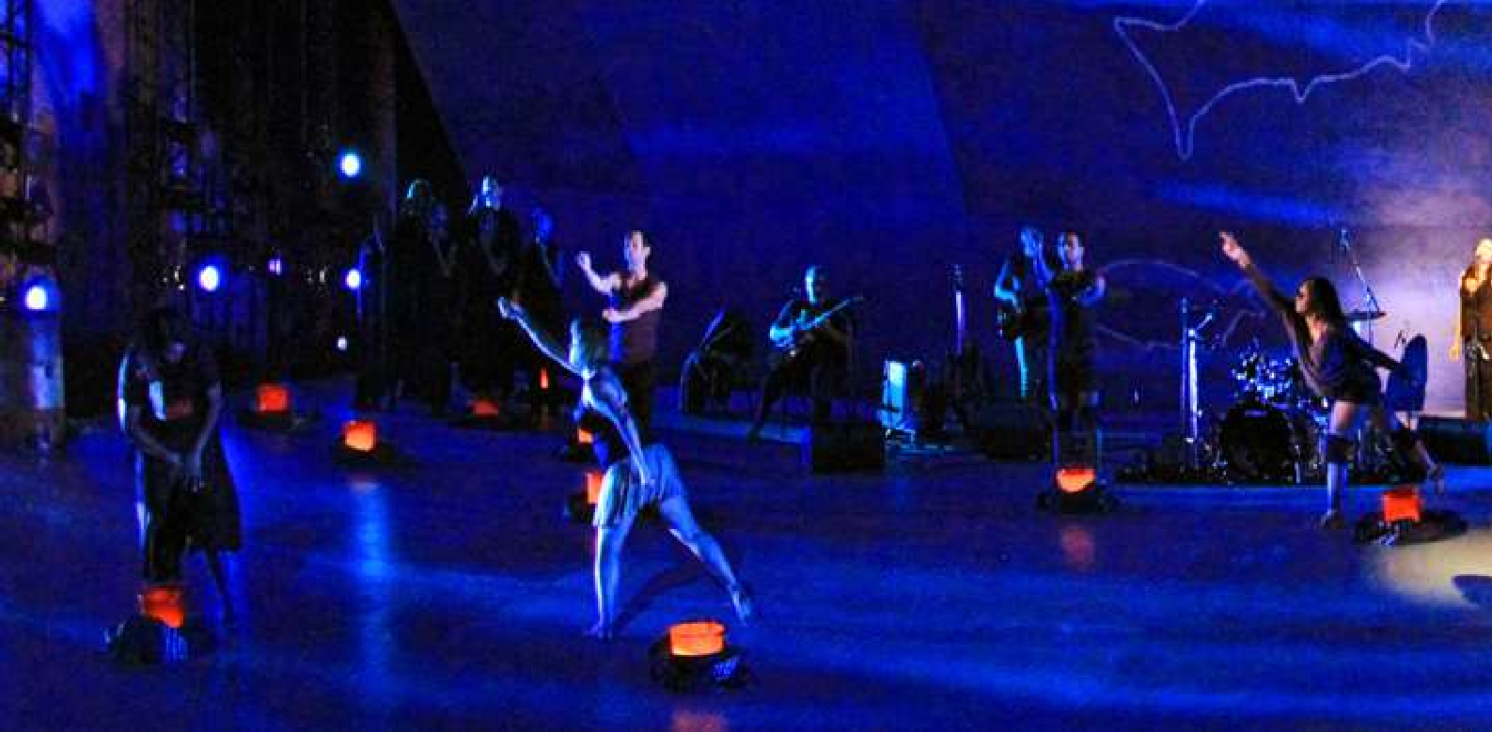OUR RECONCILIATION
JOURNEY

The Festival is proud of the organisational outcomes resulting from its commitment to the RAP including; a Welcome To Country protocol document endorsed by the MLALC, Cultural Awareness Training for staff, formal acknowledgements at all major events and in leading publications, staff events to celebrated NAIDOC Week, secured funding and placements for two paid Aboriginal and Torres Strait Islander internships which resulted in the mapping of clear pathways for employment.
Since 2016 the organisation has offered designated Aboriginal and Torres Strait Islander seasonal employment roles in programming. Additionally we worked with Arts Ready facilitating two full- time paid internships in administration roles in the organisation.
As well as our organisational outcomes, the Festival continues to celebrate and profile the talents of respected artists, leaders and companies through our program.
8

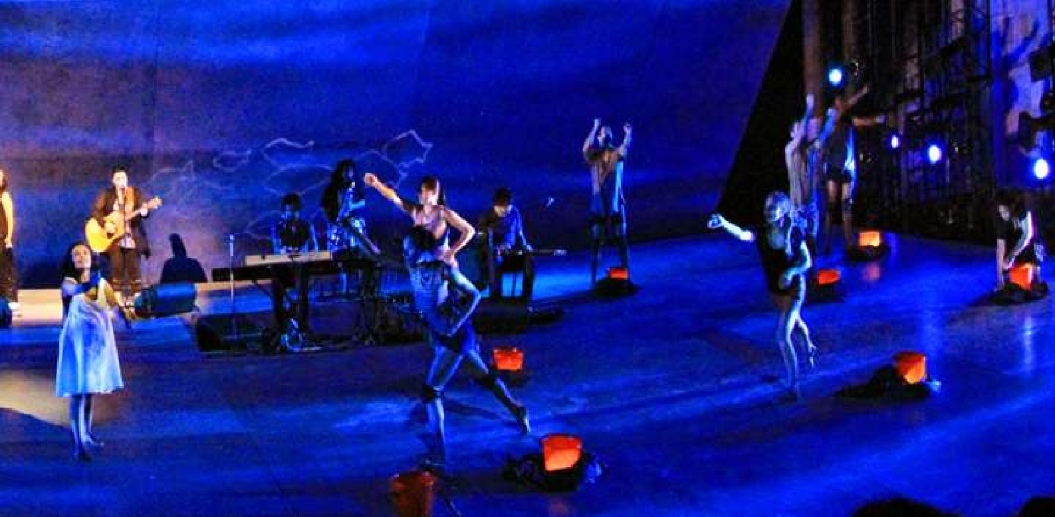2013

I Am Eora
Sydney Festival 2013
Photo credit: Prudence Upton
In July 2013, Sydney Festival launched its first RAP. Sydney Festival’s vision for reconciliation is to formally and informally engage with Aboriginal and Torres Strait
Islander artists and communities and contribute to positive outcomes for Aboriginal and Torres Strait Islander peoples. This relates to our core business objectives of consolidating our position in the ‘arts’ space by presenting high calibre unique arts projects and developing organisational capacity by ensuring we have a work environment that attracts the best employees.
The Festival’s reconciliation journey is driven by the RAP and a commitment to leading the practical and effective reconciliation with our Aboriginal and Torres Strait Islander people.
We continue and remain ever grateful for the ongoing guidance we receive from the Metropolitan Local Aboriginal Land Council, the City of Sydney Aboriginal and Torres Strait Islander Advisor Panel and respected community leaders. Their advice, insight and patience were invaluable during the development and ongoing implementation of our RAP.
Indigenous art and culture have always held a special place within the Sydney Festival program. Over the years, the Festival has celebrated and profiled the talents of respected artists, leaders and companies.

2014
We were proud to initiate, co-commission and produce Black Diggers in close collaboration with Queensland Theatre Company. Further to this, the Festival was thrilled to present The Shadow King with a cast including Tom
E. Lewis, Jimi Bani, Jada Alberts, Selwyn Burns, Frances Djulibing, Rarriwuy Hick, Damion Hunter, Kamahi Djordon King, Natasha Wanganeen and Bart Willoughby. Aboriginal and Torres Strait Islander artists were also integrated into

many other Festival programs including: as part of About an Hour we presented Marrugeku’s Gudirr Gudirr, a solo dance piece by Dalisa Pigram with visuals by Vernon Ah Kee; City of Sydney’s Lawn Library in the Festival Village featured workshops and storytelling by Matt Doyle; and both Domain concerts featured projections of Daniel Boyd’s exquisite History is Made at Night.

2015
We presented works by contemporary Aboriginal and Torres Strait Islander artists across artforms and contexts: Vicki
Van Hout’s Long Grass as part of About an Hour, Malthouse Theatre’s Blak Cabaret at the Festival Village, Anita Heiss and William Barton performing with the Sydney Symphony Orchestra at the annual free Symphony in The Domain, plus
Radical Son and Stiff Gins performing at Parramatta Opening Party.

2016
Sold out shows across several venues characterised this year’s performance works by artists from different nations across Australia – the intimacy of backyard storytelling with Uncle Wes Marne in Fire Bucket, the directorial feature film debut of Stephen Page’s Spear, the physical joy and documentary story of Djuki Mala, the urgency of climate change explored in Marrugeku’s Cut the Sky, the soulful songs of Kev Carmody, and the fusion of Tiwi song, dance and jazz music in Tiwi + Jazz.

2017
In 2017, Bayala was a centrepiece of the Festival, which also included Let’s Speak Sydney language classes, the installation Patyegarang’s Notebooks by Charles Madden and Lille Madden with Jonathan Jones and a morning ceremony song by Nardi Simpson and Jacinta Tobin sung by a choir on 26 January. Two works from Indigenous
theatre company ILBIJERRI – Blood on the Dance Floor and

9

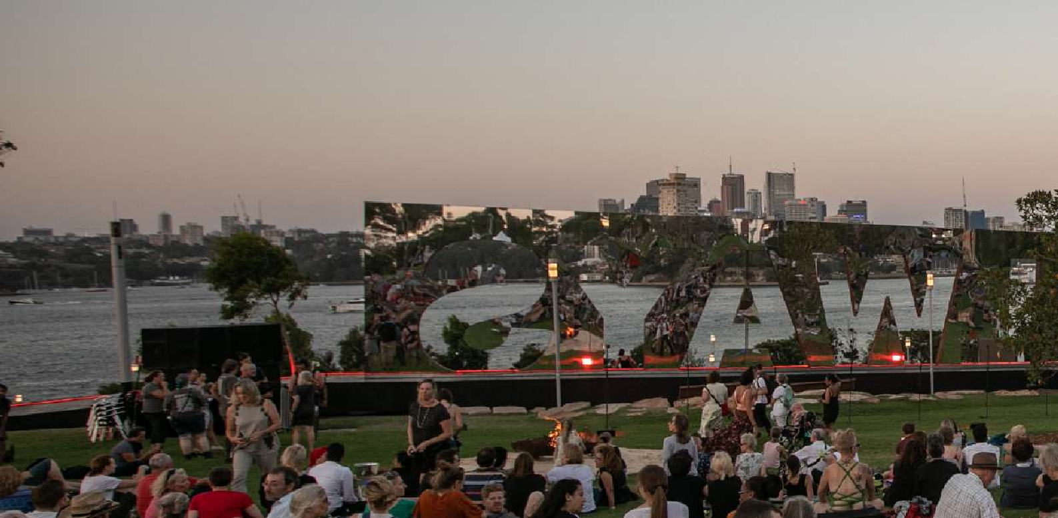
Which Way Home – were crowd favourites as was the world premiere of The Season by Nathan Maynard. Senior artist Vernon Ah Kee’s largest ever solo exhibition Not an Animal or a Plant showed at the National Art School whilst other performing artists engaged with the Yellamundie National First Peoples Playwriting Festival. As a special highlight to mark the 50th anniversary of the 1967 referendum, 1967: Music in the Key of Yes was a sell-out success.

2018
We continued our commitment to Indigenous programming through our Blak Out program. My Name is Jimi and My Urrwai saw the expansion of our partnership with Belvoir and the storytelling of artists from the Torres Strait. Bayala, our Indigenous language project, saw another sold-out series of classes and the moving Baraya song project saw close to 300 local choir singers perform a song on 26 January that acknowledged our history and colonial starting points. Tribunal brought the Indigenous and asylum seeker experience under the same roof and Bambula,
with Paul Grabowsky and The Wilfred Brothers, fused lndigenous language and culture with jazz.

2019
Sydney Festival’s Blak Out program returned with a diverse celebration of First Nations voices across theatre, dance, music and visual art. Dancer and Wiradjuri man Joel Bray invited audiences to an intimate encounter with his life story in Biladurang, performed partly in the nude and entirely in a hotel suite. The Sydney Opera House played host to Spinifex Gum, a musical collaboration between Marliya (a choir of young Indigenous women singing in English and Yindjibarndi) and The Cat Empire musicians Felix Riebl and Ollie McGill, with musical guests Briggs, Emma Donovan and Peter Garrett. Legs On The Wall showcased Man With The Iron Neck, an affecting work written by screen icon Ursula Yovich and co-directed by Josh Bond and Gavin Robins. The Bayala program returned

10

for the third time, teaching Sydneysiders how to speak their local language; Blak Box – Four Winds at Blacktown Showgrounds gave voice to stories from Elders and young members of Blacktown’s Indigenous community; and ALWAYS and The Vigil were hallmark presentations at Barangaroo Reserve.
Sydney Festival 2019 acknowledged First Nations custodianship of this land with three events and installations at Barangaroo Reserve. The ALWAYS sculpture
– a huge outdoor installation of the declaration ‘Always’ by local Bangarra artist in residence Jacob Nash – stood to remind visitors that this land always was and always will be Aboriginal land. In sight of the ALWAYS sculpture, an overnight vigil was held from dusk on 25 January until dawn on 26 January. This was a chance for all Australians
to come together by campfire, hear stories of Country from Elders, reflect on the meaning of the day before the First Fleet arrived, and understand the impact that colonisation has had upon Australia. On the morning of 26 January from 8.30am, the Was and Will Be concert featured members of the Marliya choir from Spinifex Gum, storytelling by Elders from local community and a performance by Troy Brady.

2020
In 2020, First Nations voices and storytelling were the highlight of the program, with many of the Festival’s biggest critical and commercial successes included theatre performances BLACK TIES from ILBIJERRI Theatre Company and Te Re-hia Theatre, Opera Australia’s musical revival Bran Nue Dae, Nardi Simpson’s Black Drop Effect, Black Cockatoo directed by Wesley Enoch AM, Jane Harrison’s The Visitors, powerful Gurrumul Yunupiŋu tribute Buŋgul and Archie Roach’s career-spanning concert Tell Me Why. First Nations Canadian musician Jeremy Dutcher revivified the music of his ancestors with a standing ovation performance at City Recital Hall and sold-out Salon Series show at the Harry and Penelope Seidler House, while didgeridoo maestro and composer William Barton packed the Sydney Town Hall Vestibule alongside ‘Dreamtime

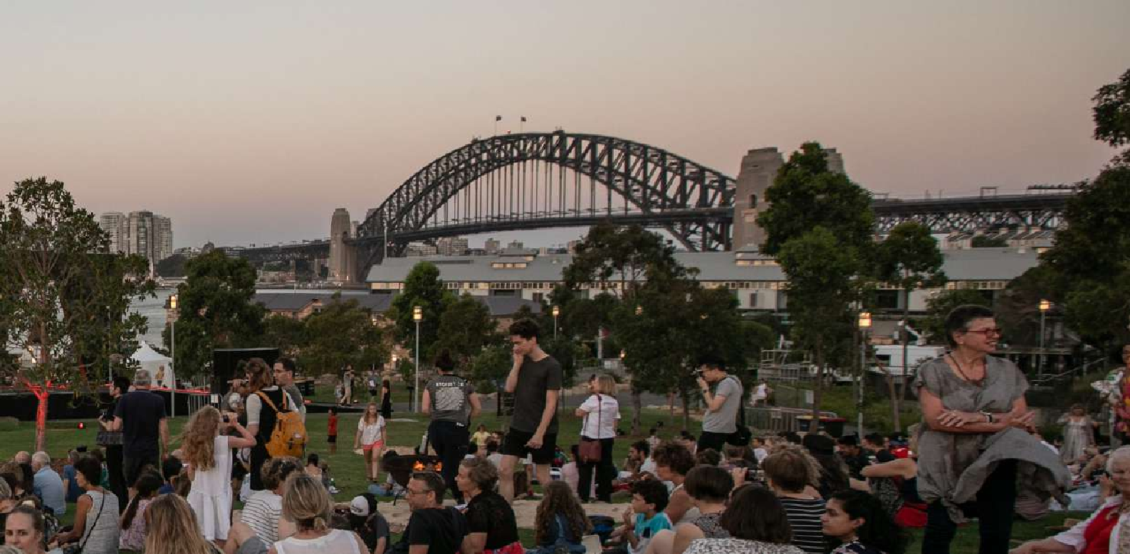Opera Diva’ Auntie Delmae Barton and top violinist Veronique Serret. The Festival also showcased a wealth of First Nations visual art, from world-first career surveys and new work debuts by Fiona Foley, Vernon Ah Kee and Taloi Havini to Three Views’ subversion of colonial coastal defence bunkers, Reko Rennie’s monumental tribute to

ALWAYS
Sydney Festival 2020
Photo credit: Victor Frankowski
Indigenous sovereignty REMEMBER ME and Daniel Boyd’s stunning, 360-degree video projections VIDEO WORKS
at Carriageworks, Indonesian artist Jumaadi’s exhibition and shadow play performance, and Pacific-spanning contemporary and traditional art exhibition Wansolwara. On the 250th anniversary of Cook’s landing, sovereignty and new concepts of nationalism were top of the agenda, with Sydney Festival leading the cultural conversation through Procession, The Vigil and Proclamation. To complement these works, the Festival also programmed Beyond 2020: My Australian Dream (presented in partnership with UTS), a panel discussion and oration
by Professor Tom Calma AO, a screening of the Adam Goodes documentary My Australian Dream, and a series of storytelling and language events at the State Library of NSW. The Future is Floating and three UTS Big Thinking Forums examining new, inclusive ways to conceptualise Australian national identity, First Nations leadership in arts and culture, and what defines a project as First Nations, further allowed these concepts to be explored.
The 2020 Festival also saw the creation of a powerful addition to the national discussion around 26 January – the Procession, a cleansing ceremony, song and dance led by Aboriginal Elders through the streets of Sydney. A positive walking experience of reflection, Procession brought together hundreds from Indigenous Australian and Torres Strait Islander communities to celebrate culture in the main street of Sydney, as well as thousands of general public, who accompanied Procession on its way to Barangaroo Reserve for The Vigil. In 2020 The Vigil cemented its
place as an annual 25 January tradition – an overnight opportunity to gather together in reflection on the eve of Australia Day and consider all of the narratives that
make up our national identity, from Australia’s Indigenous
heritage to its colonial institutions and contemporary multicultural migration. Thousands came together at Barangaroo Reserve from dusk right through until dawn, enjoying dance, poetry and live music performances from artists such as Dan Sultan and guests, and experiencing the resilience, beauty and joy of First Nations cultures.

2021
In 2021, Sydney Festival’s Blak Out program returned with a well-rounded selection of theatre, music, dance and art by First Nations writers, performers and artists. First Nations storytelling was at the forefront of the Australian Made 2021 program, with highlights including Bangarra Dance Theatre’s dance performance Spirit: A
Retrospective 2021 at The Headland outdoor pop-up stage and Sunshine Super Girl which transformed Sydney Town Hall into a tennis court for the remarkable story of Evonne Goolagong. Two decades after thousands of Australians walked across the Bridge in the name of reconciliation, Burrawa – a local Aboriginal word that means “above” or “upwards” – delivered fresh perspectives on the history
of our Harbour City with Indigenous Storytellers leading this inaugural BridgeClimb Sydney tour. The Festival showcased a wealth of First Nations visual art with a line- up that included Carol McGregor, Judy Watson, Archie Moore, Megan Cope, Alick Tipoti and a stunning showcase of work by 30 contemporary First Nations artists at the Maritime Museum, Defying Empire: The 3rd National Indigenous Art Triennial. First Nations musicians took over much-loved local venues in the Festival’s Allowed & Local series, with sets from Ngaiire, Christine Anu, Thandi Phoenix and Kobie Dee getting audiences grooving in their seats.
While over at the Seymour Centre, didgeridoo virtuoso William Barton and powerhouse violinist Véronique Serret mesmerised and transfixed audiences with Heartland, blending traditional songlines and modern storytelling
in a new musical collaboration featuring Aunty Delmae Barton’s poetry. Following last year’s 250th anniversary of Captain James Cook’s voyage to Australia, To Cook Cook

11

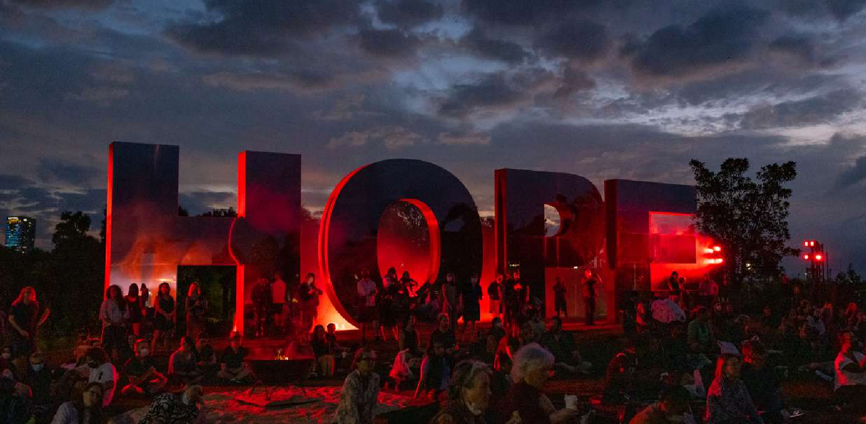or Not (presented in partnership with Biennale of Sydney) challenged prevailing historical narratives with Festival Director Wesley Enoch, comedian Dane Simpson, singer- songwriter Ngaiire and TV Presenter Matty Webb. The 2021 Festival saw The Vigil return for a third year, cementing this tradition of cleansing, reflection and performance on the eve of Australia Day.

Vigil: Songs for Tomorrow
Sydney Festival 2022
photo credit: Jackie Manning
While we continue to implement aspects of the RAP to improve organisational culture, we must not lose sight of our core purpose and the area in which we can contribute the most to reconciliation; as a meeting place of ideas and stories. Through commissioning, presentation and
conflation of ideas, the Festival has its greatest opportunity to instigate change. Sometimes this takes the form of a provocation and other times artist help us shine a light on hidden truths. Embedding cultural respect, strengthening relationships and developing opportunities for Aboriginal and Torres Strait Islander people within our organisation will fundamentally improve the way in which we go about being a better meeting place.

2022
Sydney Festival continued its role as a platform for Aboriginal and Torres Strait Islander voices in 2022, which saw the inaugural appointment of Sydney Festival’s Creative Artist in Residence, First Nation Designer Jacob Nash. Jacob provided essential cultural and creative consultation across the Festival’s major projects, and designed some of the most memorable features of the program. These included the evocative set of critically acclaimed Festival highlight, Wudjang: Not the Past and Future Dreaming. Jacob also curated Vigil: Songs for Tomorrow, the fourth incarnation of this essential moment of reflection in the national calendar.
In the 2022 program, First Nations visual artist Dean Cross drenched a corner of Carriageworks in gold for his installation, Icarus, My Son, which investigated themes
of home, ambition and loss in remote communities.

A collaboration between Yuwaalaraay musician and storyteller Nardi Simpson and Festival stalwarts Ensemble Offspring resulted in –barra, an absorbing sonic and
visual journey through flowing rivers and rumbling red dirt of Yawaalaraay country in north-western New South Wales, whilst at Speakers Corner William Barton wove the
unmistakeable growl of the didgeridoo into the grooves of Australian jazz icon James Morrison. Aboriginal Dreaming Cruises invited audiences to understand the significance of harbour landmarks from the First Nations perspective, and the Australian Museum’s exhibition Unsettled revealed harrowing stories behind our nation’s foundation.

12

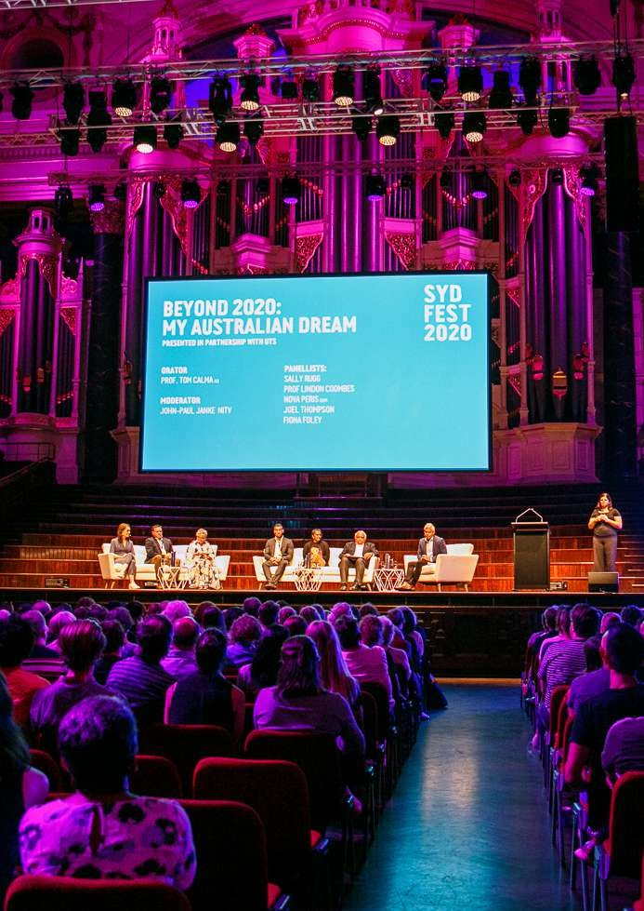Beyond 2020: My Australian Dream
Sydney Festival 2020
photo credit: Yaya Stempler

13

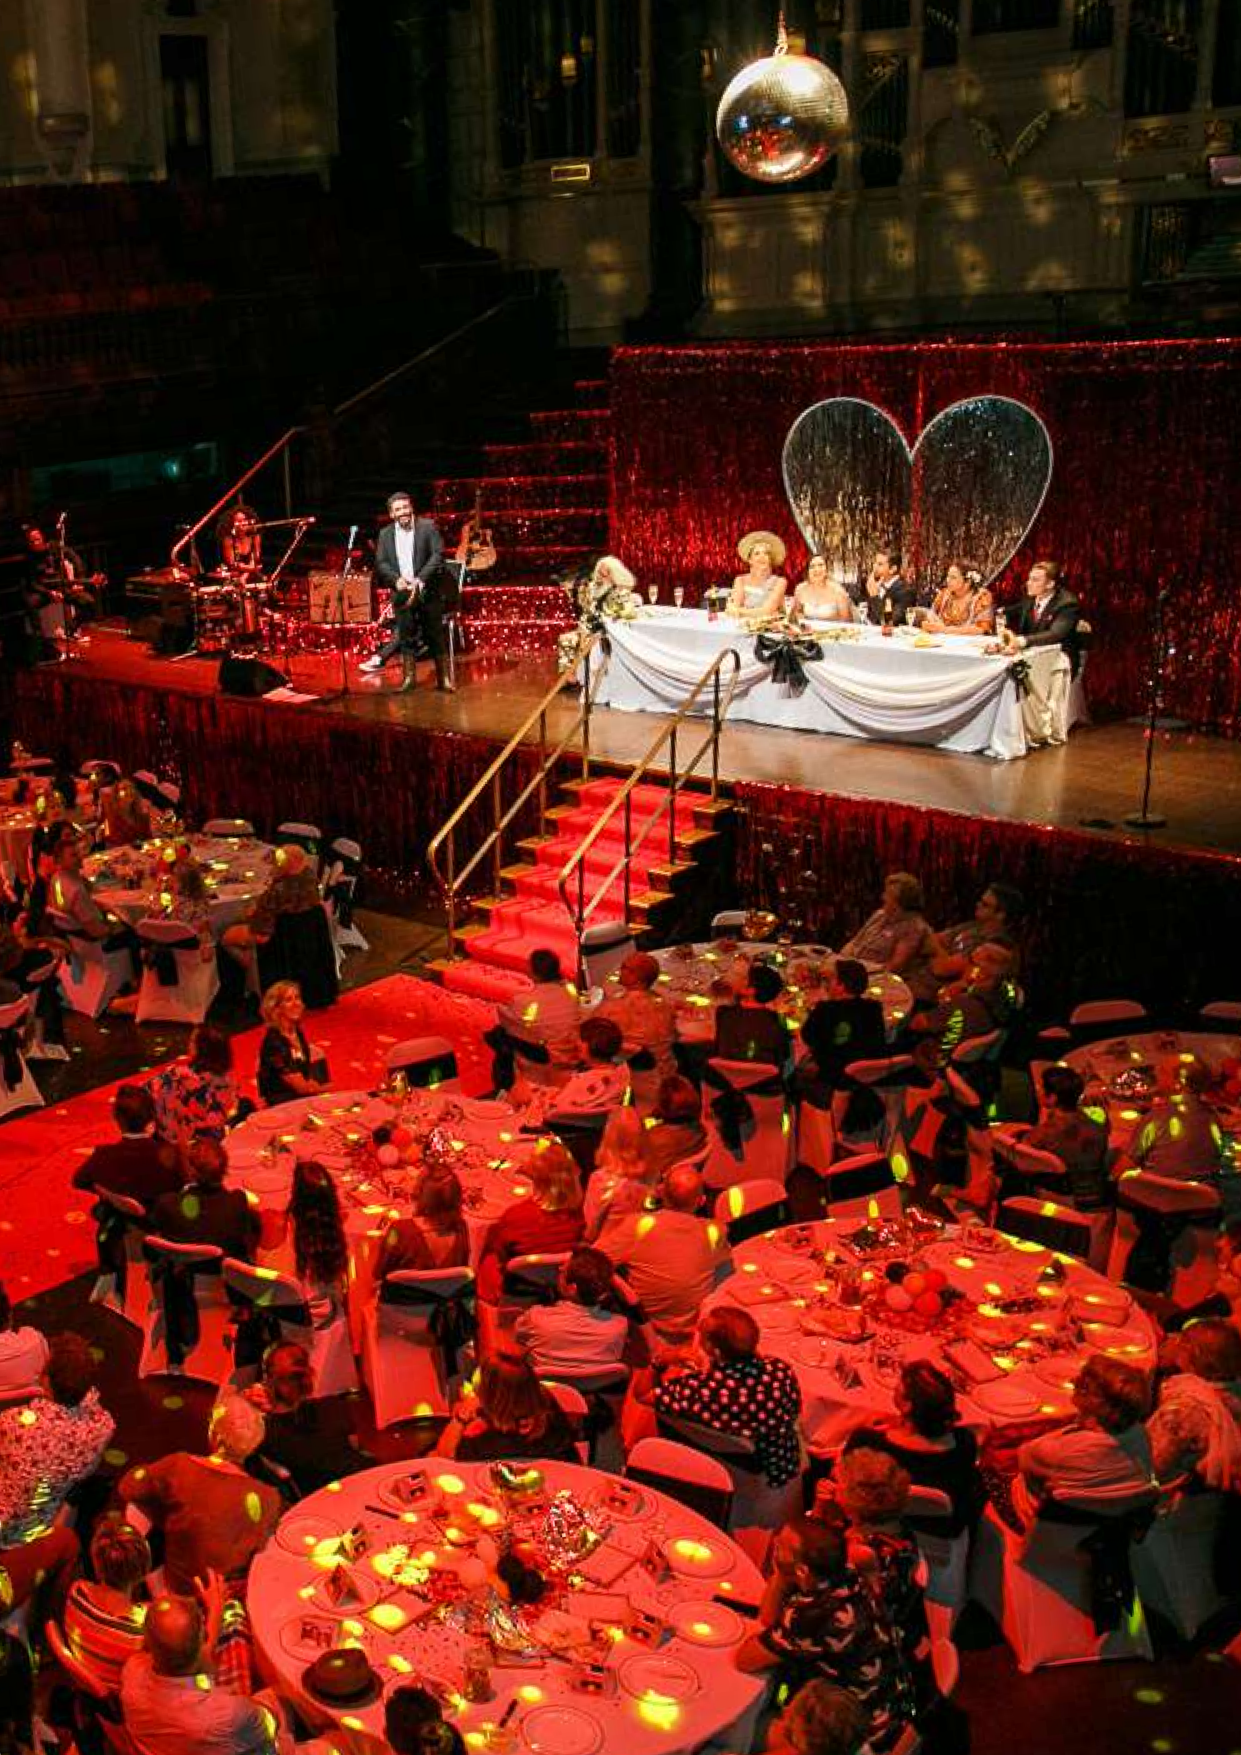Black Ties

Sydney Festival 2020

14

RELATIONSHIPS

Sydney Festival is one of Sydney’s most important global meeting places. We want all citizens to participate in, have access to, and feel genuine ownership of, their Sydney Festival. Long-range strategic and respectful partnerships between Aboriginal and Torres Strait Islander peoples and other Australians are essential to the festival’s relevance in contemporary Australia, its aim to increase participation of Aboriginal and Torres Strait Islander content and audiences, and its ability to leave a lasting cultural legacy on which to build for future generations.

Action | Responsibility | Timeline | Measurable Target
Work in collaboration with First Nations artists and companies to ensure their agency in sharing their stories and work with our audiences | Festival Director / Creative Artist in Residence | Oct 2022 | Number of First Nations works in 2023 program
Continue consulting and working with Metropolitan Land Council | Executive Director /  Festival Director / Creative Artist in Residence | ongoing | Number of collaborations and engagement of speakers
Ensure pathways for First Nations audiences are broad and inclusive welcoming the community to enjoy all of the Festival program | Marketing Director / Creative Artist in Residence | Jan 2023 | Audience development plan in place Number of First Nations audiences
Establish a First Nations Advisory committee | Executive Director /  Festival Director / Creative Artist in Residence | Dec 2022 | Inaugural meeting held
Maintain First Nations representation on the Sydney festival Board of Directors | Chair of the Board | ongoing | Number of Board Directors

15

RESPECT

It is essential that Sydney Festival respects Aboriginal and Torres Strait Islander peoples, their cultures, lands and histories to maintain its profile as a cultural leader locally, nationally and internationally. By acknowledging the enormous contributions Australia’s first peoples have made to this country and by fostering a sustainable and progressive platform for future Aboriginal and Torres Strait Islander stories, engagement and employment, Sydney Festival will be able to accurately reflect its time and place in contemporary society.

Action | Responsibility | Timeline | Measurable Target
Establish an annual cultural awareness program for both full-time and seasonal staff | Executive Director | Nov 2022 | Number of staff completing program
Maintain Welcome to Country and Acknowledgement of Country protocols for Sydney Festival use | Head of Programming Operations | ongoing | Protocols in place and implemented consistently
Continue to include Vigil celebrations as a cornerstone event of the First nations program | Festival Director / Creative Artist in Residence | Jan 2023 | Event/celebration delivered
Actively promote traditional languages through programming and external communications practices | Festival Director / Creative Artist in Residence | Oct 2022 | Traditional place names used in marketing comms Traditional language used to greet guests at Festival events and functions

16

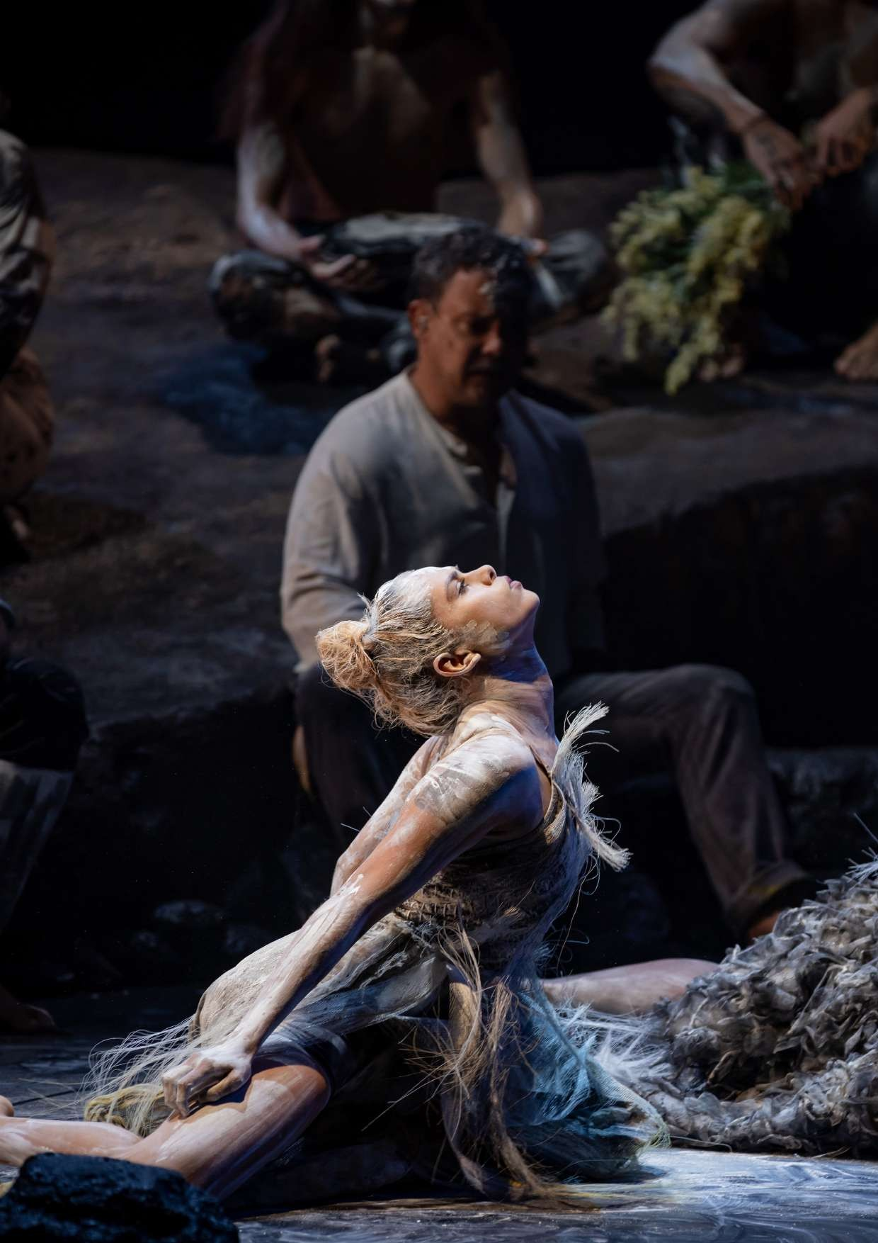Wudjang: Not the Past

Sydney Festival 2022

17

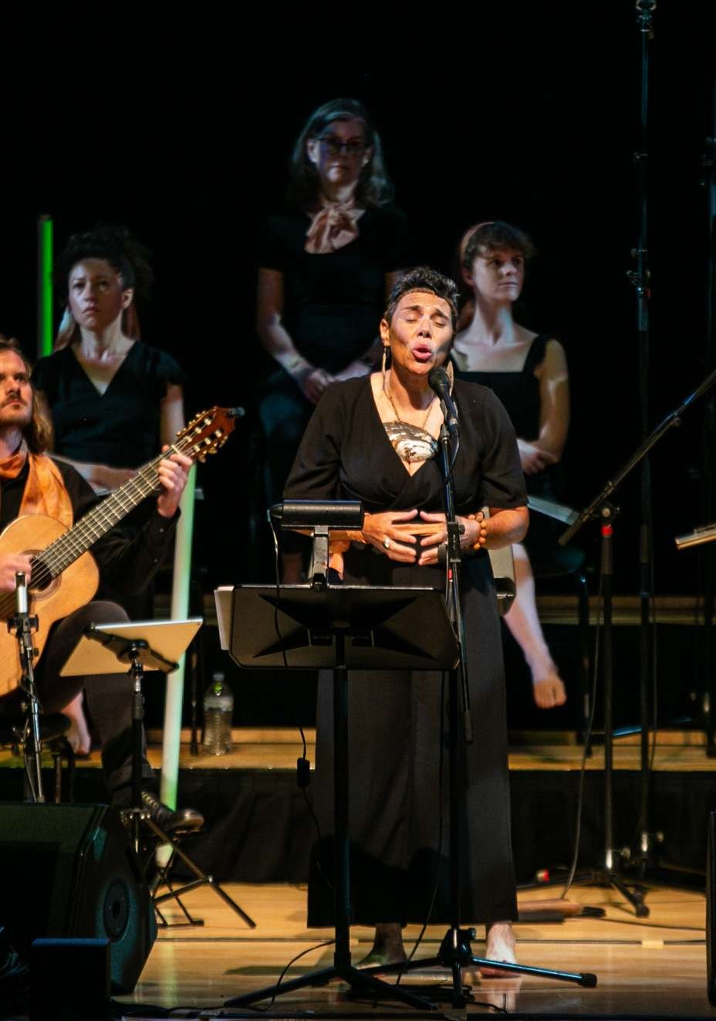-barra Sydney Festival 2022
Photo credit: Yaya Stempler

18

Opportunities for Aboriginal and Torres Strait Islander individuals, organisations and communities are important to the program and staff development of Sydney Festival if it is to maintain its profile as a progressive, inclusive and socially responsible arts organisation. The growth of a valuable network
OPPORTUNITIES
of Aboriginal and Torres Strait Islander arts and corporate professionals will bring new perspectives and awareness of creative and business opportunities and workplace satisfaction.

Action | Responsibility | Timeline | Measurable Target
Work with NAISDA and other organisations to develop training and career development for First Nations artists and arts workers | Creative Artist in Residence / Head of Programming Operations | June 2023 | Program agreed with NAISDA
Prioritise producing and leaderships roles for First Nations people within the organisation | Creative Artist in Residence / Head of Programming Operations | June 2023 | Not less than one seasonal programming role filled by a First Nations worker Maintain the Creative Artists in Residence  as an identified First Nations position
Participate in a paid internship program i.e., Career Trackers | Executive Director | June 2023 | Engage an intern for the 2023 calendar year
Explore sharing unused office space and resources with First Nations artist and companies | Executive Director / Head of Finance and Administration | June 2023 | Office space used
Network with First nations arts sector by attending and promoting performances and events | Programming department | ongoing | Numbers of attendances at performances/events
Align partnerships with other corporate organisations with RAP's and a demonstrated commitment to the reconciliation process. | Executive Director, External Relations Director | Oct 2023 | Corporate partner secured and aligned to the first nations program

19

TRACKING AND PROGRESS

Action | Responsibility | Timeline | Measurable Target
Review results for 2022/23 and publish in the organisation’s Annual Review | Executive Director / Marketing Director | Apr 2023 | Report completed
Complete Action Plan for 2023/24 | Executive Director / Festival Director / Creative Artist in Residence | June 2023 | Report completed

20

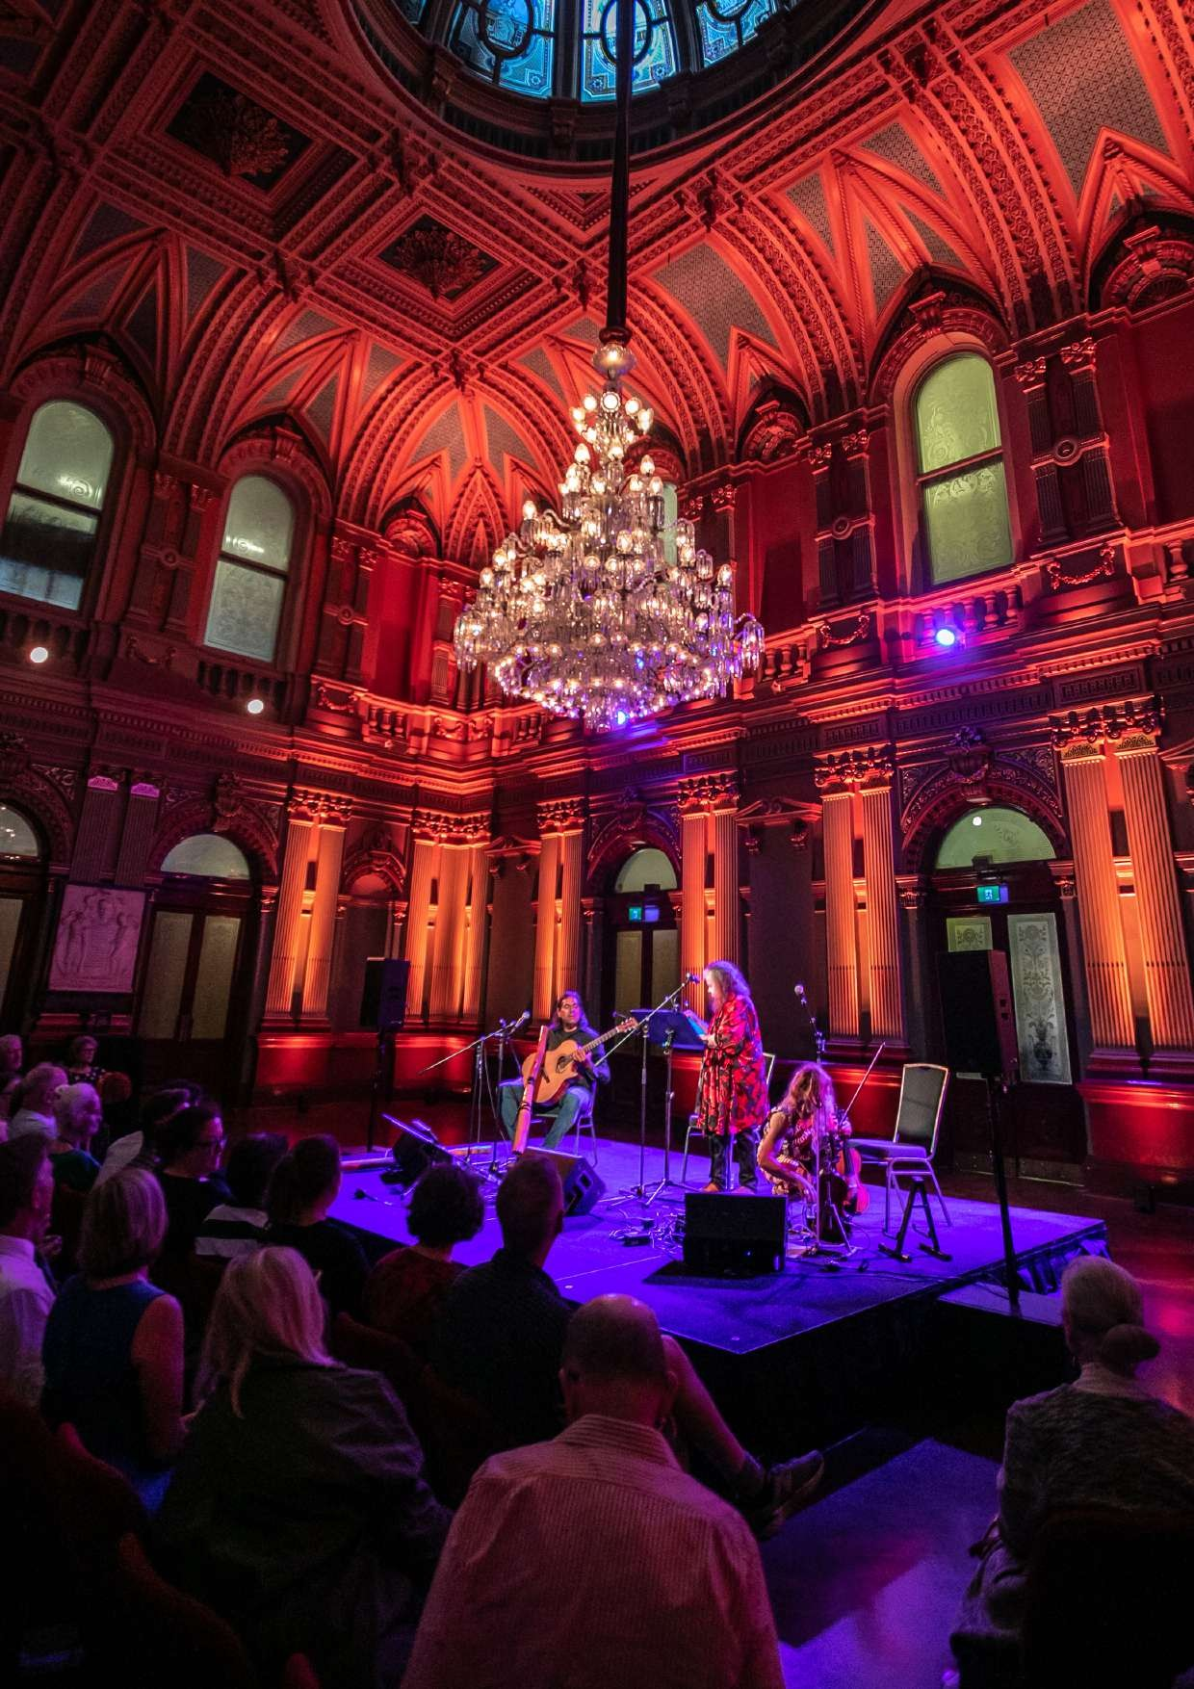Salon Series Sydney Festival 2020
Photo credit: Victor Frankowski

21

SYDNEY FESTIVAL
Level 5, 10 Hickson Road The Rocks, NSW 2000 Sydney, Australia

T: 02 8248 6500
E : mail@sydneyfestival.org.au

sydneyfestival.org.au

