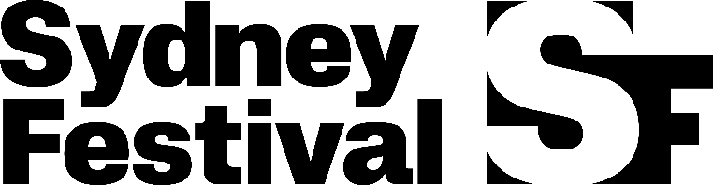

Media & Communications Coordinator, Sydney Festival 2027

This is a fantastic opportunity to gain hands-on experience working on one of Australia's leading arts festivals, supporting a high-profile communications campaign and collaborating with artists, journalists and creative professionals from around the world.

Each January Sydney Festival shakes up our city with a summer festival of art, music, dance, theatre and immersive experiences.

We are proud of our long history of commissioning ground-breaking new Australian art, and we're equally proud to be a great place to work, with many of the seasonal team members returning year after year.

Sydney Festival is committed to equity and inclusion. We welcome and encourage
applications from Aboriginal and Torres Strait Islander peoples, people from culturally and linguistically diverse backgrounds, people with disability and people from the LGBTQI+ community.

- Title: Media & Communications Coordinator
- Salary: $70,000 + superannuation (pro-rata)
- Contract: September 2026 – January 2027
- Location: The Rocks, Sydney, NSW
- Reports to: Communications Manager

Purpose of the Position
The Media & Communications Coordinator plays a key role in planning and delivering the PR campaign for Sydney Festival 2027.
Working closely with the Communications Manager, external PR agency and wider Marketing & Communications team, you will help bring the Festival's 2027 program to life. As the first point of contact for media enquiries, you'll also play a central role in delivering media launches, interviews, filming opportunities and photography throughout the Festival campaign.
Organisational context of the position
The position forms an integral part of Sydney Festival’s Marketing and Communications team, which is responsible for the ongoing management of the Festival’s brand and reputation, while also generating box office income.
This is achieved through an integrated communications campaign, alongside targeted campaigns for individual events, productions and program strands. The department also delivers marketing benefits to sponsors and is responsible for ensuring the Festival is recognised as a vibrant, inclusive and trusted cultural organisation, making it attractive to audiences, artists, sponsors, the media and other key stakeholders.
The position works closely with colleagues across the External Relations, Programming, Production and Administration teams, as well as external agencies and suppliers.

Roles and Responsibilities
Duties will include:
Media Office
- Act as the first point of contact for the Sydney Festival Media Office.
- Oversee media ticketing, reviewer databases, cancellations and attendances.
- Upload media information to relevant internal and external platforms.
Media Campaign
- Support the development of press releases and other media materials.
- Assist with artist liaison for interviews and media opportunities.
- Contribute to PR campaign reporting.
Photography & Filming
- Coordinate Festival photography and photographers' schedules.
- Seek filming and photography approvals.
- Meet and assist photographers and film crews onsite.
- Assist with the distribution and archiving of Festival photography.
Monitoring
- Monitor media coverage and distribute daily media reports.
General
- Support the Communications Manager and PR agency as required.
- Contribute to Marketing & Communications team meetings.
- Contribute ideas to the social media content calendar.
- Attend Festival events, media launches, press calls and press nights.

Skills and Experience
While experience in a similar communications or PR role would be an advantage, we welcome applications from people with a passion for arts and culture, or experience in the arts, music, cultural or entertainment sectors. If you're enthusiastic about live performance and excited by the opportunity to help tell the stories behind Sydney Festival, we'd love to hear from you.
We're looking for someone who:
- Has an understanding of Public Relations and marketing principles, practices and current industry trends.
- Has a general understanding of the local and national media landscape.
- Has excellent written and verbal communication skills.
- Is confident working with journalists, photographers, film crews, influencers and other media stakeholders.
- Is creative, proactive and enjoys working collaboratively as part of a team.
- Has exceptional attention to detail and strong organisational skills.
- Is confident representing the Media & Communications team independently at events and media opportunities.
- Can manage multiple priorities and deadlines while remaining calm under pressure.
- Is adaptable and comfortable responding to changing priorities and last-minute requests.
- Is available to work early mornings, evenings and weekends during peak Festival periods, when required.

To Apply
Submit your resume and cover letter by email to Nia Jones, Sydney Festival Communications Manager at marketing.jobs@sydneyfestival.org.au

Early applications are encouraged, and an appointment may be made prior to the closing date.
Closing date: Tuesday 18 August 2026.

