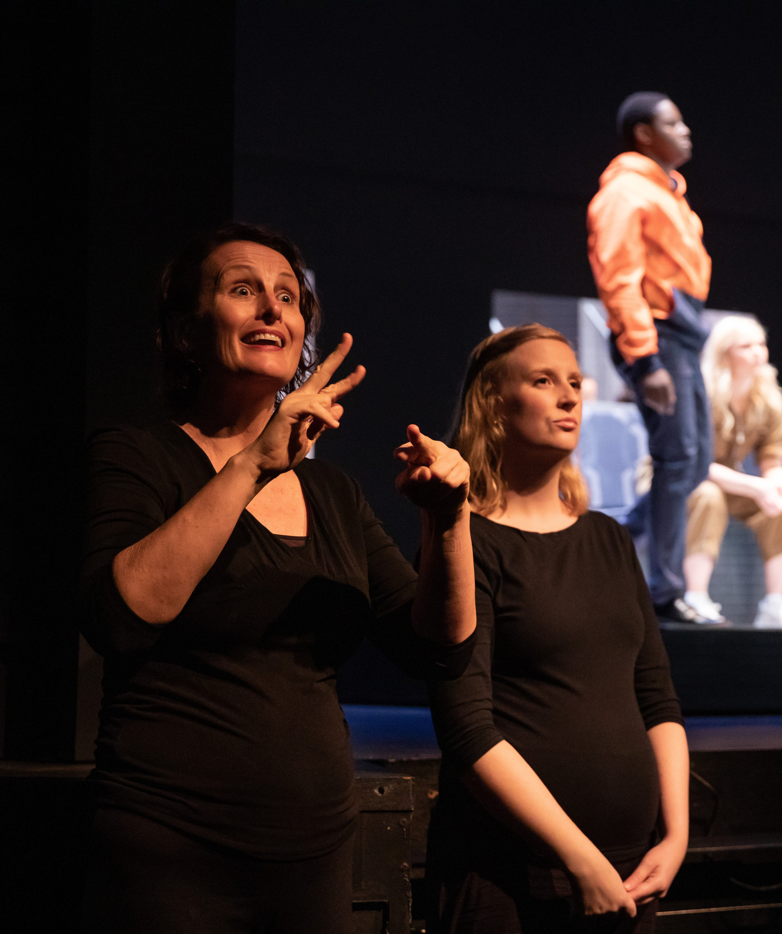DISABILITY INCLUSION ACTION PLAN 2022 - 2024
1

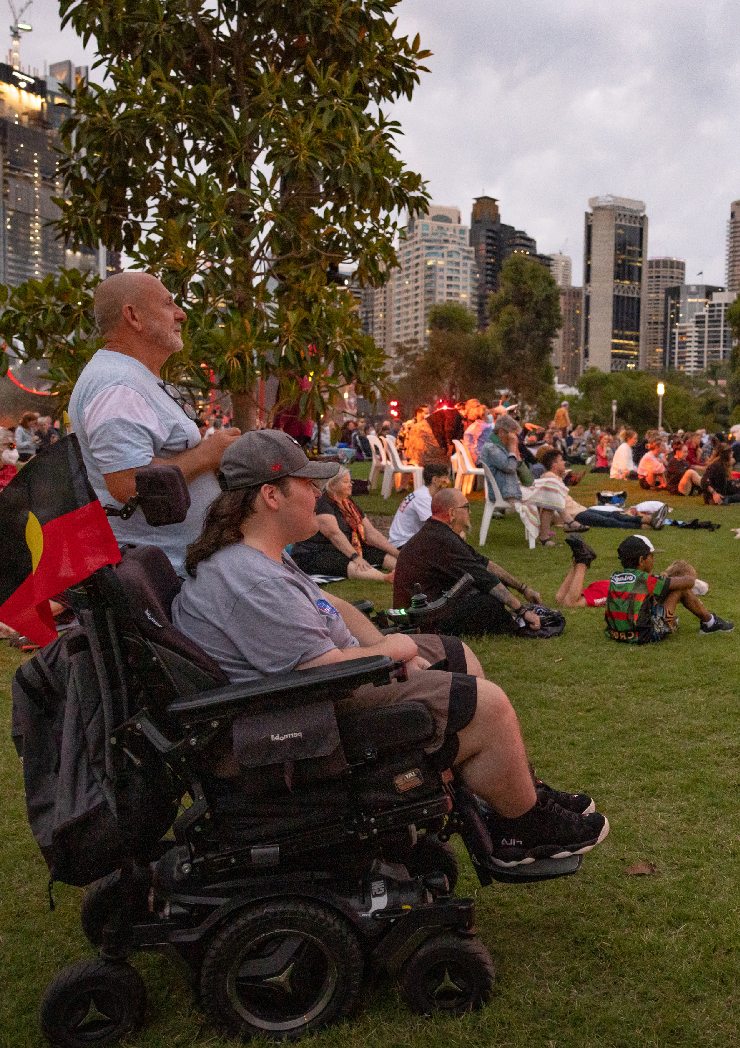Vigil: Songs For Tomorrow
Sydney Festival 2022

Acknowledgement of country
Sydney Festival acknowledges the 29 clans of the Eora Nation, the Traditional Owners of the land on which the Festival resides and takes place. We pay our respects to Elders past and present and recognise the continuing connection to lands, waters, and communities.

Acknowledgement of community
We acknowledge and recognise that the voice and contribution of people and communities with diverse lived experience of disability, both past and present, are essential in realising an inclusive society.

Access program
Sydney Festival would like to acknowledge those people who contributed their time and expertise to participate in the development of this plan, including:

- Our Access and Inclusion Advisory Committee members
- Our internal DIAP Working Group – Rebecca Gribble, John Bayley, Dimitri Cachia, Ellen Kavanagh, Aimee Ocampo, Jane You and Chris Tooher
- Our survey respondents
- Our artists, staff, contractors and volunteers
- Our audience members, partners and other stakeholders
- Accessible Arts and access consultants Morwenna Collett and Liz Martin.

Alternative formats
We acknowledge and recognise that the voice and contribution of people and communities with diverse lived experience of disability, both past and present, are essential in realising an inclusive society.

A note on language
We recognise that there are varying views on language and terminology around disability in Australia and internationally. Language can be both a personal, and also political, choice.
We use the person-first language of ‘person with disability’ to recognise that disability is just one aspect of a person’s life and does not determine who they are. However, we respect that different people have different preferences about language.

3

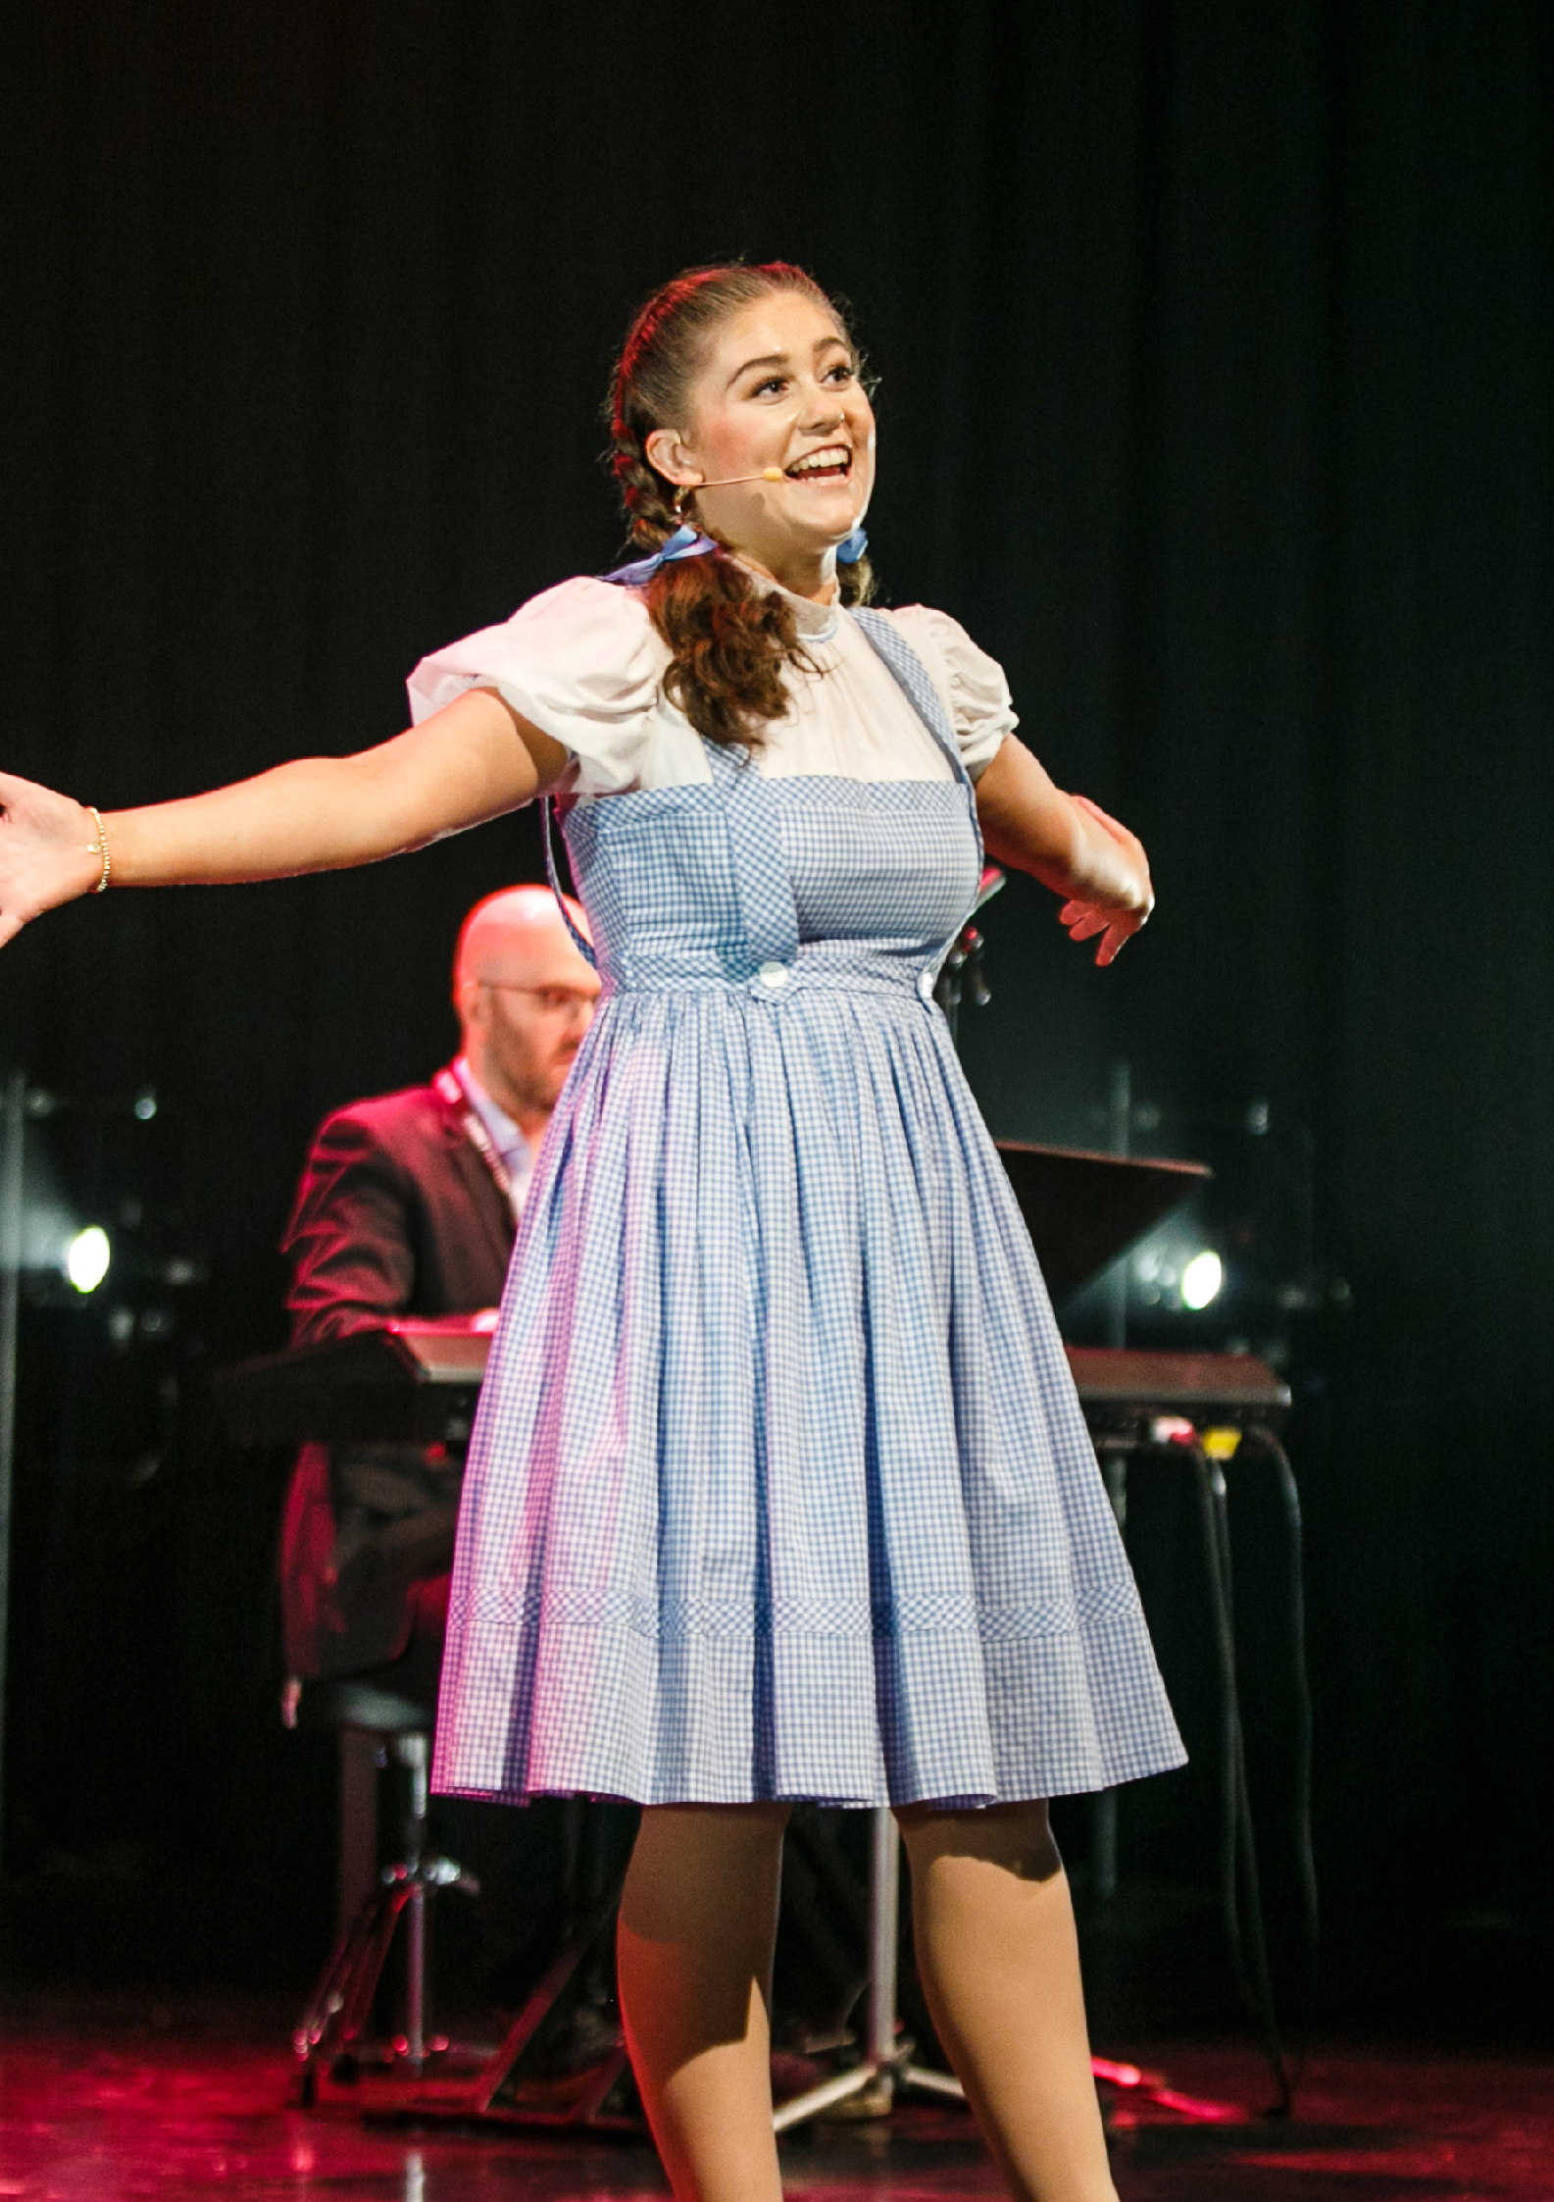The Aspie Hour
Sydney Festival 2020

CONTENTS

Acknowledgement of Country 3
Other Acknowledgements 3
Alternative Formats 3
A Note on Language 3
Message from the Executive Director 7
Introduction 8
About Us 8
Disability in Australia 10
Our DIAP 13
Our Achievements to Date 14
Methodology and Consulation 16
Governance, Monitoring and Review 19
Plan, Commitment, Vision and Goals 20
Contact Us 24

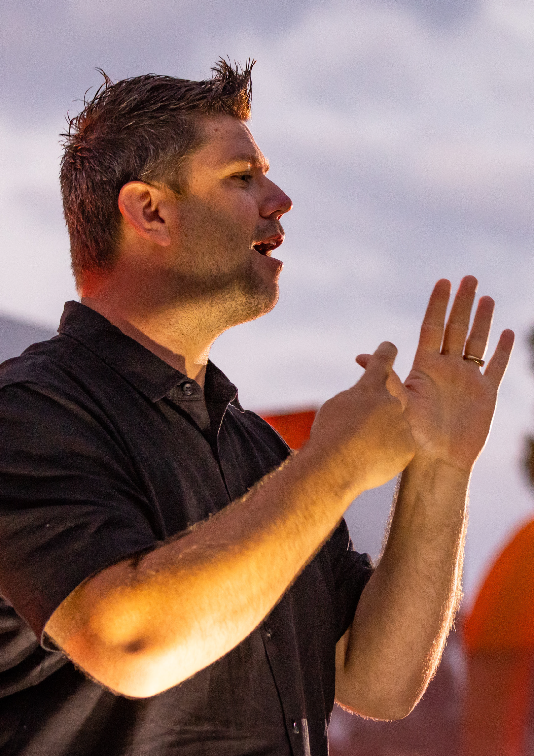Vigil: Songs For Tomorrow
Sydney Festival 2022

A MESSAGE FROM THE EXECUTIVE DIRECTOR

Sydney Festival celebrates the art of summer with an annual festival that presents the world’s leading artists and organisations across the city’s finest venues and stages, found spaces and pop-up precincts.

Sydney Festival welcomes and encourages the entire community to this annual celebration by actively pursuing inclusivity and access as a key priority in its operational planning. Our journey to better access and inclusion is ongoing, in recent years initiatives such as our Disability Programming Initiative and the introduction of our Access and Inclusion Panel have been significant drivers in realising this priority.

We are working to embed access and inclusion principles into the hearts and minds of everyone across the organisation – we want it to be front and centre in all our thinking and just ‘part of what we do’. We are always learning as an organisation, and we will continue to learn and explore new possibilities in this area – by working with people with lived experience, keeping up to date with new technologies and working with partner organisations (e.g. Radio 2RPH, Accessible Arts) who are experts in this field.

Finally, I would like to acknowledge the work and invaluable advice provided to the organisation by the Access and Inclusion Advisory Panel. Members of the panel share a deep passion and enthusiasm for the Festival and their personal experiences,
observations and expertise are critical in informing our ongoing journey in access and inclusion for all.

Christopher Tooher
Executive Director

7

COVER IMAGE:
ANTHEM
Sydney Festival 2020

INTRODUCTION

Our Disability Inclusion Action Plan highlights our work to date and outlines our approach for further improving
accessibility and inclusion for people with disability across all aspects of our festival.

It reinforces and focuses our work to ensure we include and represent people with disability – as artists, audiences, staff, partners, donors and other stakeholders. We want all members of the community to have the opportunity to experience our festival and this plan acts as our Roadmap to how to we will continue to work towards this over the next three years.

About Us
Every January, Sydney Festival presents bold and memorable experiences that excite the city of Sydney. Since its inaugural year in 1977, Sydney Festival has grown to become one of Australia’s largest annual cultural celebrations, with an international reputation for modern and popular programming. Sydney Festival celebrates our city, and the Festival’s style and energy reflect the confidence, diversity and vigour of one of the world’s most beautiful cities.

8

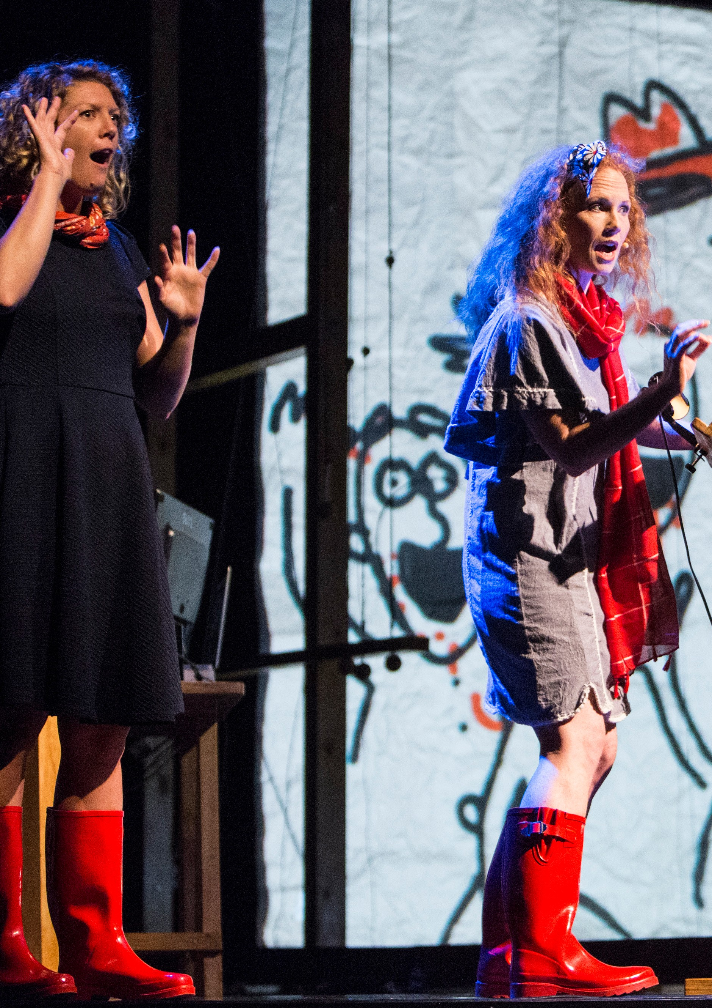

9

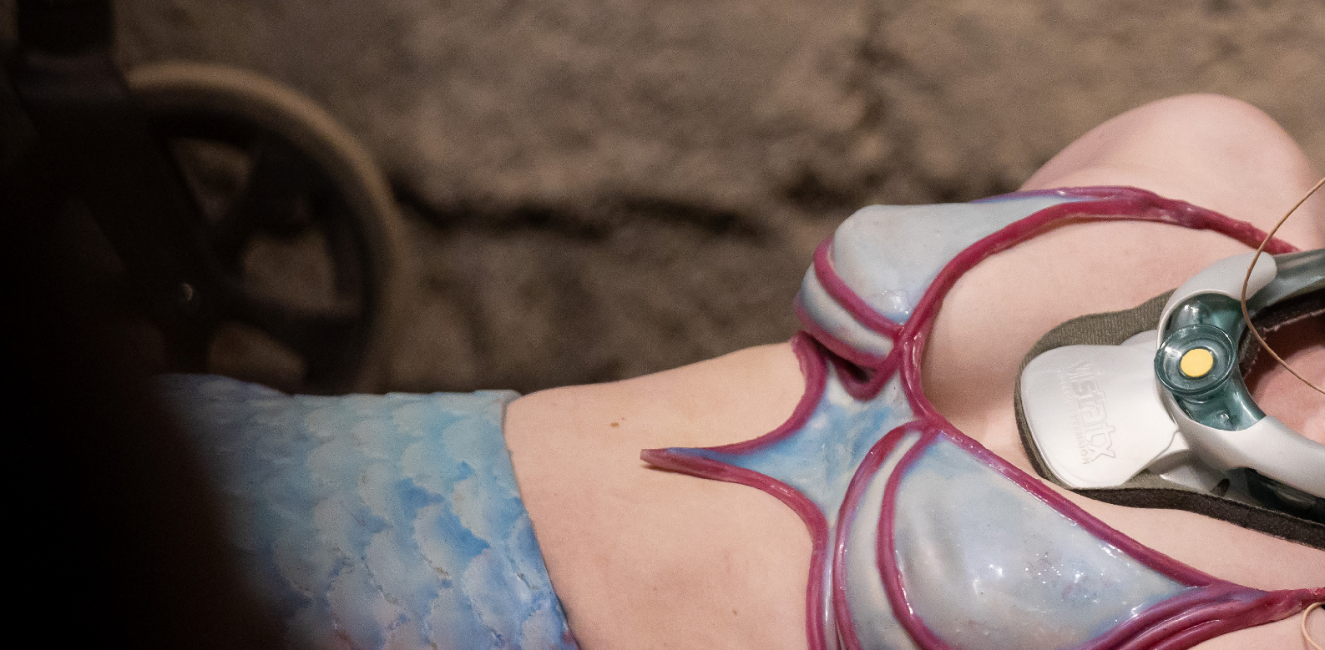DISABILITY IN AUSTRALIA

The 2006 UN Convention on the Rights of Persons with Disabilities defines people with disability as those ‘who have long-term physical, mental, intellectual or sensory impairments which in interaction with various barriers may hinder their full and effective participation in society on an equal basis with others’.

Sydney Festival subscribes to the social model of disability that distinctively signals the difference between a person’s individual condition or impairment, and the barriers they experience which are created by the environment and society around them. Instead of the condition, it is the ‘barriers’ which are disabling as these limit opportunity, autonomy and self-expression and instead create disadvantage.
10

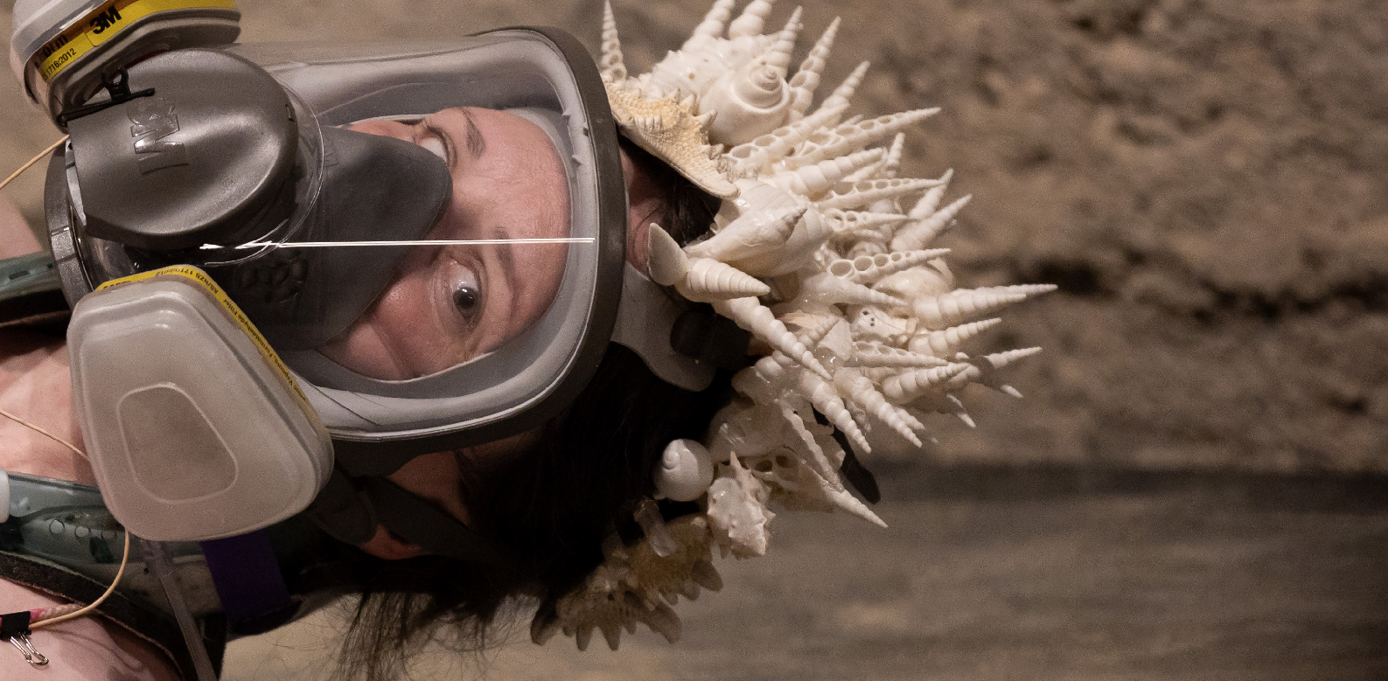Disability can be both permanent or temporary and invisible or visible. We include mental health within our definition of disability, as well as members of the d/Deaf community (who may not choose to identify as people with disability, but instead as part of a cultural and linguistic minority, with their first language being Auslan). We recognise that not everyone who faces these barriers chooses to identify as a person with disability and we understand that identity and disclosure in the context of disability is complex and very personal. We also understand the principles of universal design, that one size does not fit all, and the complexities of intersectionality within disability.
The Mermaid
Sydney Festival 2020

Disability impacts us all. It is a very broad diversity group and is very commonly experienced amongst our community – with people either directly identifying themselves, being a carer
for someone else or having a family member or close friend with disability. The statistics shared below demonstrate how widespread disability is:

- One in five Australians are people with disability (17.7% or 4.4 million people).

- Of the 7.8 million residents of NSW, 1.37 million (18.34%) have disability.
- More than 1 million people with disability are from non-English speaking backgrounds.

- Just under half (45.1%) of Aboriginal and Torres Strait Islander people aged 15 years and over, experience disability.

- People with disability are twice as likely to be in the bottom 20% of gross household incomes.

- 45% of those with disability in Australia are living either near or below the poverty line, more than double the OECD average of 22%.

- 45% of the population will experience a mental health condition at some point in their lives.

- 3.4 million (15%) of Australians have a physical condition.

- Vision Australia estimates there are currently 357,000 people in Australia who are blind or partially sighted.

- 1 in 6 Australians are impacted by hearing loss. There are approximately 30,000 Deaf Auslan users with total hearing loss.

11

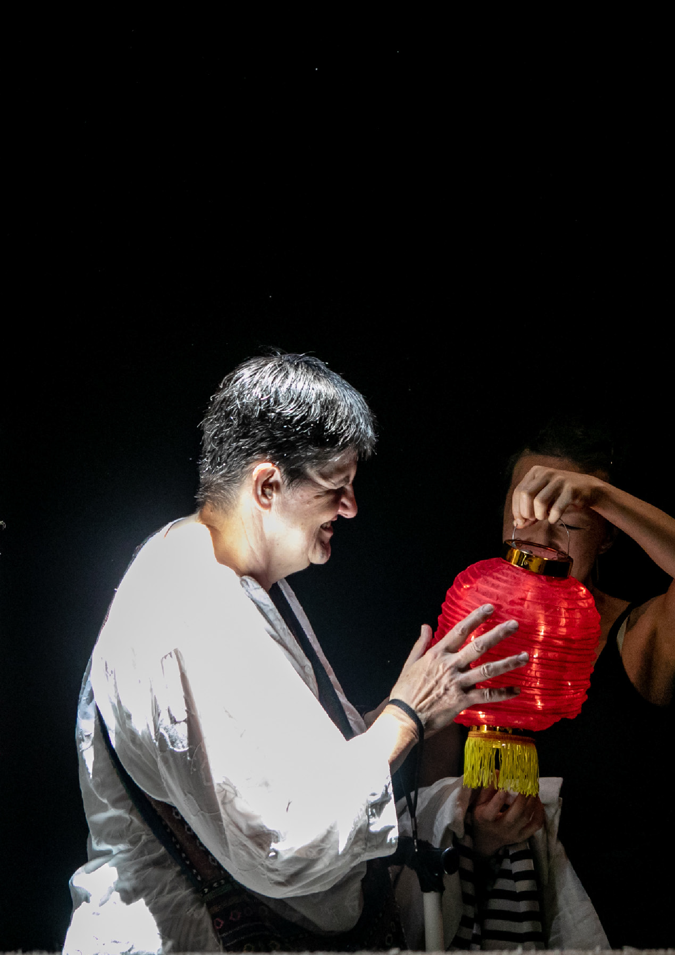A Ghost in My Suitcase - Tactile Tour
Sydney Festival 2019

OUR DISABILITY INCLUSION
ACTION PLAN

Our purpose is to present bold and memorable
experiences which ignite, unite and excite Sydney in January. And these experiences need to be for everyone.

This Plan outlines our strategy to embed access and inclusion principles across all aspects of our work. It builds upon the previous plans and work done in these areas by the organisation over the past decade.

Our DIAP is a crucial component of our organisational planning and will shape how we engage with audiences, artists, staff and other stakeholders. As a public funded organisation, we have a responsibility to make our work accessible for everyone and believe that access and inclusion makes good business and artistic sense.

We are conscious of writing and implementing this Plan during the COVID19 pandemic, and that there are particular access barriers being experienced by the disability community during this unique moment in our history. The pandemic ‘lens’ has helped shape some of the actions in this plan, particularly in relation to our digital work.

This Plan is written at a particular moment in time and sets out a roadmap for the next three years. While we have identified many focus areas and opportunities for improvement, we want to ensure this Plan ‘lives and breathes’, so it may be adapted
and updated over the course of its life to best reflect current community needs. We are committed to continuous improvement and working closely with people with disability inside and outside our organisation to continue to identify barriers and find solutions, as we are acutely aware that improving access and inclusion is an ongoing journey.

We look forward to realising the objectives, goals and actions outlined in our DIAP.

13

OUR ACHIEVEMENTS
TO DATE

Access and Inclusion Advisory Panel
In 2017, Sydney Festival formed its Access and Inclusion Advisory Panel.
This Panel was formed to provide independent and external advice to Sydney Festival on access and inclusion matters and represent the interests of all Sydney Festival stakeholders with disability. The Panel has been instrumental in the development of previous DIAPs and will continue to play a critical role
in monitoring and providing advice for its implementation for this DIAP. The Panel meets with Sydney Festival staff at least 3 times per year to discuss accessibility issues and continue conversations that help further develop the Festival’s commitment to accessibility and inclusion.

Disability Programming Initiative
In 2019, under Artistic Director Wesley Enoch, and in collaboration with Accessible Arts, Sydney Festival introduced the Disability Programming Initiative as a way to increase the representation of artists with disability in the annual program. This initiative encouraged artists with disability to pitch their work to the Festival for consideration in the upcoming program. Each year of the initiative, approximately 40 pitches were received and reviewed by Sydney Festival’s programming team and a panel of independent artists with disability. After shortlisting, two events were programmed in the 2020 Festival. One was Hannah Cormick’s The Mermaid, and the other was The Aspie Hour by Ryan Smedley and Sophie Smyth. Liz Martin and Eliza Hull’s Into the Space Between The Notes was programmed for the 2021 Festival but was unfortunately cancelled due to Covid-19 border closures.

14

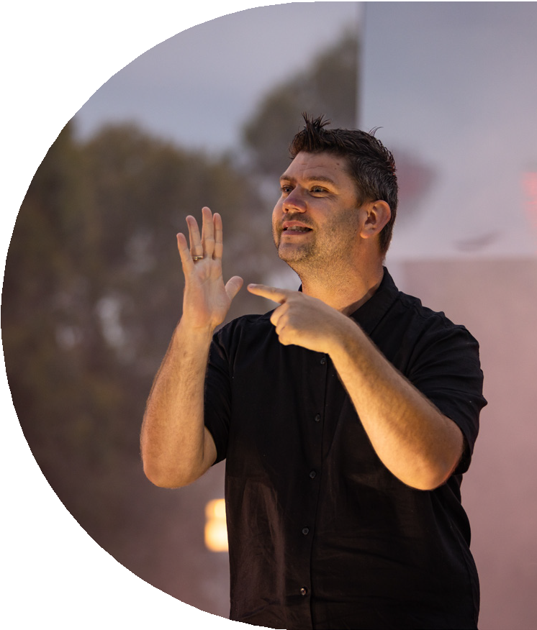
Createability Internship Program
In 2018 Sydney Festival took part in Create NSW’s inaugural Createability Internship program; a partnership between Create NSW, The Department of Family and Community Services (FACS) and Accessible Arts to develop strong career pathways for people with disability or who are d/Deaf in NSW-based arts, screen and cultural organisations. It provided a customised, paid internship during the 2019 Festival for the successful applicant who then went on to secure a permanent role within Sydney Festival.

Staffing and Recruitment
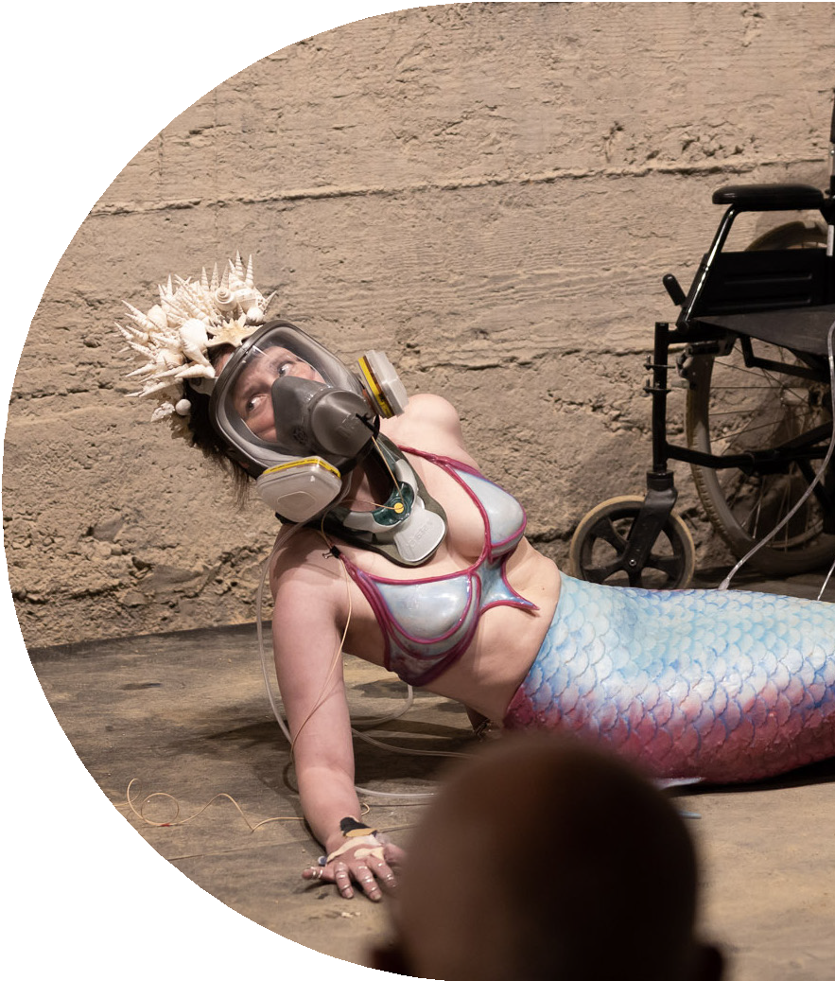
We have ensured that pathways in our recruitment process encourage and welcome people with disability to seek employment with the organisation. We currently have staff throughout the organisation, from administration to senior management, who identify as living with disability. In all aspects of the organisation, we continue to look into pathways to better representation and inclusivity, within our board, our permanent staff and our contract positions.

Access Program
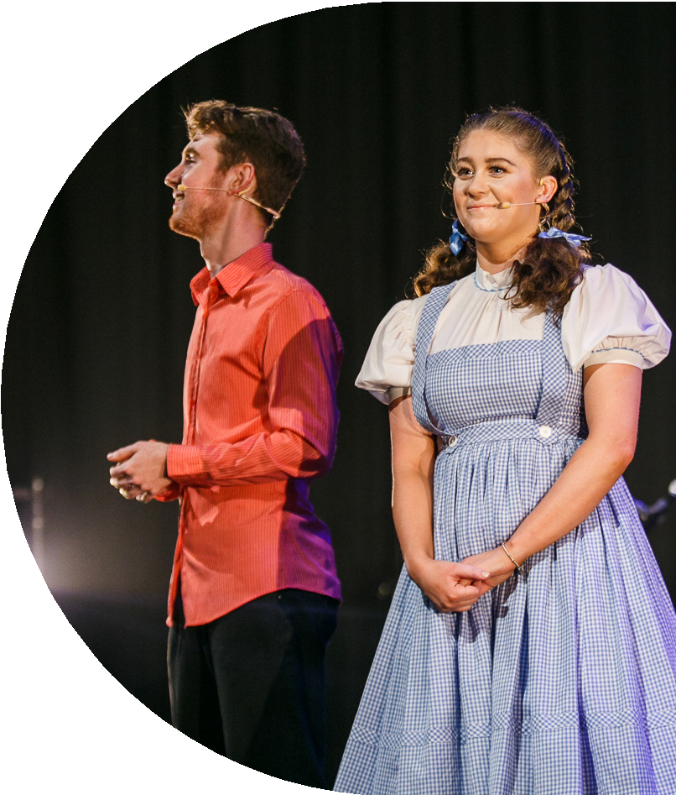
Over many years, Sydney Festival has researched and implemented best practice to enhance the enjoyment of live performance for patrons with disability, including access to information, audio description, touch tours, relaxed performances,
Auslan interpreted and captioned performances. This includes an understanding of available options as well as technological innovations that can be considered and possibly implement, with consultation regarding the productions. With the continued exploration of avenues to improve accessibility at Festival performances and with growing audiences, the Access Program has grown in size each year. In 2011, the Festival recorded no accessible performances, aside from wheelchair accessibility and assistive listening. In 2012, the Festival recorded 6 accessible
shows. Many years on in 2020, the festival recorded 32 accessible shows, a further 19 in the following Covid-impacted year of 2021, and 22 shows in the 2022 program.

15

METHODOLOGY AND
CONSULTATION

To develop this Plan, we partnered with arts and disability peak body Accessible Arts and have engaged with a diverse mix of stakeholders with disability to seek feedback and ideas.

In 2021, we formed our first internal Disability Inclusion Action Plan Working Group (DIAP WG), made up of representatives from across the entire organisation, who have been working together to steer and guide the creation of this document.

Accessible Arts has led the consultation phase of this Plan’s development, which has included:

- Presentations and discussion with the Senior Management Team
- A series of staff interviews with representatives from each area
- An internal survey to staff members and contractors
- An external survey
- A series of focus group discussions, with external festival stakeholders with disability and the internal DIAP Working Group.
- A staff workshop to review the draft Plan.

All consultation methods were accessible, incentives and honorariums were offered for participation, to acknowledge people providing their time and expertise into the process.

The types of consultation processes used throughout the development of this plan will continue throughout the Plan’s implementation and beyond, to ensure we
are receiving feedback directly from people with lived experience to inform our thinking and design of our future work.

16

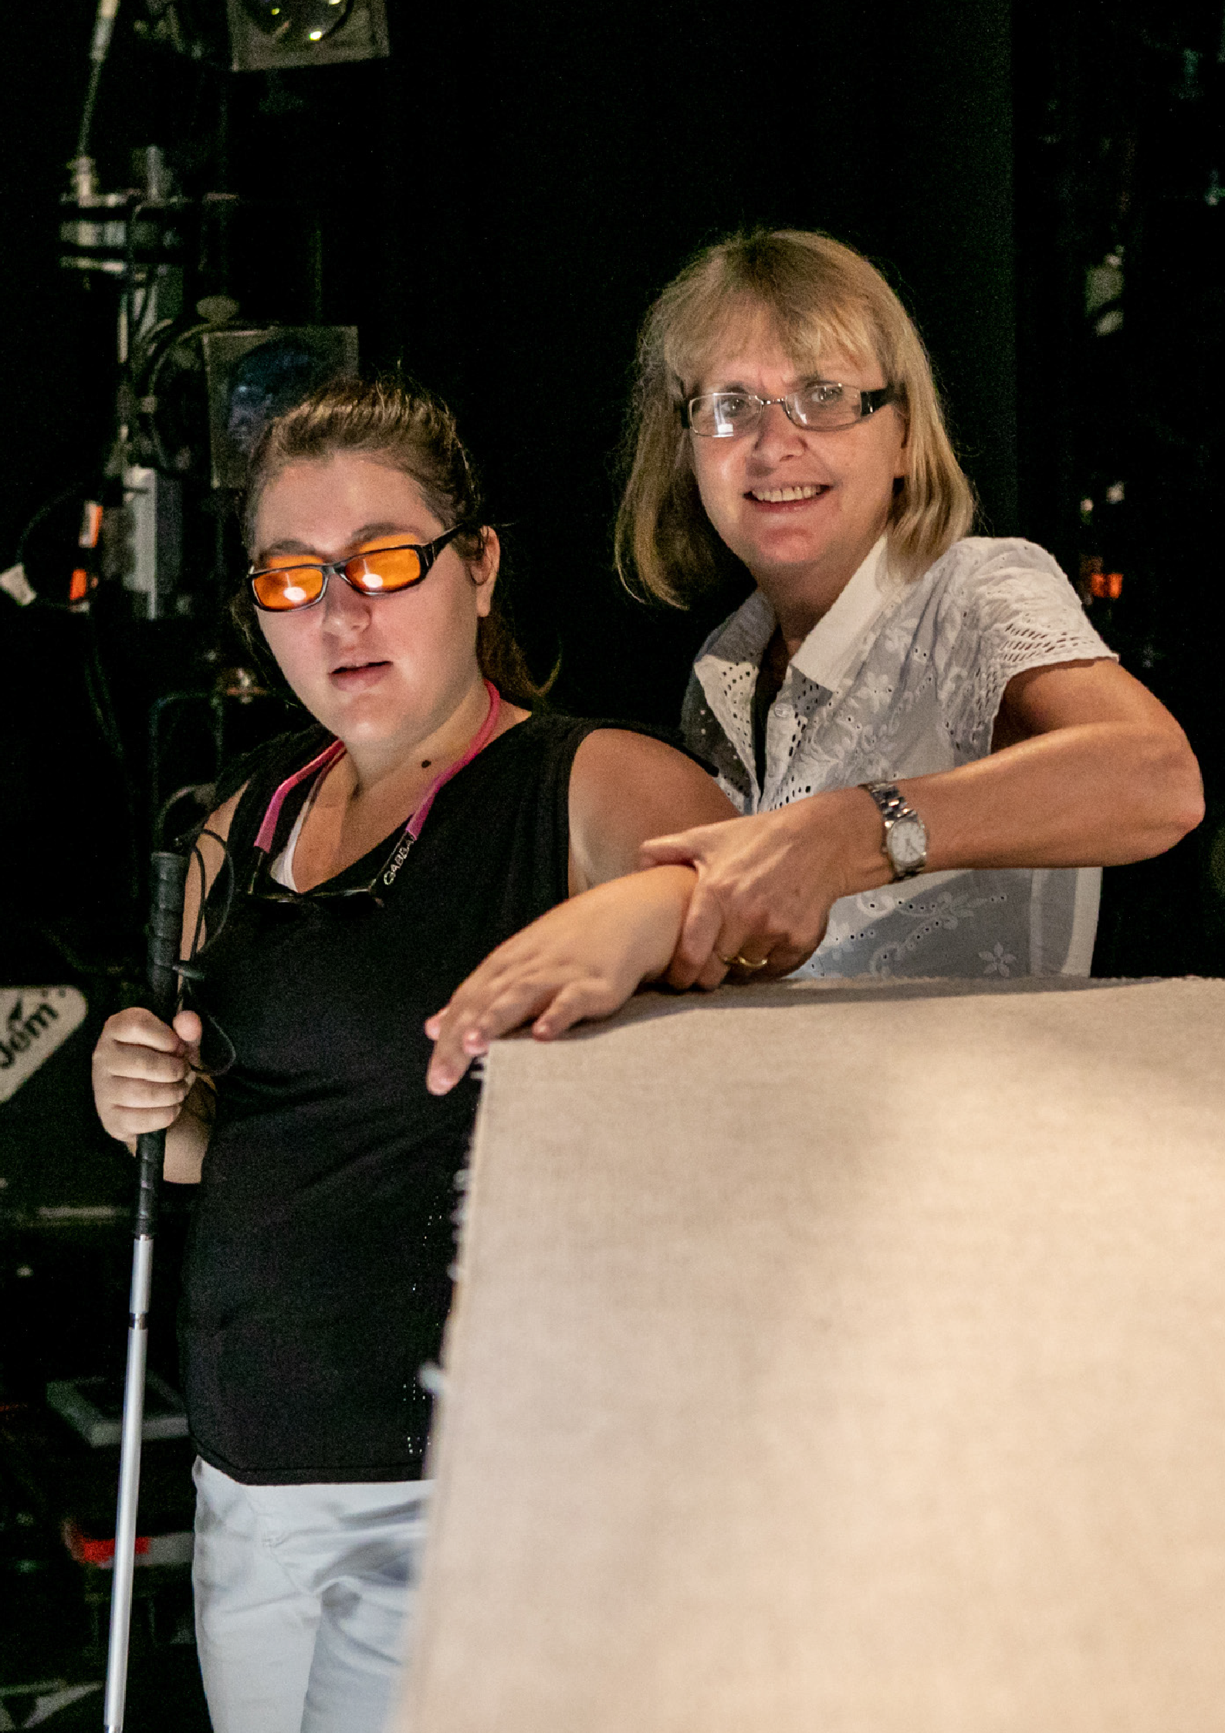A Ghost in My Suitcase - Tactile Tour
Sydney Festival 2019

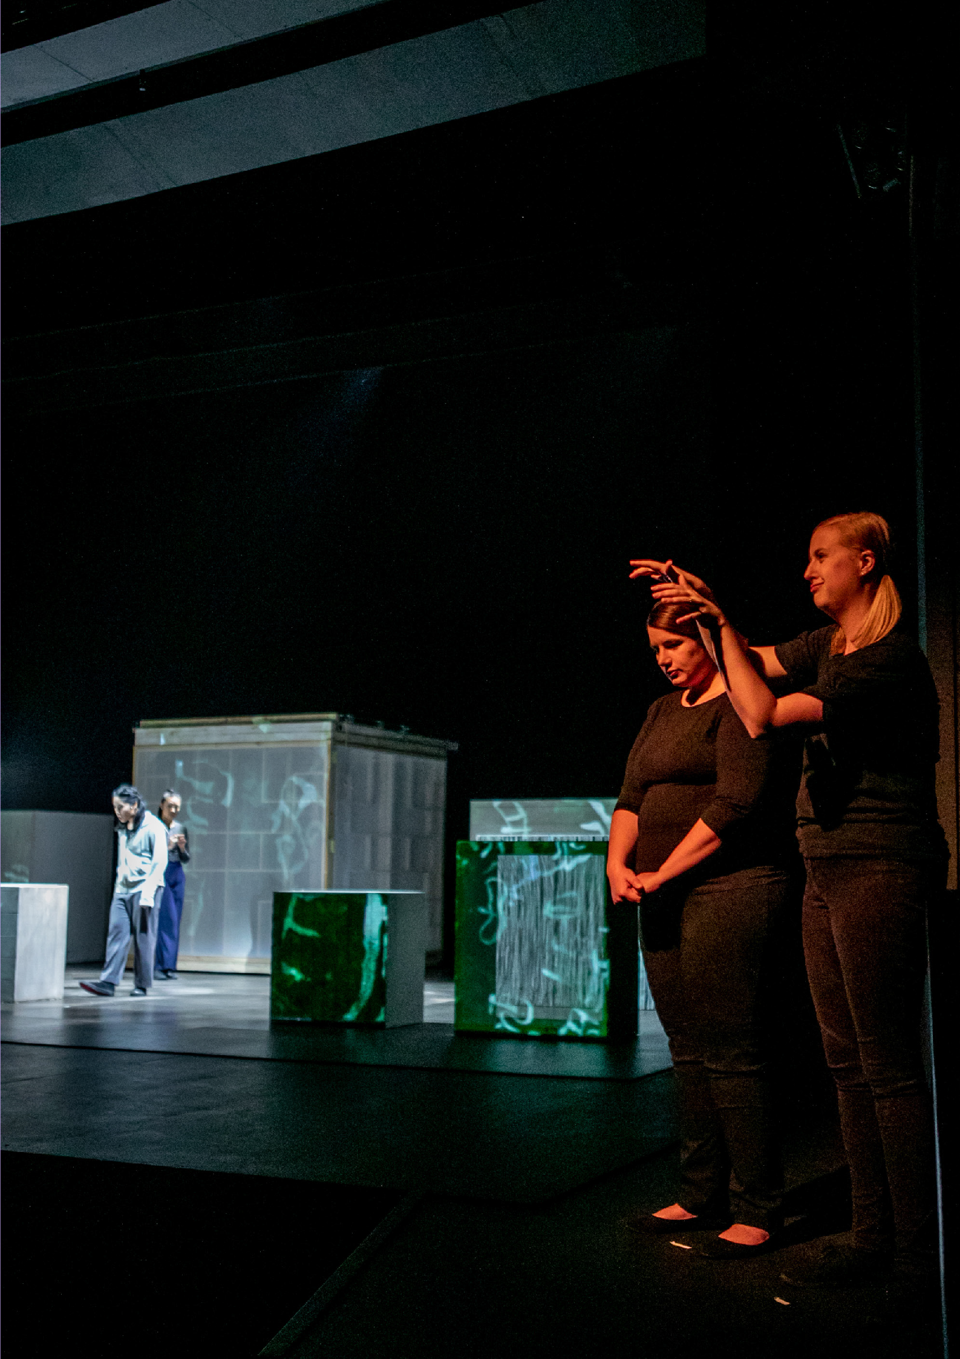A Ghost in My Suitcase
Sydney Festival 2019

GOVERNANCE, MONITORING AND REVIEW

To support the implementation of this Plan, we continue to utilise the internal DIAP Working Group, as well as our external Access and Inclusion Advisory Committee, throughout the Plan’s lifecycle.

The DIAP Working Group will meet at least twice per year to monitor and review Plan progress, with reports on progress made to our Senior Management Team. Our Board will also be provided with a report on progress on an annual basis.

We may also engage other experts, partners and stakeholders with lived experience of disability to assist us with Plan implementation as required.

We will provide an external report on Plan progress annually, through our Annual Report, which is shared widely with all our stakeholder groups.

19

PLAN, COMMITMENT, VISION AND GOALS

We want to:

We are committed to increasing disability confidence and competence within our organisation and are working to create an environment where we can provide opportunities for everyone on an equal basis.

- Ensure our physical and digital events are as accessible, and appealing to as many people within our community as possible.

- Make the ‘whole of journey’ experience easy for all our audience, from finding out about events, to booking tickets, to getting there, to navigating around the venue, to accessing the show and providing us with feedback afterwards.

- Showcase the talents of a diverse range of artists, including artists with disability.

- Provide pathways into the organisation and ensure that anyone has the opportunity to work or volunteer with us.

- Be accountable and open to change.

- Embed access and inclusion principles in all our activities, so it just becomes ‘what we do’.

- Be leaders, advocates and champions in this area.

- Live and breathe an inclusive and accessible organisational culture.

20

To do this, we have set ourselves the following goals to achieve over the next three years:
The Rabbits - Tactile Tour
Sydney Festival 2016

- We will continue to champion positive attitudes and inclusive behaviours in relation to people with disability across all aspects of our organisation.

- We consider the needs of the diverse range of audiences, artists, staff, crew, volunteers and other stakeholders in all of our activities.

- We value diversity and inclusion in our staff cohort, with people with disability having the opportunity to gain and retain employment with an organisation with an inclusive workplace culture.

- Our information, services and programs are built with inclusive systems and processes in mind, giving people with disability choice and control.

Our Plan follows the NSW Disability Inclusion Action Planning Guidelines, with the following outcome areas, to which our goals closely relate:
- Attitudes and Behaviours
- Accessible and Liveable Communities
- Employment
- Systems and Processes

Each of these areas seeks to remove or reduce the social, economic, physical and behavioural barriers that prevent people with disability fully engaging in society and engaging with the Sydney Festival.

This Plan aligns with international, national and NSW social policy and legislative frameworks including:

  - UN Convention on the Rights of Persons with Disabilities 2006 (UNCRPD)

  - Disability Discrimination Act 1992 (DDA)

  - Disability (Access to Premises – Buildings) Standards 2010

  - National Disability Strategy 2010-2020 (NDS)

  - National Arts and Disability Strategy 2009

  - Disability Inclusion Act NSW 2014.

21

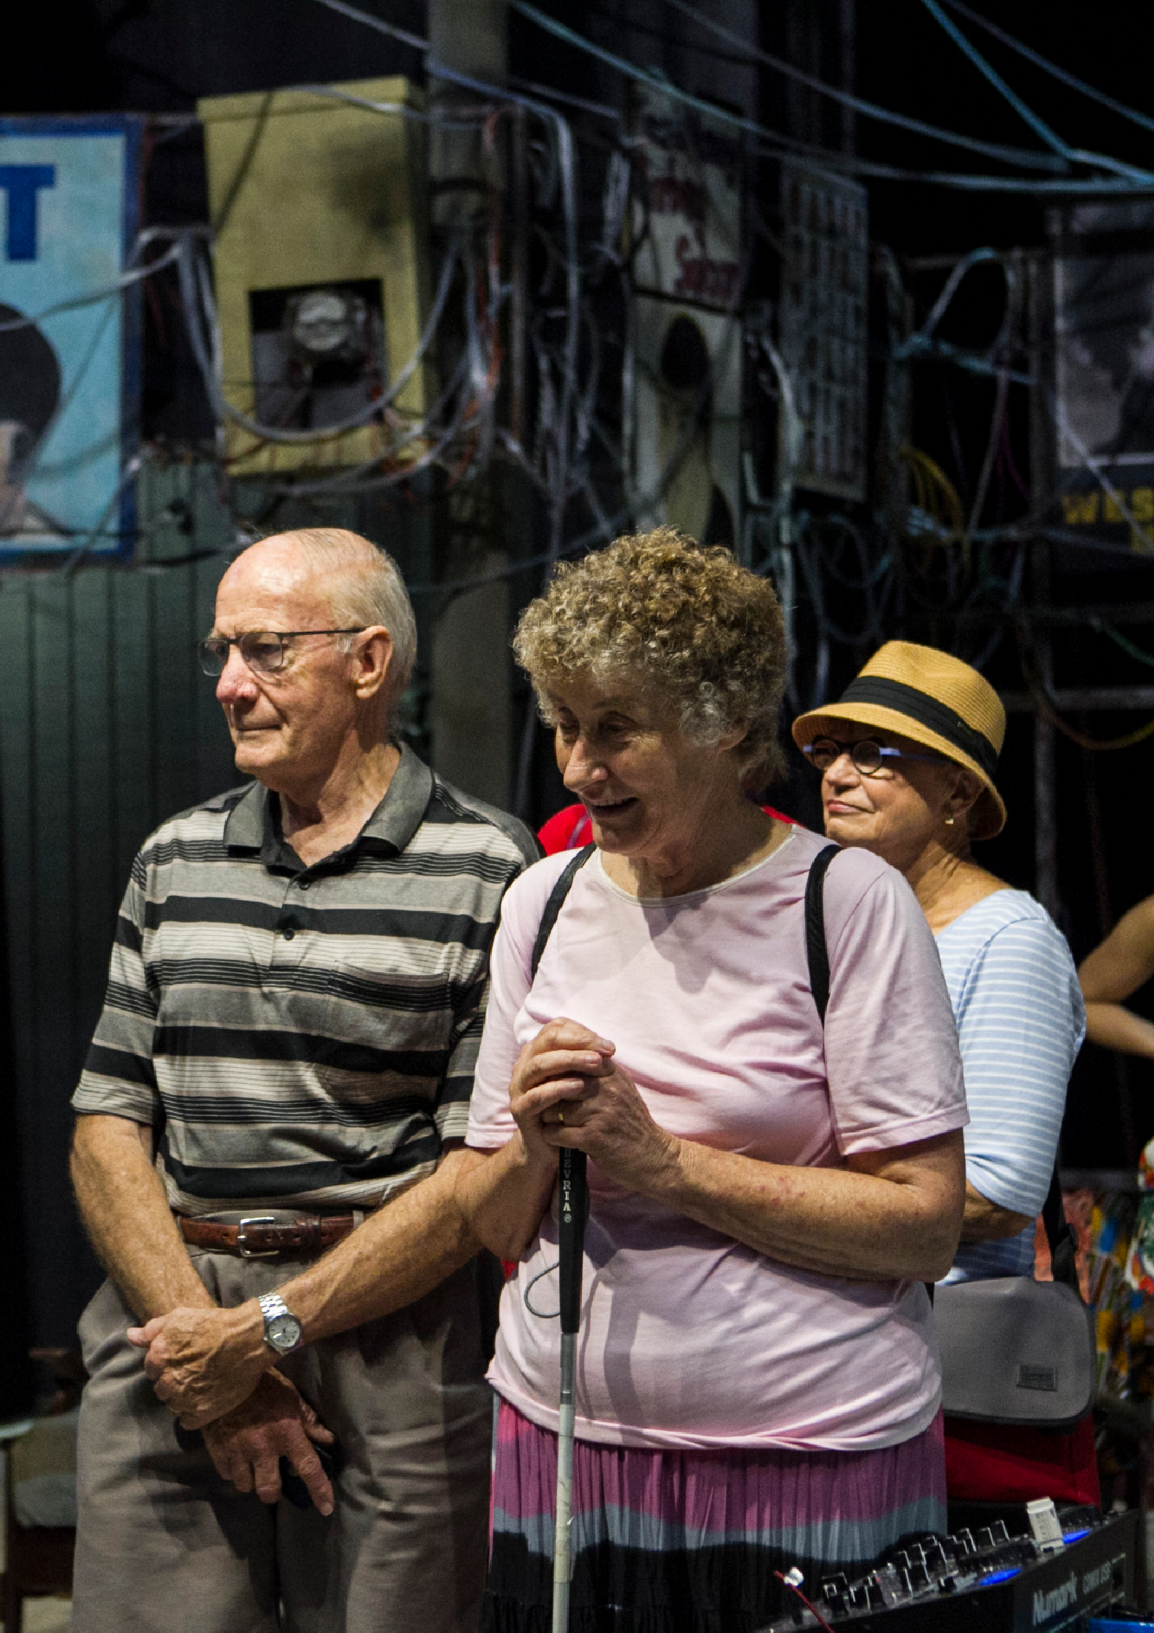Barber Shop Chronicles - Tactile Tour
Sydney Festival 2018

CONTACT US

Our Plan is available to the public through our website and accessible formats are available on request.
This plan is also registered with the Australian Human Rights Commission (AHRC).

We value community feedback on our progress in meeting the goals and actions outlined in our DIAP. We encourage individuals and organisations to share their thoughts and experiences with us to ensure our continued improvement.

Please contact us on:
Email: mail@sydneyfestival.org.au Phone: 02 8248 6500

You can also contact our
Access and Inclusion Advisory Panel Chair directly:
Email: Access.Panel@sydeyfestival.org.au

24

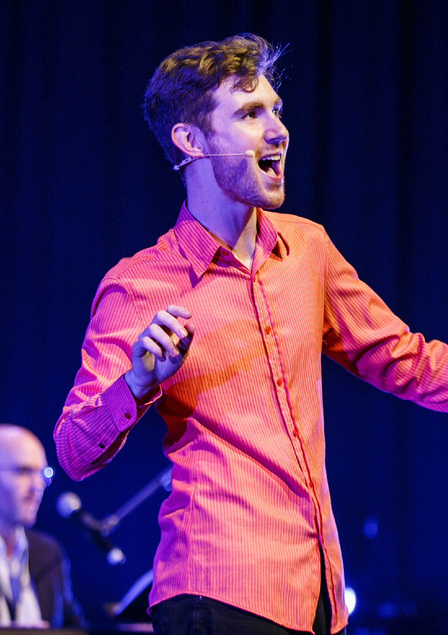The Aspie Hour
Sydney Festival 2020

SYDNEY FESTIVAL
Level 5, 10 Hickson Road The Rocks, NSW 2000 Sydney, Australia

T: 02 8248 6500
E : mail@sydneyfestival.org.au
sydneyfestival.org.au

