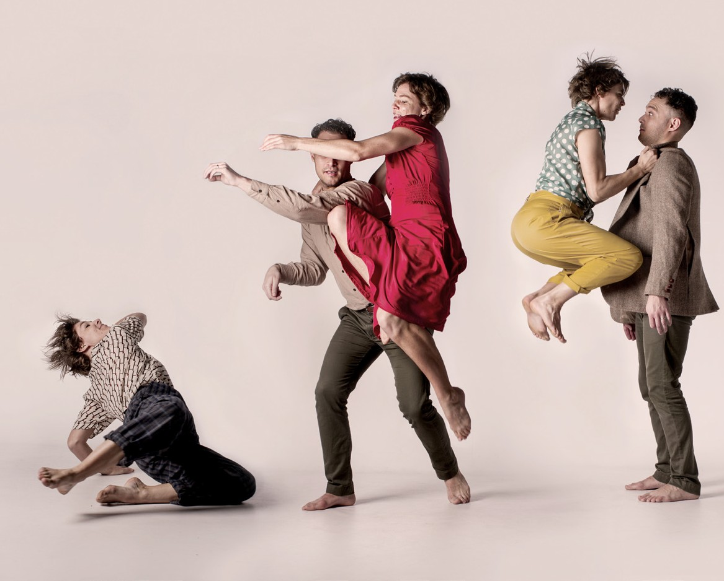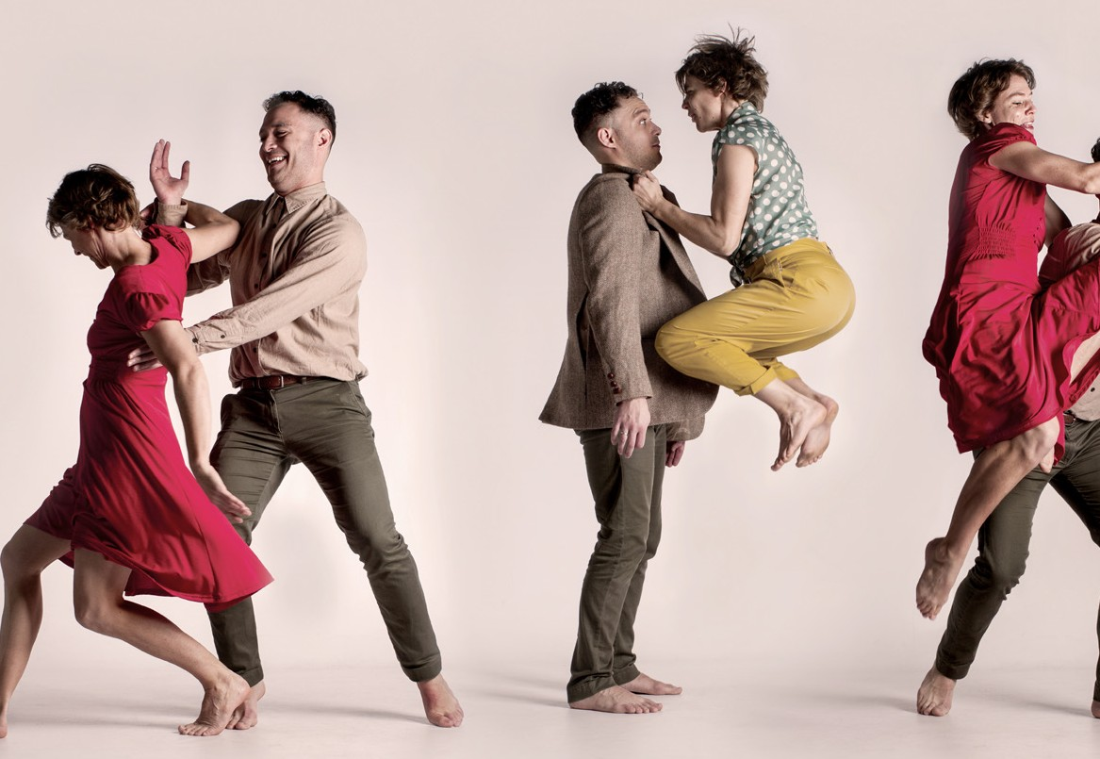
Photos: Gavin Clarke, Anya McKee

THE RIVOLI
DANCE MAKERS COLLECTIVE | AUSTRALIA

THE RIVOLI
DANCE MAKERS COLLECTIVE | AUSTRALIA
GRANVILLE TOWN HALL 22–25 JANUARY
60 MINS

Director Miranda Wheen Producer Carl Sciberras Composer Matt Cornell Designer Anya McKee
Lighting Designer Benjamin Brockman
Stage Manager Ellen Castles
Audio Content Allison Chan, Ninah Kopel & Tim Roxburgh

Choreography by Dance Makers Collective and guest performers
Dance Makers Collective Matt Cornell, Anya McKee, Sophia Ndaba, Katina Olsen, Marnie Palomares, Melanie Palomares, Carl Sciberras, Miranda Wheen &
Rosslyn Wythes
Performers Matt Cornell, Luke Currie-Richardson, Emma Harrison, Katina Olsen, Marnie Palomares, Melanie Palomares, Carl Sciberras & Rosslyn Wythes
Band Greg Poppleton Band

Featuring Future Makers, Dance Makers Collective’s Youth Dance Company
Sarah Goroch, Jessica Kuit, Beryl La, Bedelia Lowrencev, Cinzia Marrocco, Matina McAneney, Monica Moreno, Christopher Wade & Ella Watson-Heath

Featuring voices and stories of: Cedars of Lebanon, Chinese Seniors Community Dance, Jo Clancy, Kate Howarth, John & Josie Lee, Barry & Sandra McKiernan, Bhenji Ra & Gwen Wilson

ABOUT THE SHOW
The Rivoli was an iconic Parramatta dance venue. The action at the Rivoli Ballroom was broadcast on radio stations across Australia’s eastern seaboard for over a decade during the 50s and 60s. It was a place where entire families could gather to share in dancing and music. In 2020, the venue only exists in the memories of those who danced there.
This dance work began by imagining what such a venue would look like if it existed today. What kinds of communities would come together to reaffirm their shared identity through bodies and rhythm and music? We needed to look no further than this building – Granville Town Hall – to find diverse cross-sections of the community coming together to dance.
Throughout this work, you’ll hear the voices of people who danced at the Rivoli, as well as the voices of those who dance now, here in Granville, and at similar venues like it across Western Sydney. Dance has a way of bringing people and communities together in a way nothing else can. But in reflecting and strengthening certain communities, it’s also worth considering how these spaces can exclude others.
This work mirrors the interest that Dance Makers Collective has always had in social dances. In some ways, these spaces for social dance reflect the aims of DMC itself – to gather, share ideas, and to support each other creatively, socially, and artistically. To dance together.

DANCE MAKERS COLLECTIVE
Dance Makers Collective, based on Darug land, is Australia’s only collective-led professional dance company. Formed in 2012, its members are all independent artists with a vast range of unique practices. Together, Dance Makers Collective has created four works for stage; DADS was shortlisted for an Australian Dance Award and tours nationally in 2020. DMC also runs Future Makers, Sydney’s newest youth dance company, and a range of other dance programs. To read more visit dancemakerscollective.com.au.

THANKS
DMC acknowledges the traditional owners of this land,
the Darug people of the Eora nation, and pays respect to their elders past and present. Thank you to partners PYT Fairfield, Legs On The Wall, Sydney Theatre Company, FBi Radio and funding partners Create NSW, the Australia Council for the Arts, Sydney Festival, Cumberland Council and the City of Parramatta.

Dance Makers Collective

