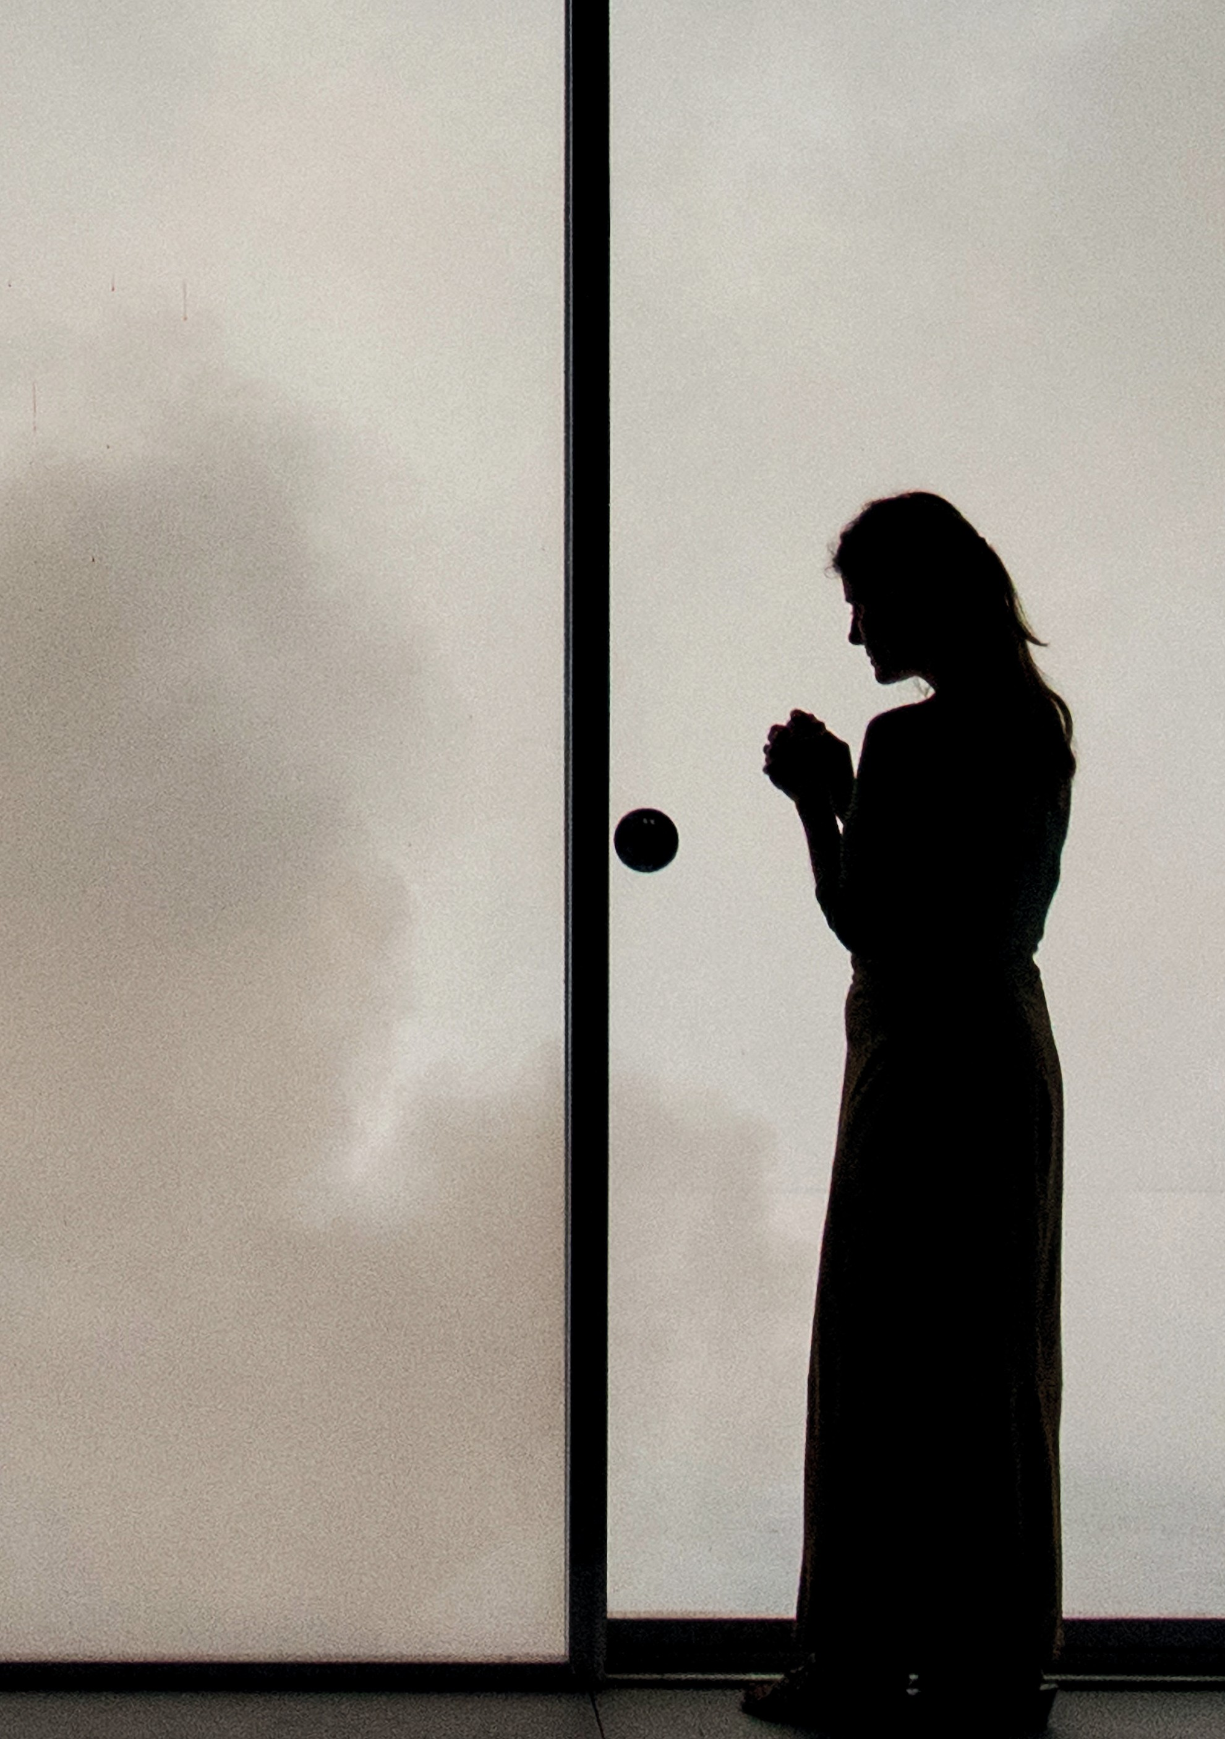

JOAN DIDION’S
THE WHITE ALBUM
LARS JAN AND EARLY MORNING OPERA | USA AUSTRALIAN EXCLUSIVE
Photos: Lars Jan

JOAN DIDION’S
THE WHITE ALBUM
LARS JAN AND EARLY MORNING OPERA USA | AUSTRALIAN EXCLUSIVE

ROSLYN PACKER THEATRE WALSH BAY
8–12 JANUARY
120 MINS

Performance created by Lars Jan / Early Morning Opera
Performed by and created with Mia Barron
With performances by Madeline Barasch,
Brad Culver, Brittany Engel-Adams, Stephanie Regina and Sharon Udoh

Director Lars Jan
Producer Miranda Wright/Los Angeles Performance Practice
Dramaturgy David Bruin
Choreography Stephanie Zaletel

Architectural Design P-A-T-T-E-R-N-S Architecture
Lighting Design Chu-hsuan Chang & Andrew Schneider
Sound & Music Jonathan Snipes
Costume Design Kate Fry
Associate Director Madeline Barasch
Sound Engineer Duncan Woodbury
Special Effects Coordinator Cristina Bercovitz Technical Direction Michaelangelo DeSerio Production Management Sarah Peterson Stage Management Amanda Eno

Special Effects Steve Tolin / TolinFX Scenic Fabrication Stereobot, Inc. Design Consultants Pablo N. Molina & Shannon Scrofano
O
Photos: Lars Jan

First published in 1979, Joan Didion’s searing, seminal essay The White Album is a shifting literary mosaic. It takes readers from the Black Panther Trials to a troubled recording session with The Doors, to student sit-ins and strikes, and into the events that put an end to the hazy hopes of the Summer of Love: the Manson Murders.

EARLY MORNING OPERA
is a genre-bending performance + art lab whose works explore emerging technologies, live audiences, and unclassifiable experience. Directed by Lars Jan, the lab is a flexible network of principal artists and an ever-expanding group of new collaborators, with expertise in fields as diverse as data visualization, architecture, cognitive neuroscience, and experimental plumbing.
Find out more about EMO’s original works includingThe Institute of Memory (TIMe), ABACUS and HOLOSCENES at earlymorningopera.com.

LARS JAN (DIRECTOR)
The son of émigrés from Afghanistan and Poland, Lars Jan is a director, artist, writer, and activist known for visually striking, genre-bending performance and installation works exploring emerging technologies, live gatherings and unclassifiable experience.
Jan’s original works with his performance + art lab Early Morning Opera – including Holoscenes, The Institute of

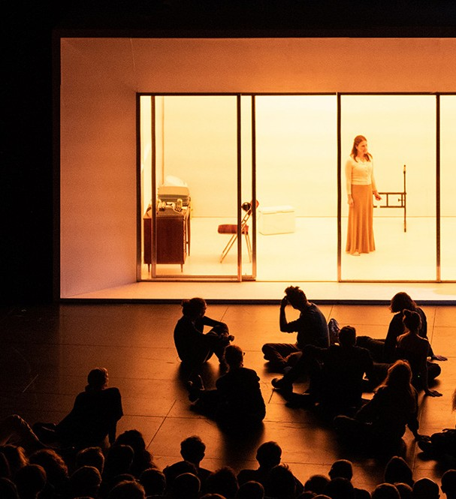

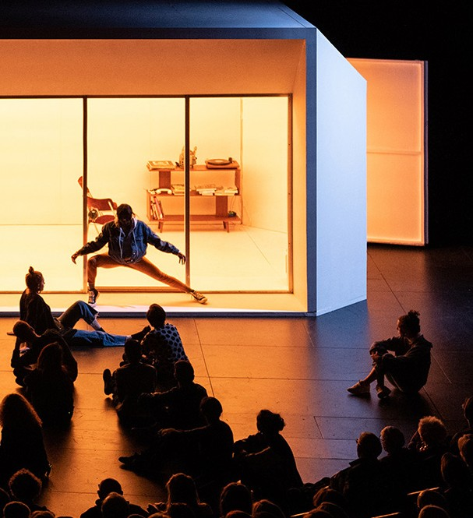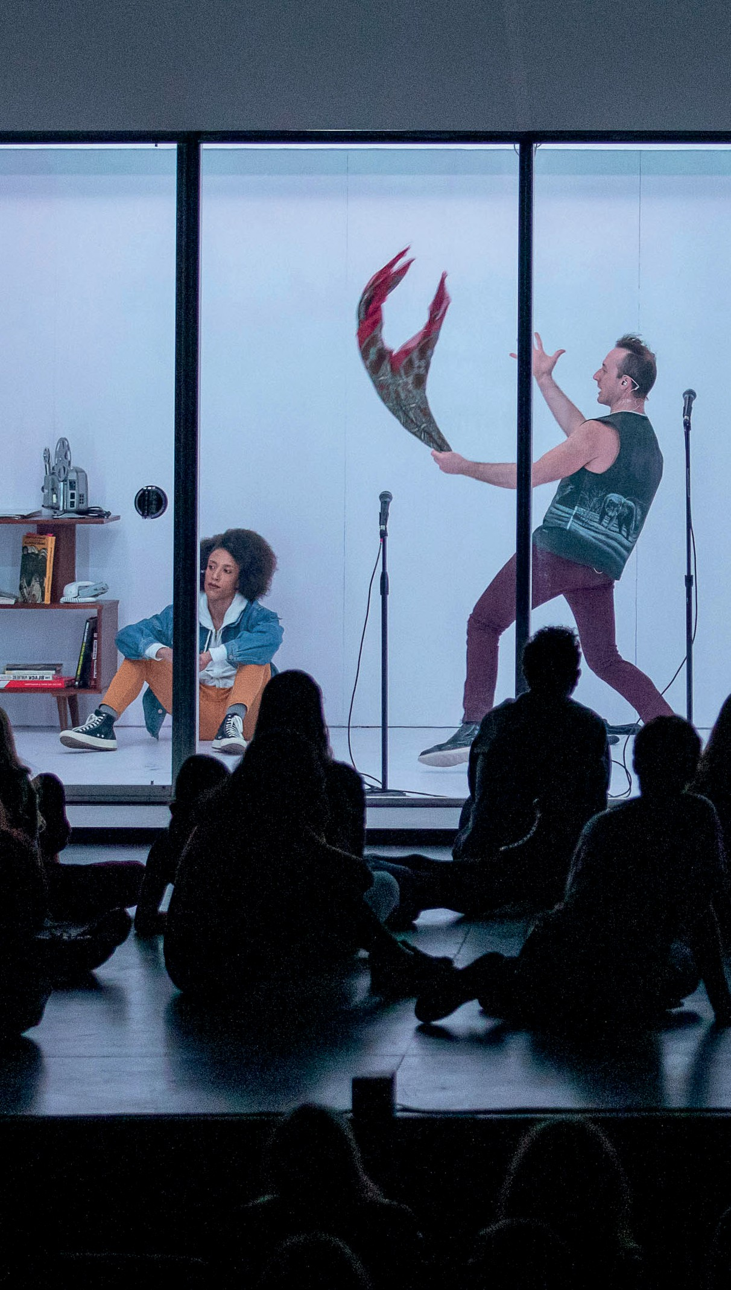Memory (TIMe), and Abacus – have been presented by BAM Next Wave Festival, Whitney Museum, Sundance Film Festival, Under the Radar Festival, PICA’s Time Based Arts Festival, Hammer Museum, REDCAT, ICA Boston, Toronto Nuit Blanche, London’s Burning Festival, Poland’s Divine Comedy Festival, NYU Abu Dhabi, and Istanbul Modern.
In June 2017, his climate change-themed installation, Holoscenes, created a sensation in Times Square, coinciding with the U.S. withdrawal from the Paris Climate Accords. As the winner of the 2017 Audemars Piguet Art Commission, Jan exhibited Slow-Moving Luminaries, a kinetic pavilion on an acre of beach during Art Basel Miami. He is represented by Charlie James Gallery in Los Angeles. Lars is a Sherwood and YBCA100 awardee, on faculty at CalArts and a TED Senior Fellow.
MIA BARRON (PERFORMER)
Mia Barron is an American actor and 2019 Obie winner, awarded for her performance in Madeline George’s hit off-Broadway play Hurricane Diane. She has also starred in The Wolves (receiving Obie and Drama Desk Awards); The Pain and the Itch, The World Over (Playwrights Horizons) and QED (Lincoln Center). She has made many
television appearances on shows including Modern Family, Elementary, NCIS, Grey’s Anatomy, Bones and Adult Swim’s The Venture Bros, in which she voices the character of Molotov.
Photos: Reed Hutchison

THANKS
Joan Didion’s The White Album was commissioned by Center Theatre Group with support from the Andrew
W. Mellon Foundation, by BAM for the 2018 Next Wave Festival, by the Wexner Center for the Arts at The Ohio State University, and by The Center for the Art of Performance at UCLA. It received generous development support from CalArts Center for New Performance, Ethan Devine, Emma McMahon and Xander Duell, Eliza Coburn, Rebecca Gold Milikowsky, Danniel Rangel, the Shiva Foundation, and the UCross Foundation. With special thanks to Fariba Ghaffari, Mark E. Pollack Foundation, and Jane Kaczmarek.
This performance is made possible by Joan Didion, Griffin Dunne, and ICM Partners.

ALSO A
T

THEATRE

OPENING
NIGHT
CYRIL TESTE | FRANCE AUSTRALIAN EXCLUSIVE
DRAMA THEATRE SYDNEY OPERA HOUSE 21–26 JANUARY
FROM $49 + BOOKING FEE

“AN ELEGANT, STREAMLINED STAGE REMIX”
THE NEW YORK TIMES

CABARET
BOOK NOW SYDNEYFESTIVAL.ORG.AU
“NOTHING SHORT OF STUPENDOUS”

COURIER MAIL

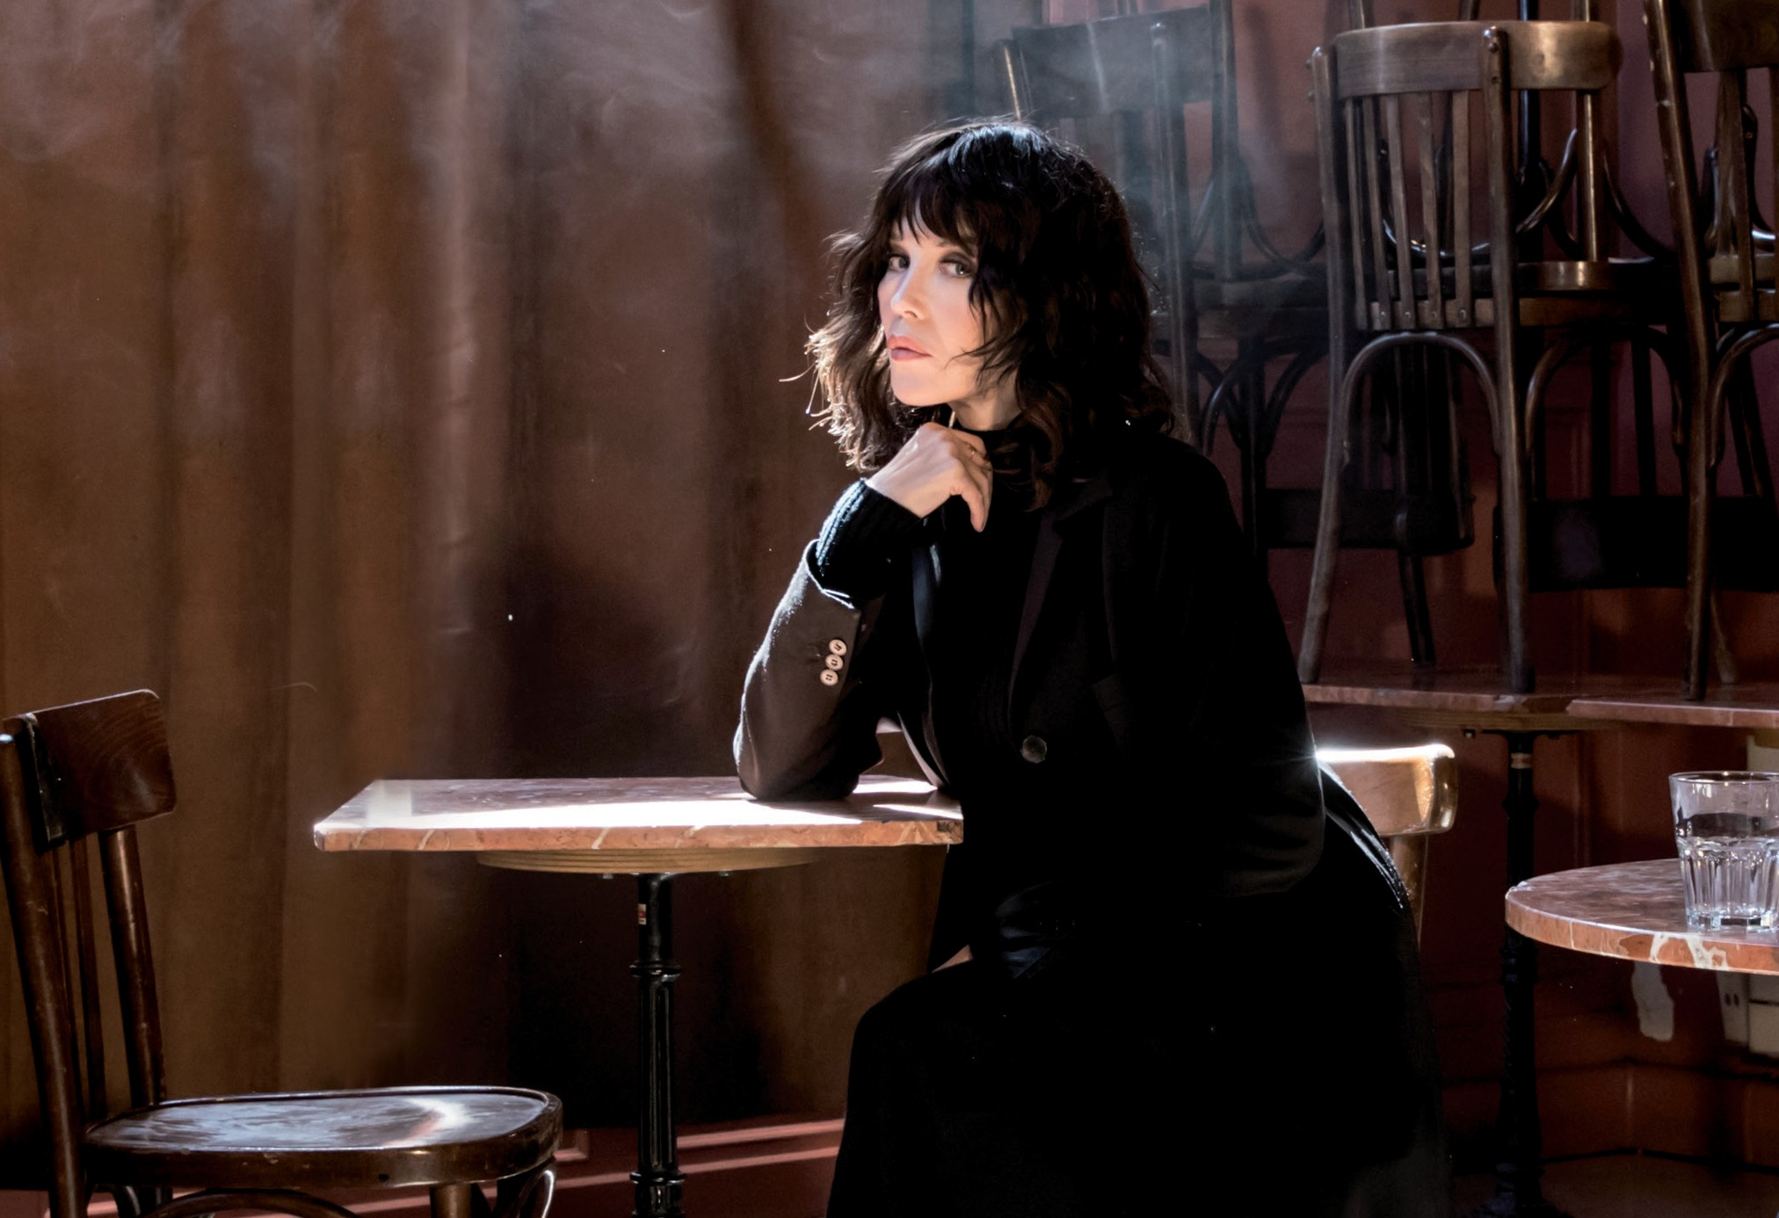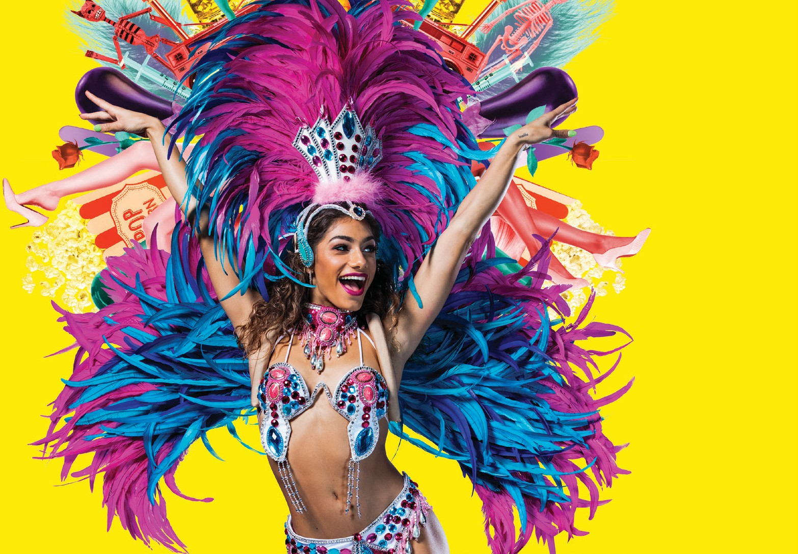

LIFE –
THE SHOW
STRUT & FRET PRODUCTION HOUSE | AUSTRALIA
MAGIC MIRRORS SPIEGELTENT HYDE PARK
8–26 JANUARY
FROM $70 + BOOKING FEE

