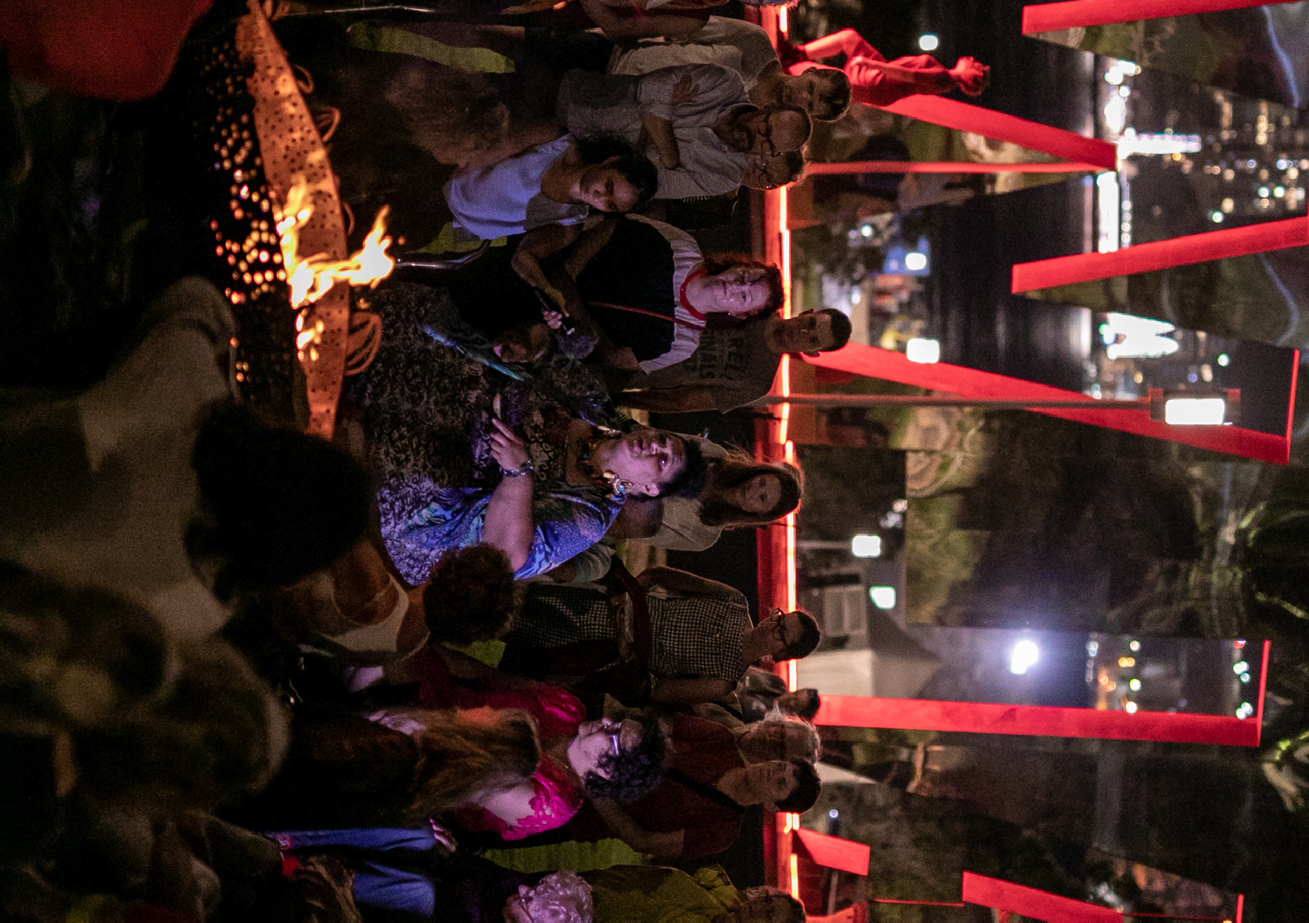Photos: Victor Frankowski
THE VIGIL
AUSTRALIA

THE VIGIL
AUSTRALIA

BARANGAROO RESERVE FROM DUSK, 25 JANUARY

MC: John-Paul Janke

ORDER OF EVENTS

Procession Arrival Proclamation Flag Raising Smoking Ceremony
Welcome and Call to Country
Sydney Festival Artistic Director Wesley Enoch
Buwal (Message) performed by Bernard Lee Singleton & Djakapurra MunyarryunDan
Dan Sultan

Mai’er Kab (Fire Dance) performed by Meuram Murray Island Dancers
Buwal (Message) performed by Bernard Lee Singleton & Djakapurra MunyarryunDan
Farewell Ceremony

Cultural Knowledge Sharing/Yarning Circle
Simone Arnol, Beatrice Sailor, Donna Gayford McLaren
Gather campfire-side and experience a night of performance and reflection on the eve of Australia Day.
Hear live music and guests alongside choral and poetry performances, and experience the resilience, beauty and joy of First Nations culture.

DAN SULTAN
To watch Dan Sultan hold an audience in the palm of his hand is to see a storyteller unafraid to lay it all out there: his troubles, desires and all those tales dragged from his life onto the stage. Ever since Sultan delivered his debut album, Homemade Biscuits, in 2006 at the age of 22, music lovers from all walks of life have found a home in his ability to bare his longings and his wounds, his rich and soulful voice spilling all sorts of guts and glory over memorable rock, roots and blues hooks.

MATTHEW DOYLE
Matthew Doyle is a professional musician (Didgeridoo player, singer and composer), dancer, choreographer and teacher. He is descendant of the Muruwari Aboriginal nation from northwest NSW.

BUUDJA BUUDJA BUTTERFLY DANCE CLAN
Wiradjuri sisters Rayma & Kerry Johnson lead a Sydney-based traditional and contemporary fused dance group for both female and male dancers of all ages.

BERNARD LEE SINGLETON
Bernard Lee Singleton of Coen, Cape York Peninsula QLD, descends from Umpila Peoples on the east coast of Cape York and Yirrganydji/Djabuguy on the Barron River. Bernard is a master craftsman and traditional performer, cultural educator and practitioner. He has recently evolved into curatorial, gallery and exhibitions and multimedia.

MEURAM MURRAY ISLAND DANCERS
Obery Sambo was taught by traditional Kokem Le (Elder of Elders). Through the Meuram Murray Island Dance group;
Obery continues this cultural legacy to the next generation of custodians of Meriam traditional song, dance, language and lore.
The Meuram Tribe is one of eight tribes of Murray (Mer) Island in the Torres Strait.

