Forums
#UTSThinkBig
UTS is the proud knowledge partner of Sydney Festival. Together we’re building experiences to better understand society, culture and art.
Join us at one of our Big Thinking Forums
and become part of the conversation.
PROUD PARTNER OF
UTS CRICOS PROVIDER CODE: 00099F
uts.edu.au/bigthinking
23013

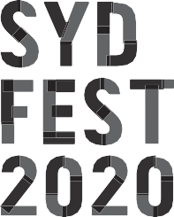

As the world faces up to imminent climate crisis, food insecurity, water scarcity and overcrowding, academics and Sydney Festival artists discuss the power of creative thinking and diversity of opinion and expression to generate strong, sustainable solutions.
UTS BIG THINKING FORUM
RETHINKING LEADERSHIP IN CULTURAL INDUSTRIES: AGENTS OF CHANGE IN A RISKY WORLD

THE GREAT HALL, UTS TUESDAY 14 JANUARY 6PM–7PM

Stay after the talk for Forums Unpacked,

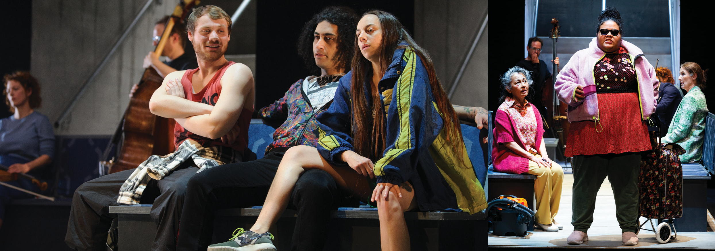a 30 minute opportunity for audience members to engage with the facilitator and panellists, reflect on the discussion and further explore its themes.

ANTHEM
15–19 JANUARY
ROSLYN PACKER THEATRE, WALSH BAY
MORE INFO AT SYDNEYFESTIVAL.ORG.AU

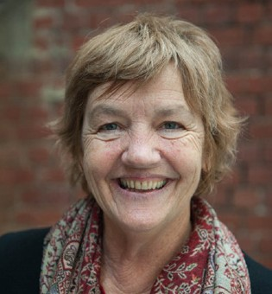
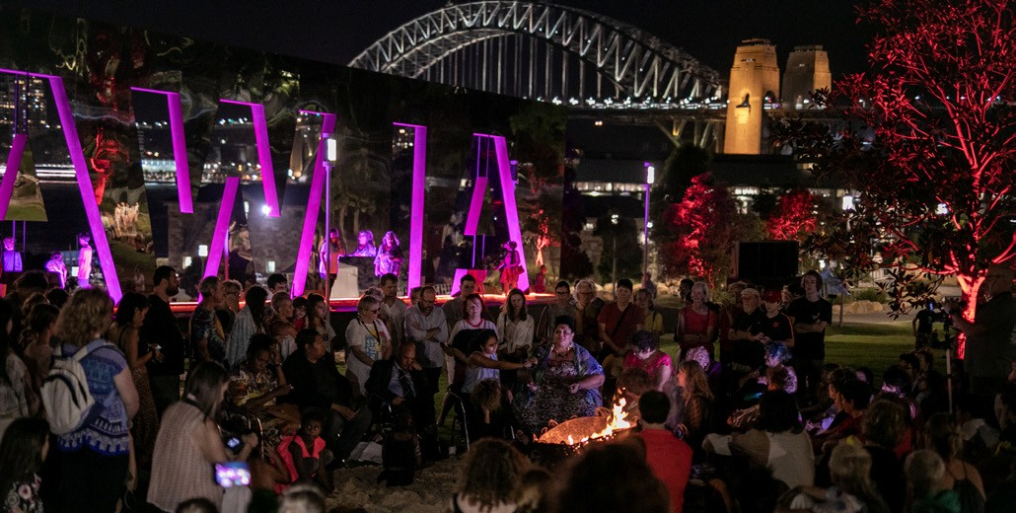SPEAKERS

FORUMS UNPACKED
Stay after the talk for Forums Unpacked, a 30-minute opportunity for audience members to engage with the facilitator and panellists, reflect on the discussion and further explore its themes.
PATRICIA CORNELIUS (ANTHEM)
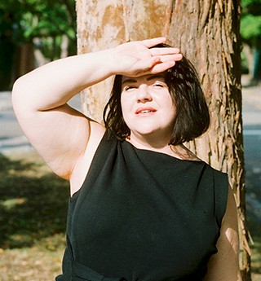
Patricia Cornelius is a founding member of Melbourne Workers Theatre. She’s a playwright, novelist and film writer. Patricia has a fierce commitment to class and her work often examines the lives of the marginalised. Her work also includes dramaturgy and mentorship with young or new playwrights. Cornelius is a recipient of numerous awards. She is the recent recipient of the Windham-Campbell Literature Prize and the 2019 Green Room Award for Life Achievement. She has written over 35 plays, including Shit, Big Heart, Savages, Do Not Go Gentle…, Slut, Love, The Call, Who’s Afraid of the Working Class? and Anthem (Sydney Festival 2020).

ALICE WHITTAKER (UTS)
Alison Whittaker is a Gomeroi poet and legal researcher from the floodplains of Gunnedah in NSW. She was a Fulbright scholar at Harvard Law School, where she was named the Dean’s Scholar in Race, Gender and Criminal Law. Her second book, BLAKWORK, was released with Magabala Books in September 2018. Prior to this, she received a black&write! fellowship from the State Library of Queensland.

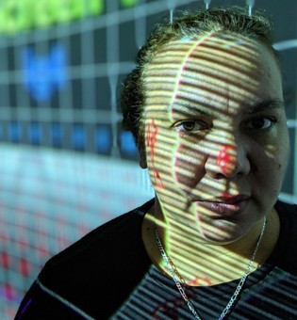
ASSOCIATE PROFESSOR PAULINE CLAGUE (UTS)
Pauline Clague is a Yaegl woman from North Coast NSW. She is founder and Artistic Director of Winda Film Festival in Sydney and co-creator of NativeSlam, a 72-hour Indigenous film challenge held at Maoriland Film Festival in New Zealand. Her work in communities teaches digital storytelling as a platform for community to keep oral history active utilising new technologies. In 2015 she won the Stanley Hawes award for her contribution to Australian Documentaries.

MODERATOR
DISTINGUISHED PROFESSOR LARISSA BEHRENDT (UTS)
Distinguished Professor Larissa Behrendt holds the Chair of Indigenous Research at UTS, is a Board Director of Sydney Festival and the host of Speaking Out on the ABC Radio Network. She is an award-winning author and filmmaker.

FORUMS UNPACKED FACILITATOR PROFESSOR SUSAN PAGE (UTS)
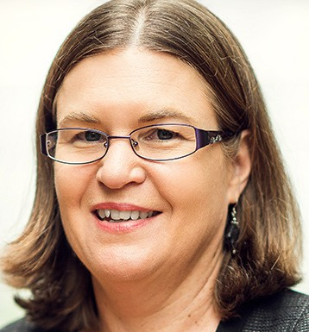
Professor Susan Page is an Aboriginal academic whose research focuses on Aboriginal and Torres Strait Islander peoples’ experience of learning and academic work in higher education and student learning in Indigenous Studies. In 2019 she led the UTS team awarded a National Australian Universities Teaching Award, the Neville Bonner award for Indigenous Education. From 2015–2018 she was a Director of the National Aboriginal and Torres Strait Islander Higher Education Consortium (Aboriginal Corporation).

