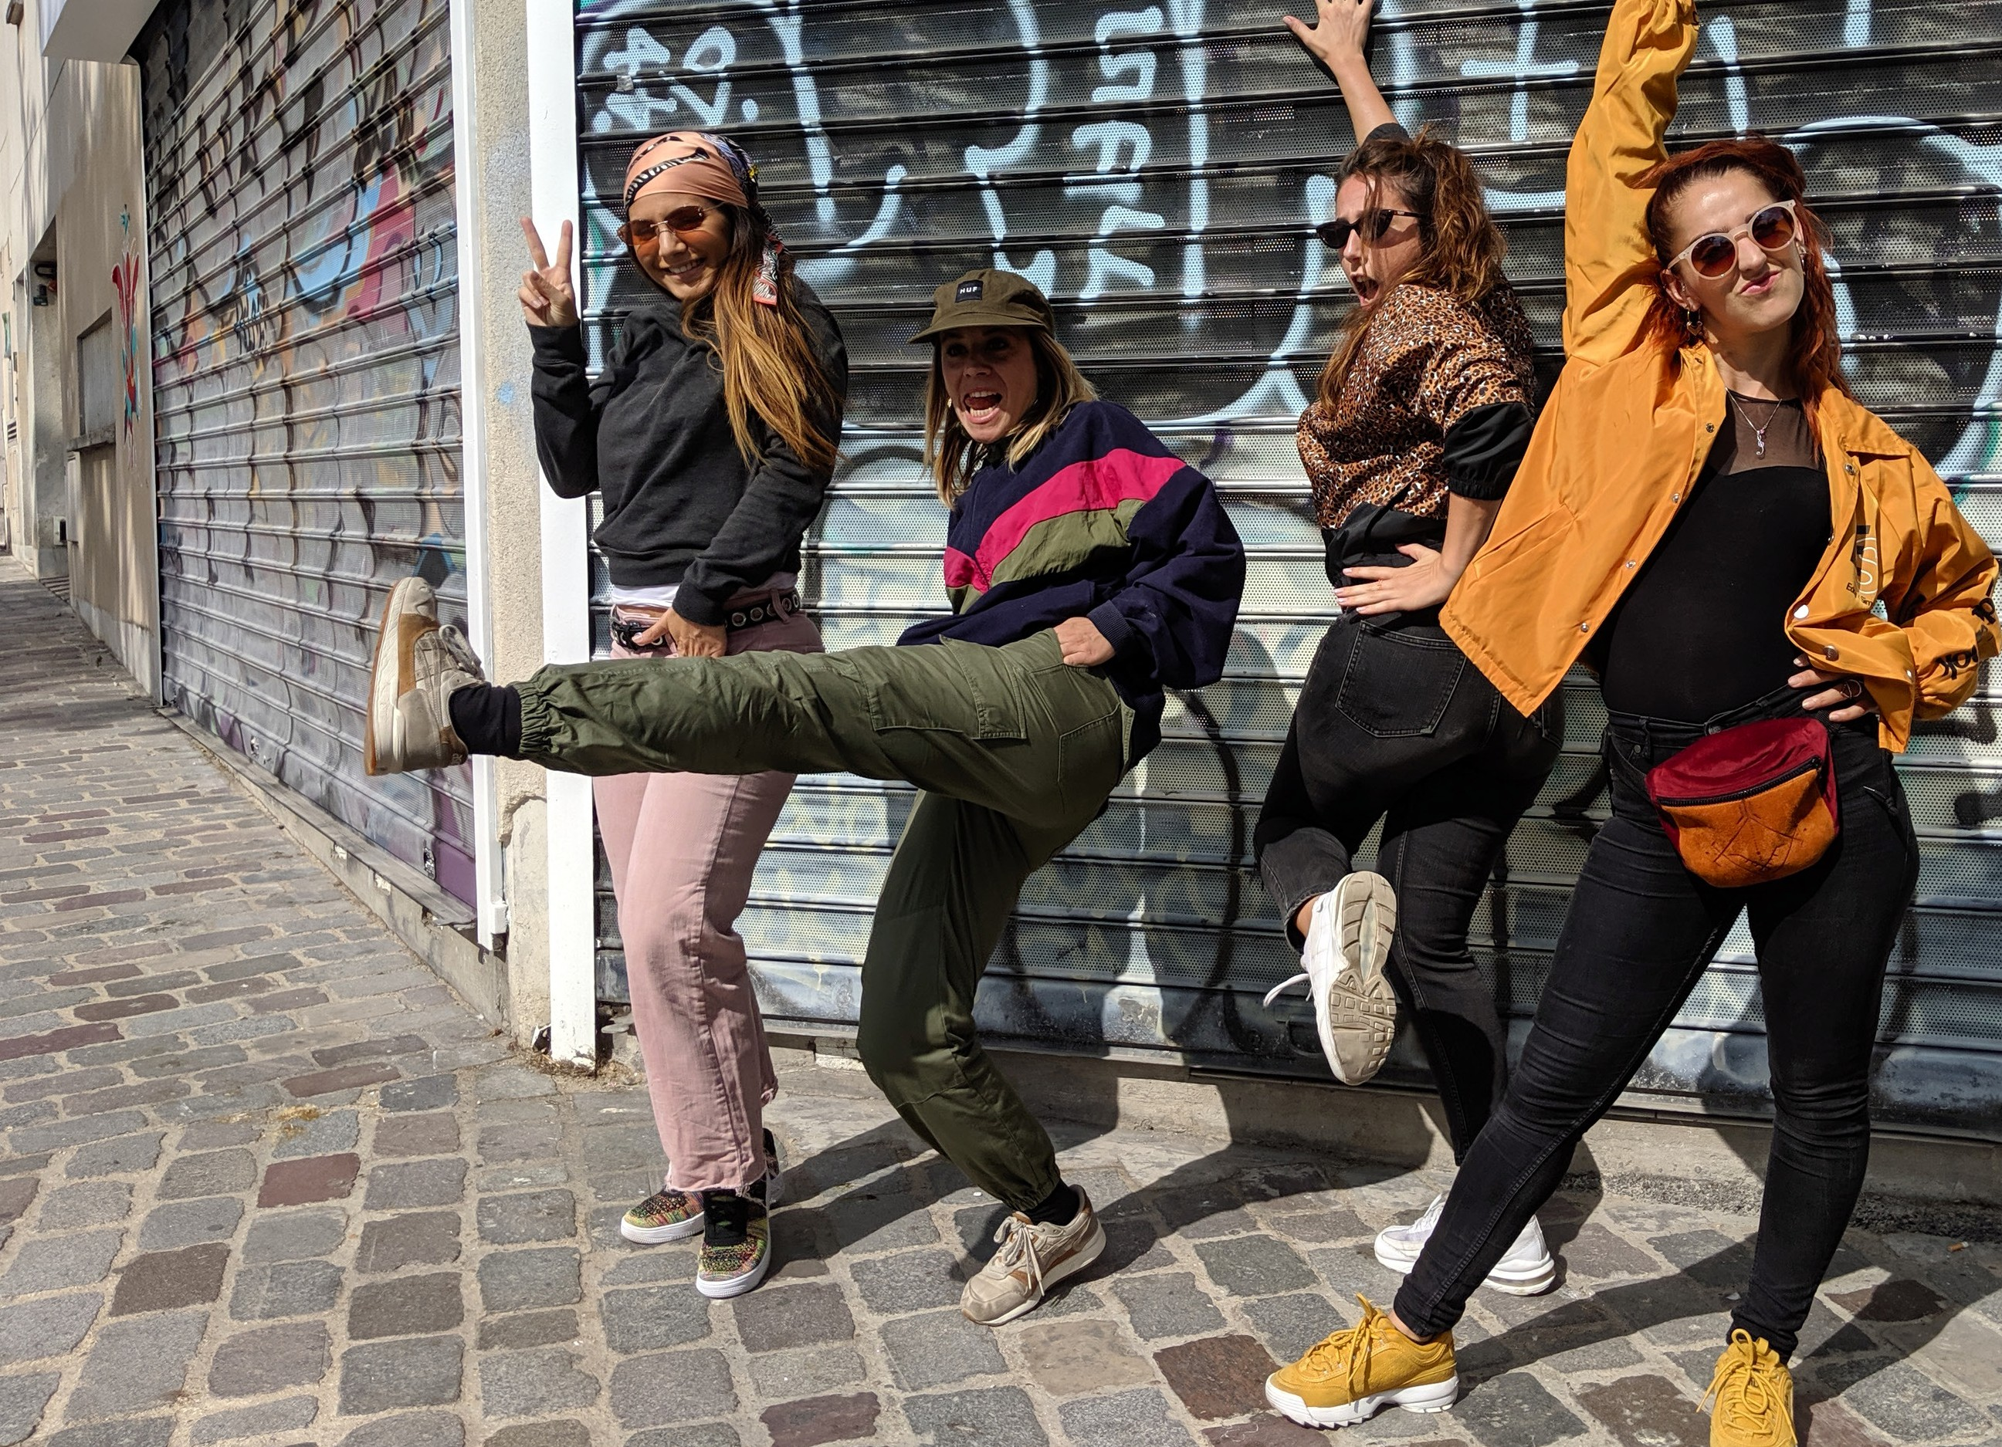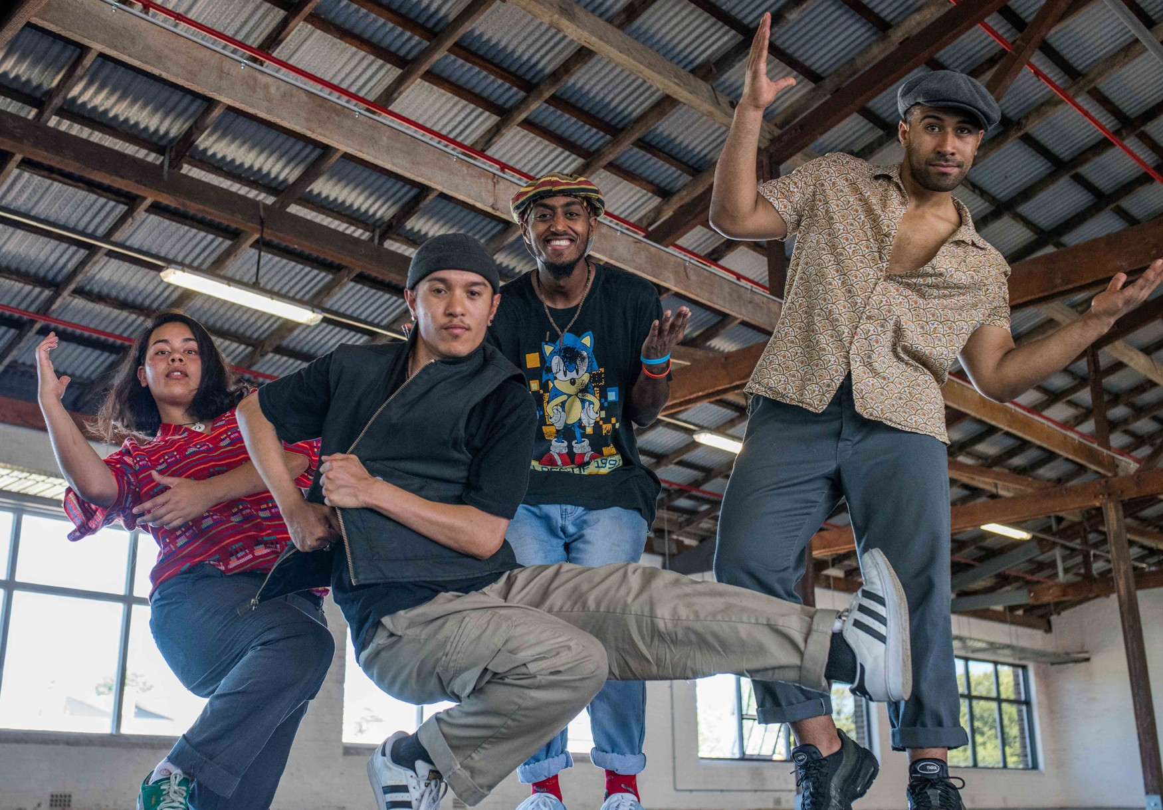

TWO
Photo: Nick Power
CREWS
NICK POWER | AUSTRALIA/FRANCE WORLD PREMIERE SEASON
FEATURING: LADY ROCKS RIDDIM NATION
Photo: Adam Scarf

TWO CREWS

NICK POWER | AUSTRALIA/FRANCE WORLD PREMIERE
CARRIAGEWORKS 8–12 JANUARY
60 MINS

Director & Choreographer Nick Power Assistant Choreographer Léa Cazauran Composer Jack Prest
Lighting Design Matthew Marshall Costume Design Gary Bigeni Dramaturg Lee Wilson
Outside Eye Anne Nguyen

Dancers
Lady Rocks (Paris) Clairéa Abecassis, Marie-Priska Caillet, Léa Cazauran, Julia Ortola
Riddim Nation (Sydney) Jamie Kha, Molonai Makalio, Azzam Mohamed, Gabriela Quinsacara
Also in rehearsal Clémence Pavageau, Patricia Carmen Crasmaruc

Production Manager Alejandro Rolandi
Company Manager Cloé Fournier
Producer Harley Stumm – Intimate Spectacle Lady Rocks Producer Lou Germain – Difstyle Associate Producer Rosalind Richards

This project has been assisted by the Australian Government’s Major Festivals Initiative, managed by the Australia Council, its arts funding and advisory body, in association with the Confederation of Australian International Arts Festivals Inc., commissioned by Sydney Festival, Adelaide Festival and Brisbane Festival.

ABOUT THE SHOW
Being in a crew is the cornerstone of hip hop culture.
It means you belong. You will build skills together, rock shows, battle rivals and turn the party out. Creativity fuelled by fun, friendship, community and competition. No overarching bureaucracy, administrators or managers. A pure dance entity. Each crew has its own story and reason for being. This show is about two crews – Riddim Nation & Lady Rocks.
– Nick Power, Director and Choreographer

NICK POWER
Nick Power is a Sydney based b*boy and choreographer whose work draws on the rituals and culture of hip hop to create contemporary performances. His practice spans
from remote Aboriginal communities to the most prestigious European contemporary dance festivals. Two Crews represents Power’s third independent dance work, following on from the highly acclaimed Cypher and Between Tiny Cities. In 2018 Powers was the recipient of the Sidney Myer
Creative Fellowship.

THANKS AND ACKNOWLEDGMENTS
This project has been supported by The Australia Council for the Arts; Bundanon Trust and the Australian Government’s Department of Communications & the Arts; Ambassade
de France en Australie and Initiatives d’Artistes en Danses Urbaines – Fondation de France – La Villette.
Intimate Spectacle is supported by The Australia Council for the Arts.
Thanks also to University of New South Wales – Creative Practice Lab, Shoalhaven Entertainment Centre, and Legs on the Wall.

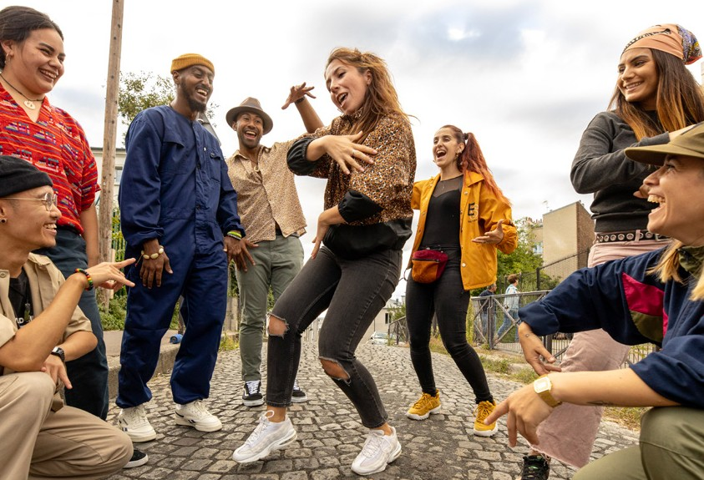

Department of Communications and the Arts
Photo: Timothée Lejolivet

