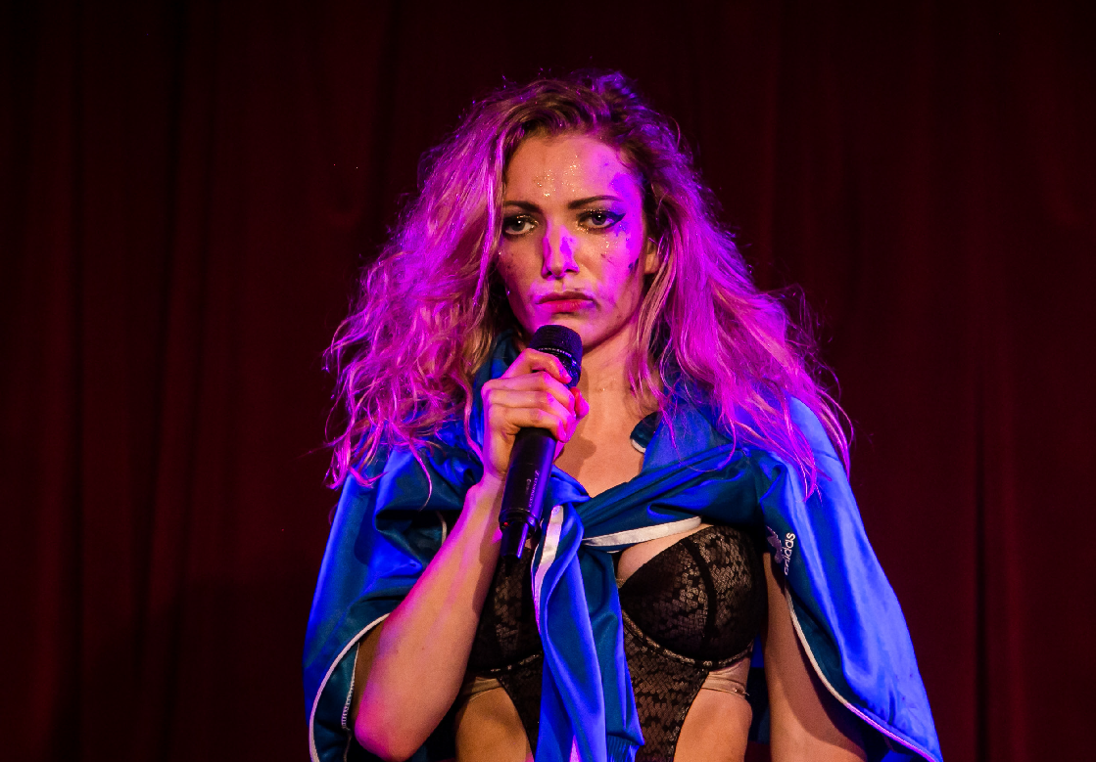
Photos: The Other Richard

TRIPLE
THREAT
LUCY MCCORMICK | UK AUSTRALIAN EXCLUSIVE

TRIPLE THREAT
LUCY MCCORMICK | UK AUSTRALIAN EXCLUSIVE

CARRIAGEWORKS 15–19 JANUARY
60 MINS

Created by Lucy McCormick
Director Ursula Martinez
Girl Squad Samir Kennedy & Lennie
Producer Karl Taylor
Photos: The Other Richard

ABOUT THE SHOW
Post-popular prodigy Lucy McCormick and her ‘Girl Squad’ present a “trashstep-dubpunk” morality play for the modern world. Casting herself in all the main roles, McCormick attempts to reconnect to her own moral conscience by re-enacting the New Testament via a
Nu-wave holy trinity of dance, power ballads and performance art. With trademark absurdism and enthusiasm, McCormick puts her best foot forward in the face of existential deadlock.

LUCY MCCORMICK makes nightclub installations, cabaret interventions and extravaganza theatre shows, marrying interests in absurdity, ineptitude, feminism and the grotesque.
Her debut solo show Triple Threat was awarded the Take Me Somewhere Brick Award, Best Performer award at Dublin Fringe, nominated for a Total Theatre Award & Off West End Award, and named one of The Guardian’s top 10 comedy shows of 2016 and ’17.
McCormick is Research Fellow at Queen Mary University of London and Associate Artist at Soho Theatre.

THANKS
Triple Threat was co-commissioned by hAb & Contact for Works Ahead, with support from Cambridge Junction,
Marlborough Theatre & Soho Theatre with funding from Arts Council England.

