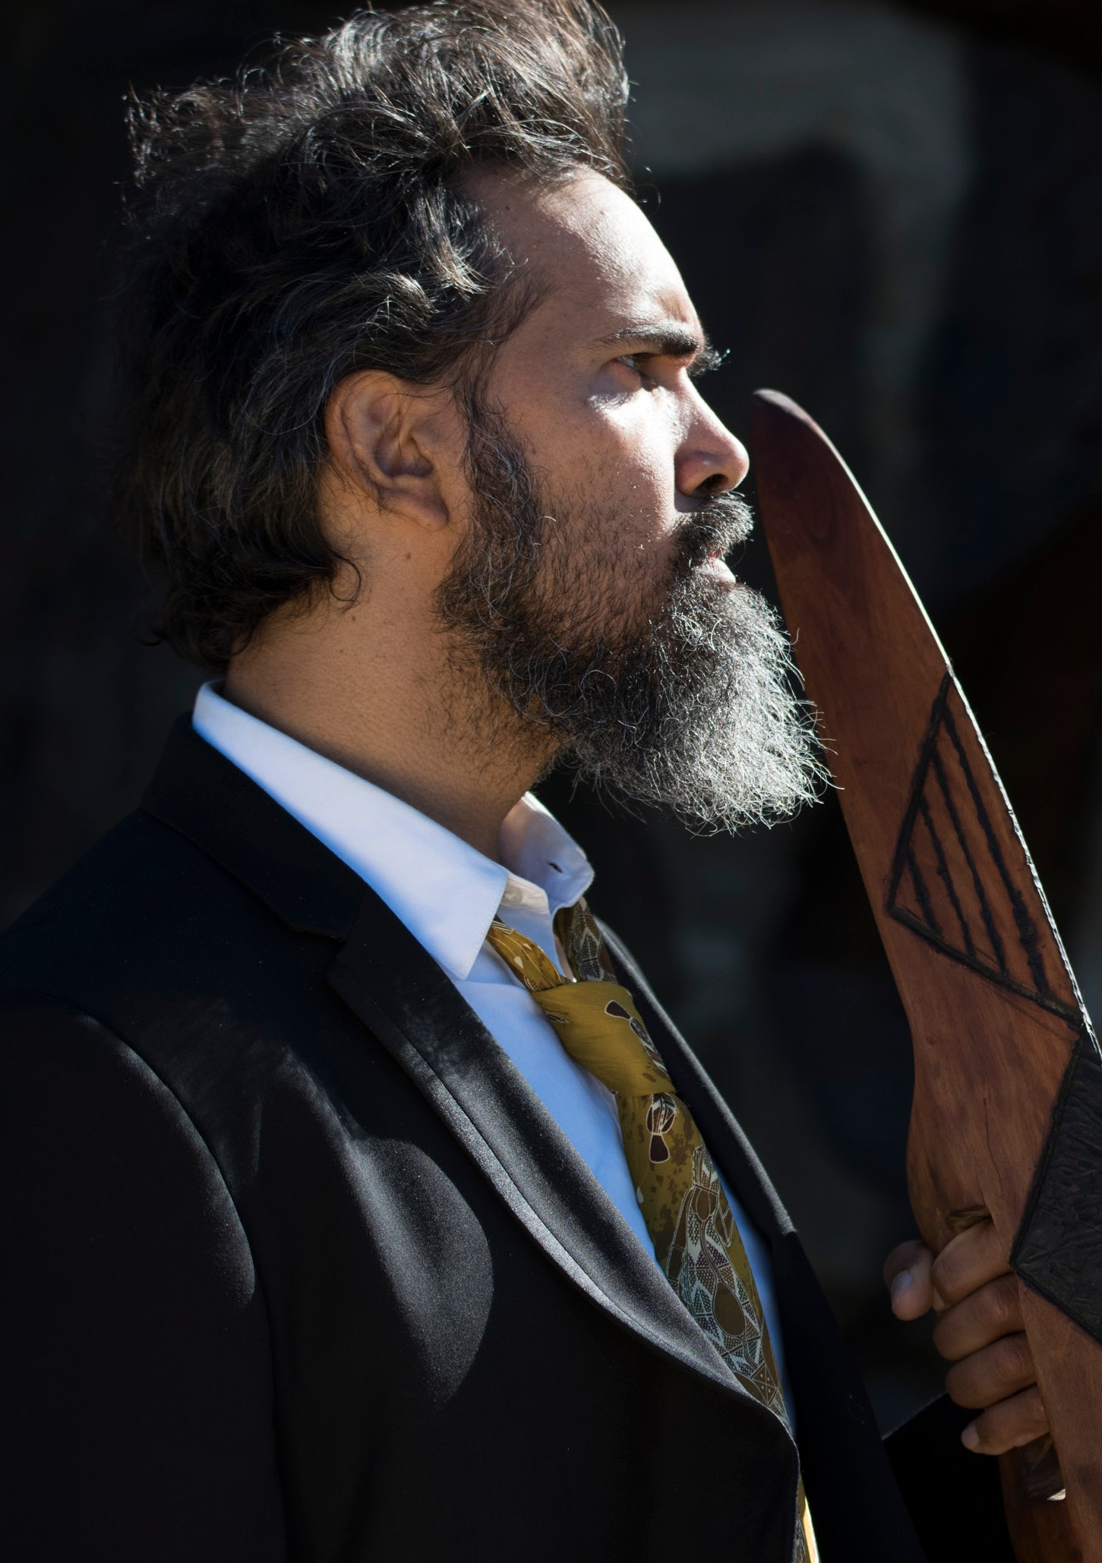

THE VISITORS
MOOGAHLIN PERFORMING ARTS AUSTRALIA | WORLD PREMIERE
Photo: Jamie James

THE VISITORS
MOOGAHLIN PERFORMING ARTS | AUSTRALIA WORLD PREMIERE

CARRIAGEWORKS 22–26 JANUARY
90 MINS

Cast
John Blair Damion Hunter Colin Kinchela Nathan Leslie Leroy Parsons Glenn Shea Kerri Simpson

Creative Team Playwright Jane Harrison
Director Frederick Copperwaite Designer Lisa Mimmocchi Lighting Chloe Ogilvie
Sound Phil Downing
Language Consultant Matthew Doyle

Production
Production Manager Oliver Anstis
Stage Manager Farlie Goodwin
Deputy Stage Manager Meagan Fitzpatrick
Set Builder Brett Wilbe

Moogahlin
Producer Liza-Mare Syron
Assistant Producer Corrine Shepherd Assistant Producer Sonny Dallas Law Community Liaison Tim Gray Finance Officer Rhanda M Managing Director Ali Muphy-Oates

ABOUT THE SHOW
January 1788, a strange sight greets clan leaders gathered on the shores of Gadigal land. Ships have anchored in Sydney Harbour – the size of which have never been seen before.
Where are they from? What do they want? Who and what do they carry? Should they be welcomed – or should they be encouraged to leave?
Famed for her plays Stolen and Rainbow’s End, Muruwari playwright Jane Harrison turns her attention to that pivotal moment when the First Fleet dropped anchor. In The Visitors, seven senior law men meet to decide how to respond. Their decision must be unanimous and will have far-reaching implications for all.
Presented by Sydney Festival, Moogahlin Performing Arts and Carriageworks, and directed by Frederick Copperwaite, The Visitors is a powerful, imaginative response to the beginnings of modern Australia.

MOOGAHLIN PERFORMING ARTS
Moogahlin (Muu-garl-in) is a Yuin/Bundjalung word meaning to play, to fool about.
Moogahlin Performing Arts is New South Wales’ leading First Peoples performing arts company. It develops, produces, and presents new works that are by and for First Peoples
communities and are committed to nurturing a new generation of First Peoples performing arts practitioners locally, regionally, and nationally by building platforms for emerging and established artists. Moogahlin was formed in Redfern NSW in November 2007 at the request of the late Kevin Smith and in honour of the founding members of the Black Theatre.

THANKS AND ACKNOWLEDGMENTS
The presentation of this work is supported by Create NSW, Australia Council for the Arts, City of Sydney, the Seaborn, Broughton & Walford Foundation, and the Australian Government through the Department of Communications and the Arts and the Catalyst – Australian Arts and Culture
Fund. The development of this work was supported by Monash University Faculty of Arts, Moogahlin Performing Arts through the 2013 Yellamundie National Aboriginal & Torres Strait Islander Playwriting Festival, Playwriting Australia,
and Melbourne Theatre Company (2013, 2014 and 2016 Cybec Electric playreading series).
Special thanks to Bangarra Dance Theatre, Sydney TAFE Eora College, Hannah Donnelly, Greg Maude, John Oates, Troy Russell, Tim Selwyn, and Andrew Snelgar.

