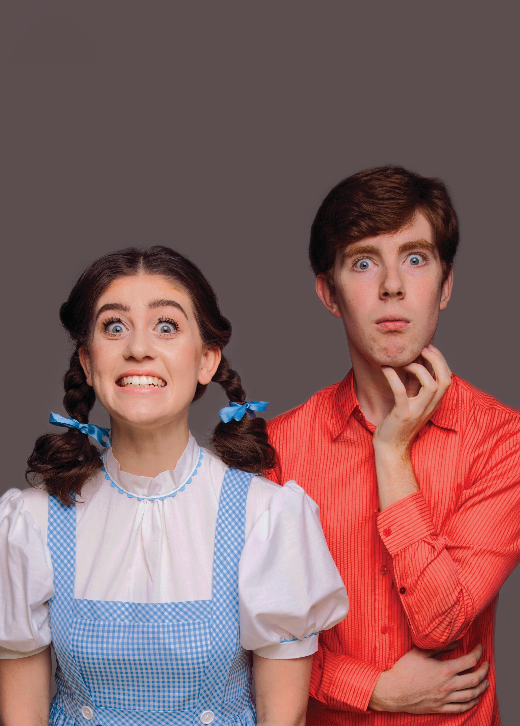

THE ASPIE HOUR
SOPHIE SMYTH AND RYAN SMEDLEY AUSTRALIA
Photo: James Penlidis

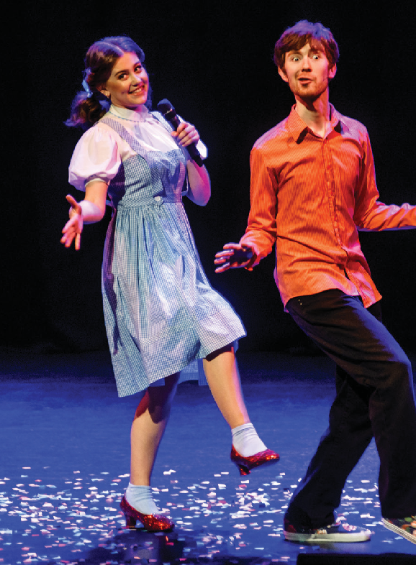THE ASPIE HOUR
SOPHIE SMYTH AND RYAN SMEDLEY | AUSTRALIA

CARRIAGEWORKS 14–18 JANUARY
60 MINS

Creator, Writer & Performer Ryan Smedley Creator, Writer & Performer Sophie Smyth Director & Dramaturg Fiona Scott-Norman Musical Director & Pianist Rainer Pollard
ARTISTS’ STATEMENT
The Aspie Hour show began very modestly almost five years ago, when the two of us both took to the stage individually as part of Federation University’s Cabaret program in the final year of our Musical Theatre studies. Two 10-minute pieces with wildly different styles,
yet focusing on the same core subjects: Asperger’s Syndrome and Musical Theatre. It was through the persistent prodding and encouragement of our director,
Fiona Scott-Norman, that we finally took the plunge to combine and expand our individual works into a full-length piece in 2017. Since then we’ve been
overwhelmed with support from audiences, going from strength to strength in Melbourne festival appearances, culminating in a Green Room Award win for Best Writing in a Cabaret last year.
“Everyone is different, yet the same”: that’s a lyric that ends one of our duets that we feel sums the show up well. The Aspie Hour is ostensibly about our
unique individual experiences shaped by our Spectrum diagnosis, yet the purpose of this show is to relate ourselves to the audience, asking “have you had an experience like this? We’re not all that different”. We’re proud of the message of inclusivity this show brings
to Sydney Festival 2020, and we hope you enjoy the creative results of our labour of love: The Aspie Hour.
Sophie Smyth & Ryan Smedley

THANKS AND ACKNOWLEDGEMENTS
Federation University Arts Academy; The Butterfly Club; Sutton’s House of Music; Samara Clifford; Eliza Grundy; David Wynen; Michael Lavine; Ann Smedley; Dianne & Peter Smyth; Glenn Elston.

