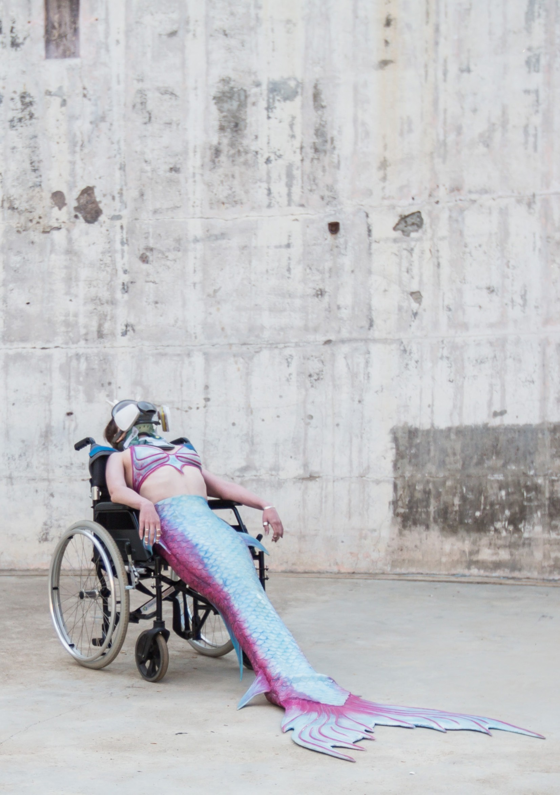
Photos: Shelly Higgs

THE MERMAID
HANNA CORMICK I AUSTRALIA

THE MERMAID

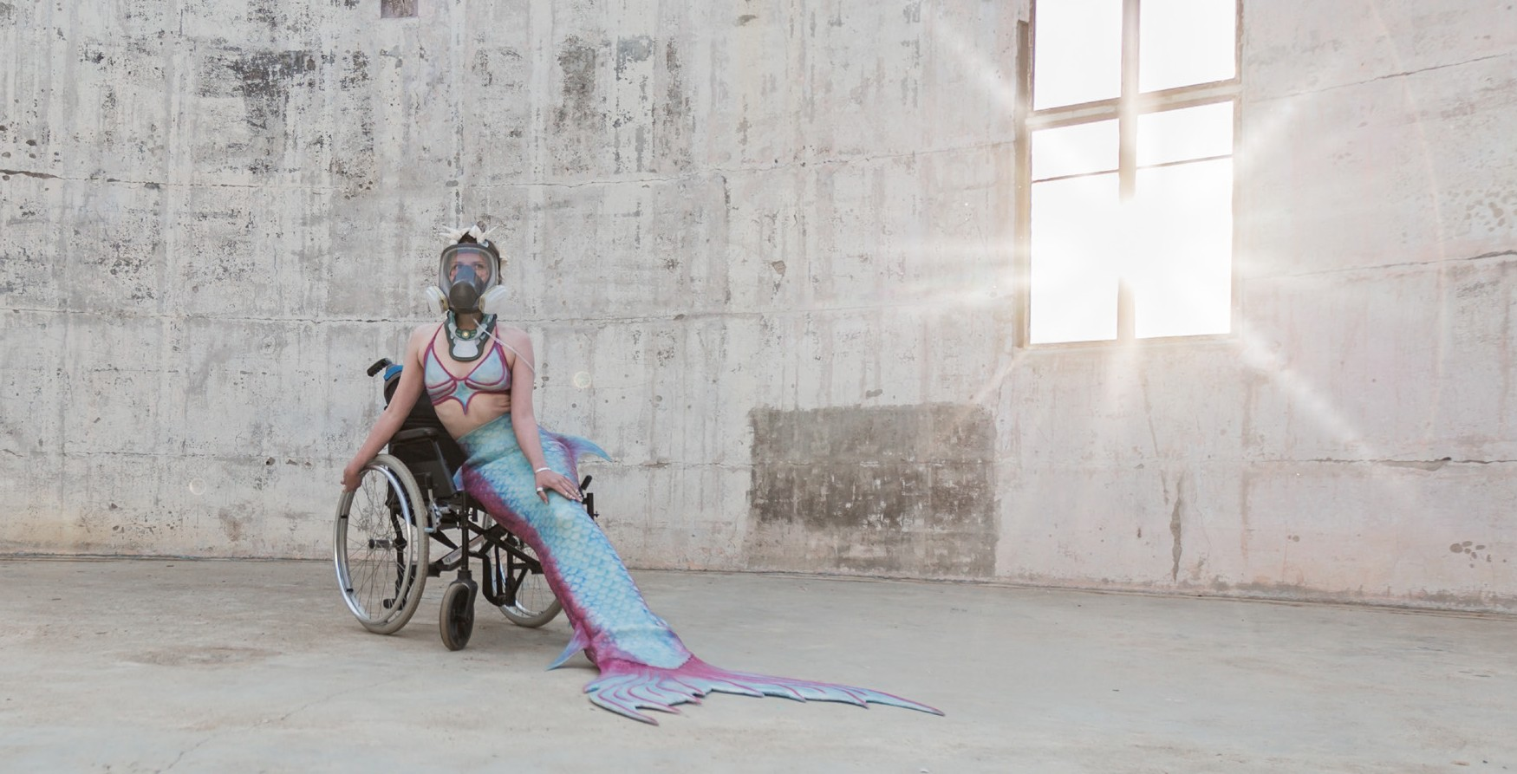HANNA CORMICK I AUSTRALIA

THE COAL LOADER WAVERTON
17–19 JANUARY
15-20 MINS

Created and Performed by Hanna Cormick
Performers Christopher Samuel Carroll, Lloyd Allison-Young
Production Assistant Gillian Schwab
Tail Design and Construction Mermaid Kat (Katrin Gray)
Texts by Hanna Cormick, featuring quotes from
Audre Lorde (The Transformation of Silence into Language and Action, 1977) and Paul B Preciado (Le courage d'être soi, Libération 2014)
Music by The Everly Ills (Lloyd Allison-Young/ Rachel Feldhaus)

ALLERGEN WARNING: This performance contains allergens coconut oil and beeswax. Patrons with airborne sensitivities are advised to take caution.
ABOUT THE SHOW
In the ocean, the Mermaid is free. On land, she cannot swim or breathe and is vulnerable to the pollution of human settlement. It is not the Mermaid that is disabled, but the environment that makes her so. This work uses the artist's real mobility aids, medical equipment, and uncontrollable disease symptoms, and may be interrupted at any moment by real medical events. Cormick's startling debut work as
a disabled artist is a formidable battle-cry for the invisible and voiceless.

HANNA CORMICK is a performance artist with a background in physical theatre, dance, circus and interdisciplinary art, and is a graduate of Ecole Internationale de Théâtre Jacques Lecoq (Paris). Cormick lives with a cluster of rare diseases known as The Trifecta: Ehlers-Danlos Syndrome, Mast Cell Activation Syndrome and Postural Orthostatic Tachycardia Syndrome, amongst many other medical complications from these diseases. Her current practice is a reclamation of body through radical visibility.

THANKS
Development of The Mermaid has been supported by the ACT Government through Art, Not Apart, Belconnen Arts Centre and Ainslie + Gorman Arts Centres. Thanks to
the Hunt Family Foundation for support of the Disability Programming Initiative.

