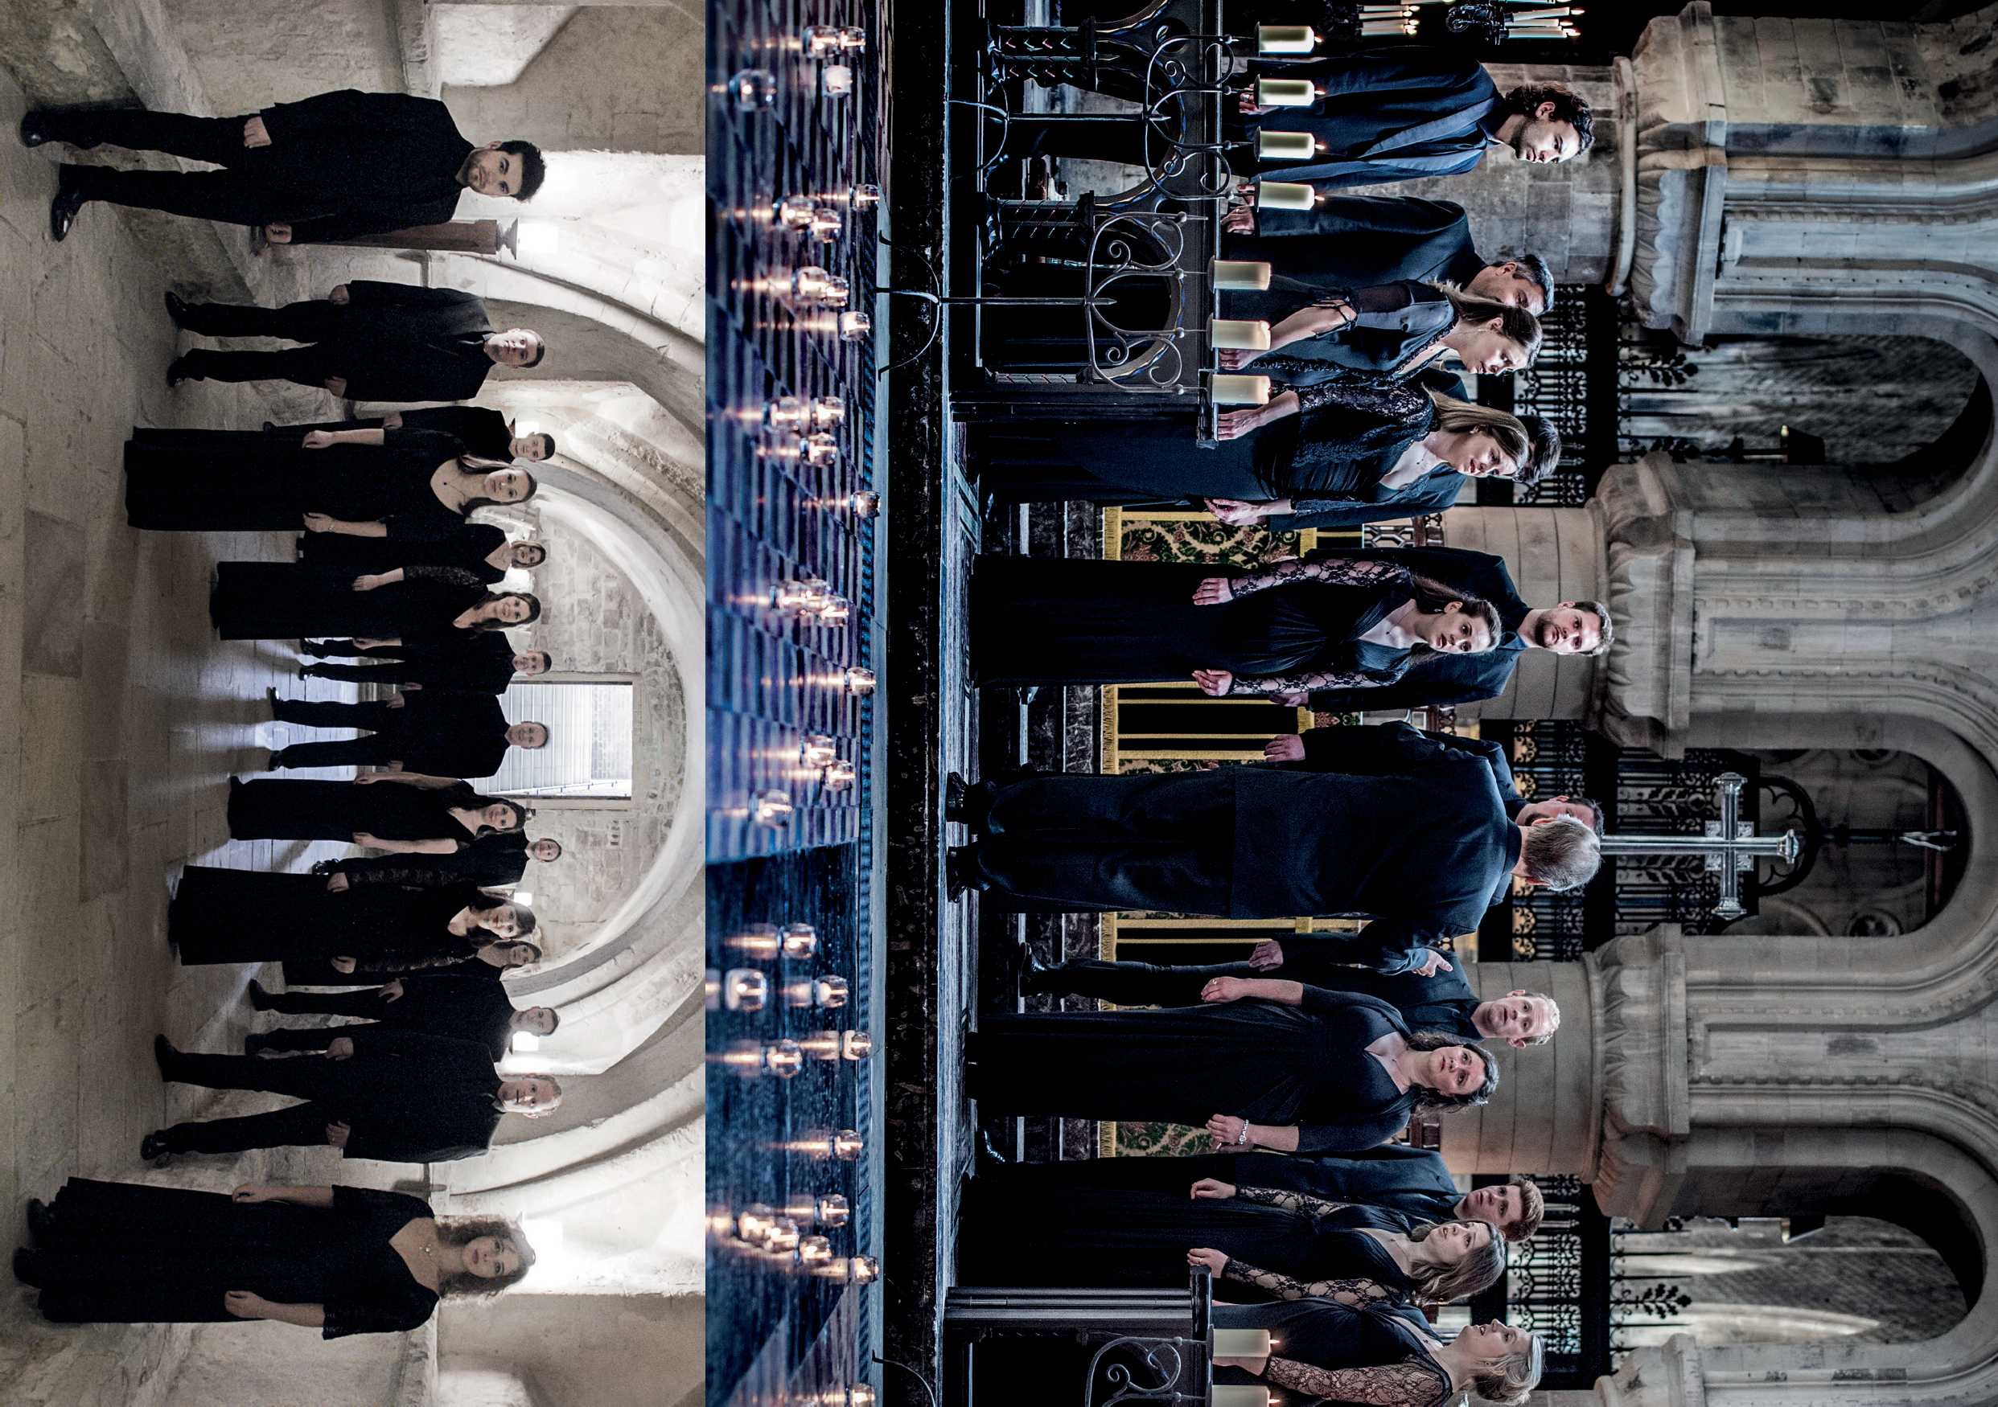Rae
TENEBRAE
MUSIC OF THE SPHERES
TENEBRAE CHOIR AND NIGEL SHORT | UK
Photos: Sim Canetty-Clarke, Chris O’Donovan Photo: Simon Gosselin

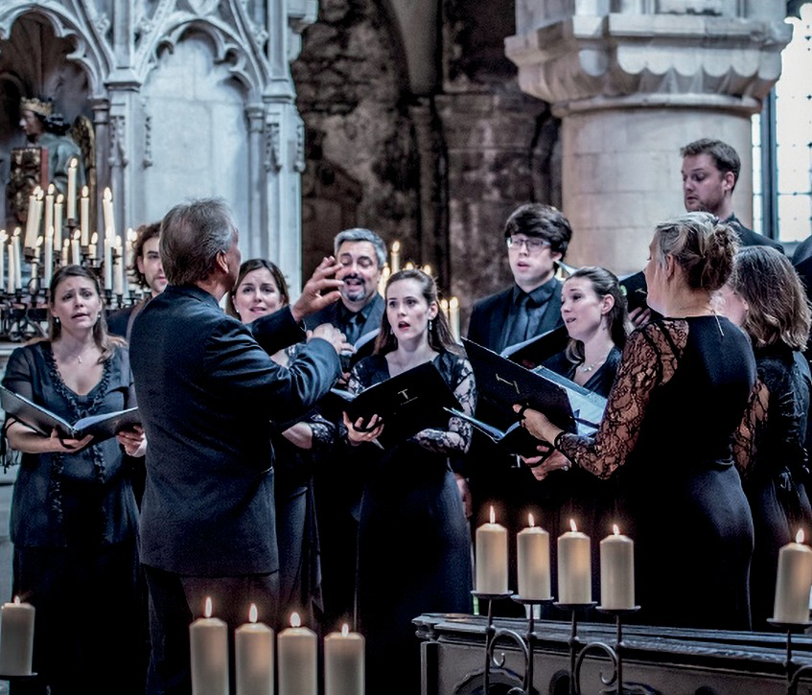
TENEBRAE
MUSIC OF THE SPHERES
TENEBRAE CHOIR AND NIGEL SHORT | UK

CITY RECITAL HALL 22 JANUARY
95 MINS

Conductor Nigel Short
Mezzo Soprano Martha McLorinan

SOPRANO
Victoria Meteyard Anita Monserrat Elisabeth Paul Katie Trethewey

ALTO
Mark Chambers Hannah Cooke Martha McLorinan

TENOR
David de Winter Nicholas Madden Chris Watson

BASS
Benedict Flinn Tom Flint
Tom Herring Oliver Hunt
PROGRAMME: MUSIC OF THE SPHERES

Gustav Holst The Evening-Watch Hubert Parry Songs of Farewell

INTERVAL

Edward Elgar O Wild West Wind, Op.53, No.3
Herbert Murrill Two Shakespeare Songs Ralph Vaughan-Williams Three Shakespeare Songs Bob Chilcott Marriage to my Lady Poverty
Judith Bingham The Drowned Lovers
Charles Stanford The Bluebird
Bob Chilcott The Modern Man I Sing

TENEBRAE
British choir Tenebrae is renowned for its interpretations of choral repertoire from the Renaissance to the present day, and for its core values of passion and precision. Under the direction of Nigel Short (a former King’s Singer), Tenebrae has twice secured the award for Best Choral Performance in the BBC Music Magazine Awards, and in 2018 it received its first Grammy nomination. Alongside a busy international schedule, Tenebrae runs a thriving outreach programme in its home city of London.

NIGEL SHORT
Award-winning conductor Nigel Short has earned widespread acclaim for his recording and live performance work with leading orchestras and ensembles across the world. A former member of renowned vocal ensemble
The King’s Singers (1994–2000), in 2001 Nigel formed Tenebrae, a virtuosic choir that combines the passion of a cathedral choir with the precision of a chamber ensemble. Under his direction, Tenebrae has collaborated with internationally acclaimed orchestras and instrumentalists and now enjoys a reputation as one of the world’s
finest vocal ensembles. To date, Nigel has conducted the Academy of Ancient Music, Aurora Orchestra, BBC Symphony Orchestra, Chamber Orchestra of Europe, English Chamber Orchestra, English Concert, London Philharmonic Orchestra, London Symphony Orchestra,
Orchestra of the Age of Enlightenment, Royal Philharmonic Orchestra, Scottish Ensemble and Britten Sinfonia.

