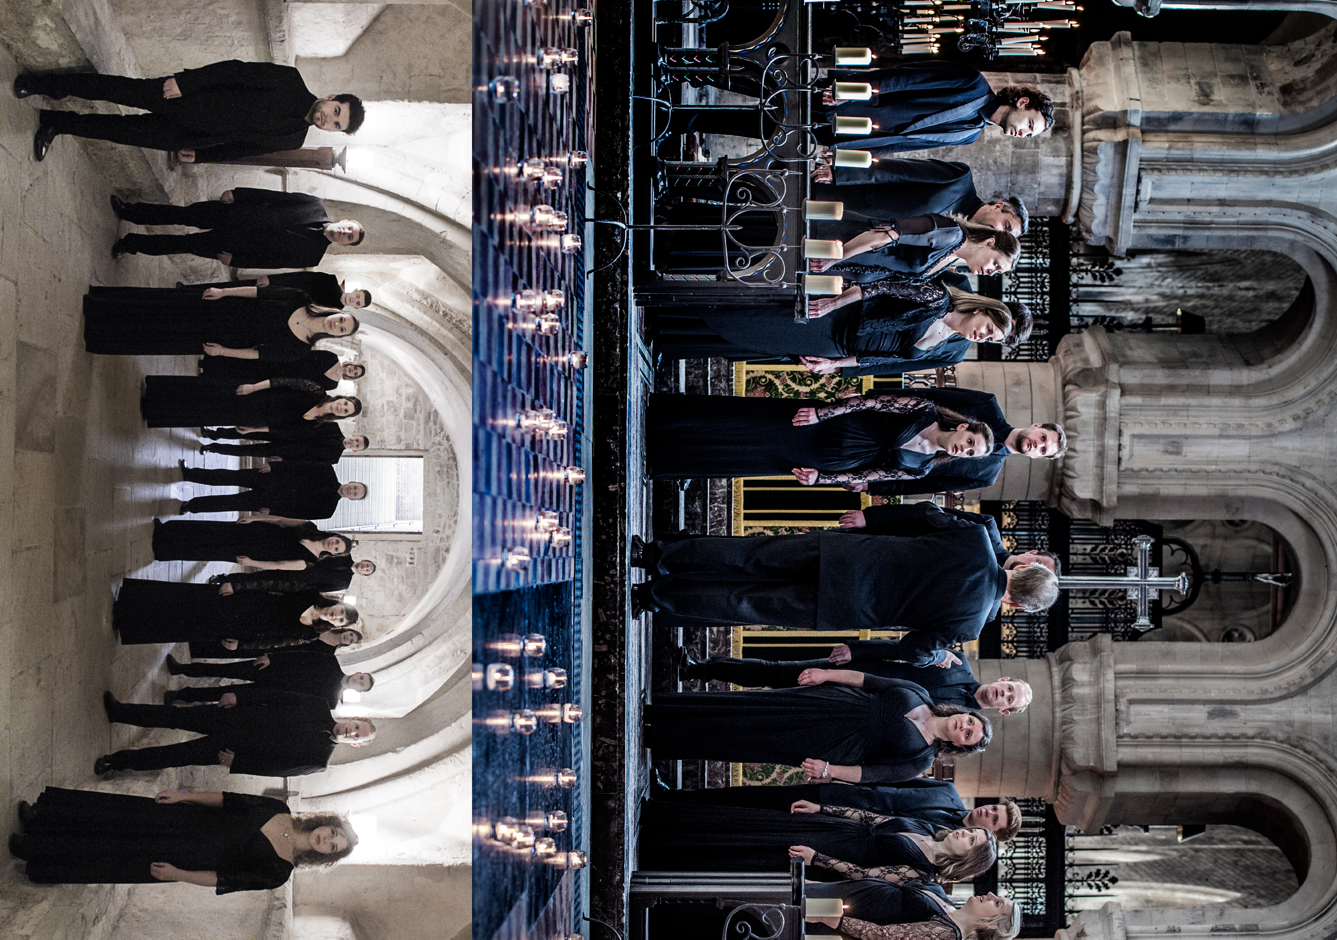Photos: Sim Canetty-Clarke, Chris O’Donovan Photo: Simon Gosselin
TENEBRAE
MUSIC OF THE SPHERES
TENEBRAE CHOIR AND NIGEL SHORT | UK

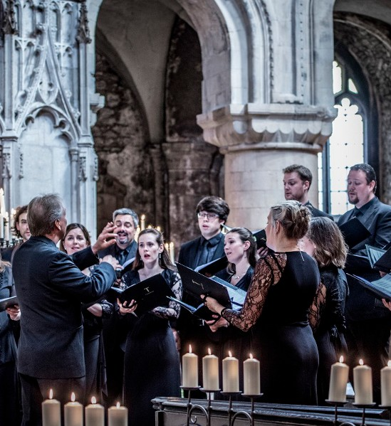TENEBRAE
MUSIC OF THE SPHERES
TENEBRAE CHOIR AND NIGEL SHORT | UK

CITY RECITAL HALL 22 JANUARY
95 MINS

Conductor Nigel Short
Mezzo Soprano Martha McLorinan

SOPRANO
Victoria Meteyard Anita Monserrat Elisabeth Paul Katie Trethewey

ALTO
Mark Chambers Hannah Cooke Martha McLorinan

TENOR
David de Winter Nicholas Madden Chris Watson

BASS
Benedict Flinn Tom Flint
Tom Herring Oliver Hunt

REPERTOIRE
Tenebrae celebrate a selection of the greatest choral works from the British Isles, inspired by Shakespeare, Shelley, Byron, Tennyson and Milton.
Repertoire includes:
Gustav Holst – The Evening-Watch Hubert Parry – Songs Of Farewell Edward Elgar – O Wild West Wind
Herbert Murrill – Two Shakespeare Songs
Ralph Vaughan Williams – Three Shakespeare Songs
Bob Chilcott – Marriage to My Lady Poverty Judith Bingham – The Drowned Lovers Charles Stanford – The Blue Bird
Chilcott – The Modern Man I Sing

TENEBRAE
British choir Tenebrae is renowned for its interpretations of choral repertoire from the Renaissance to the present day, and for its core values of passion and precision. Under the direction of Nigel Short (a former King’s Singer), Tenebrae has twice secured the award for Best Choral Performance in the BBC Music Magazine Awards, and in 2018 it received its first Grammy nomination. Alongside a busy international schedule, Tenebrae runs a thriving outreach programme in its home city of London.

