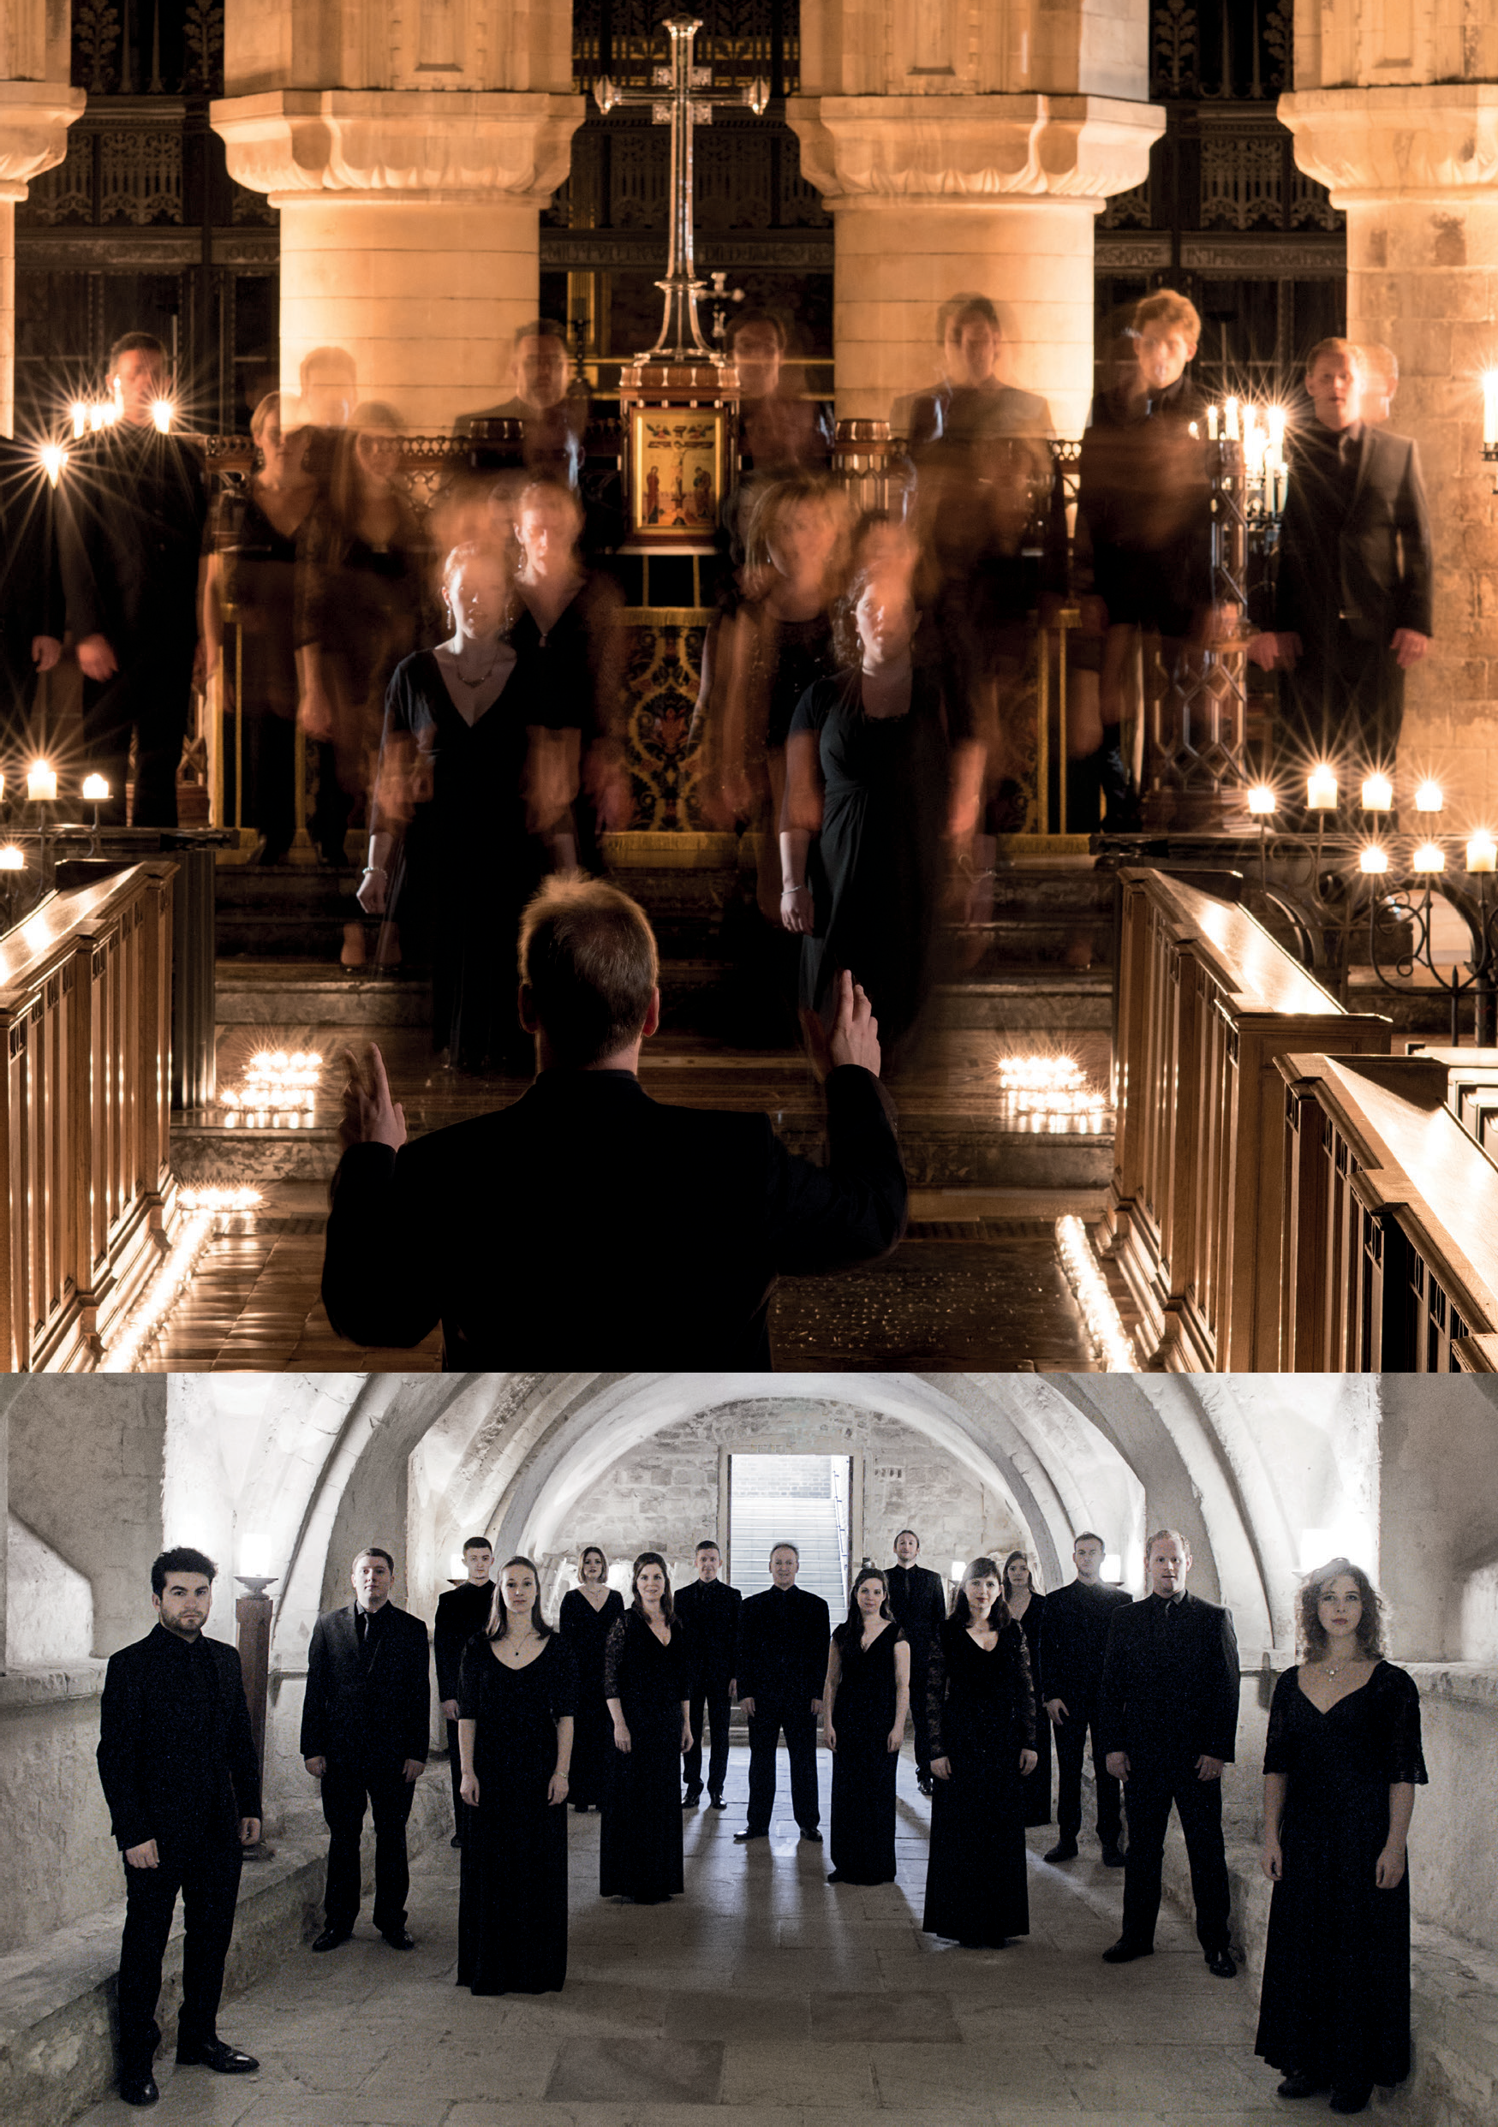

TENEBRAE
MASTERWORKS OF THE RENAISSANCE
TENEBRAE CHOIR AND NIGEL SHORT | UK
Photos: Sim Canetty-Clarke, Chris O’Donovan

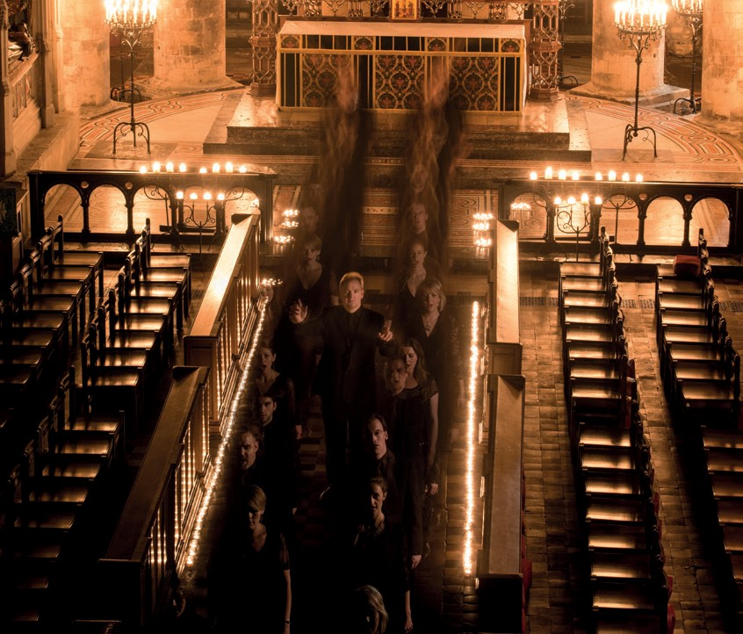
TENEBRAE
MASTERWORKS OF THE RENAISSANCE
TENEBRAE CHOIR AND NIGEL SHORT | UK
CITY RECITAL HALL 21 JANUARY
95 MINS

Conductor Nigel Short

SOPRANO
Victoria Meteyard Anita Monserrat Elisabeth Paul Katie Trethewey

ALTO
Mark Chambers Hannah Cooke Martha McLorinan

TENOR
David de Winter Nicholas Madden Chris Watson

BASS
Benedict Flinn Tom Flint
Tom Herring Oliver Hunt

PROGRAMME: MASTERWORKS OF THE RENAISSANCE

Alonso Lobo Versa est in luctum

Tomás Luis de Victoria Selection from Tenebrae Responsories and Lamentations:
Responsory I: Amicus meus osculi me tradidit signa Responsory II: Judas mercator pessimus
Responsory V: Una hora non potuistis vigilare mecum Responsory XIV: O vos omnes
Responsory XVI: Astiterunt reges terrae Responsory XVIII: Sepulto Domino

Gregorio Allegri Miserere mei, Deus

INTERVAL

Tomás Luis de Victoria Requiem Mass, 1605

TENEBRAE
British choir Tenebrae is renowned for its interpretations of choral repertoire from the Renaissance to the present day, and for its core values of passion and precision. Under the direction of Nigel Short (a former King’s Singer), Tenebrae has twice secured the award for Best Choral Performance in the BBC Music Magazine Awards, and in 2018 it received its first Grammy nomination. Alongside a busy international schedule, Tenebrae runs a thriving outreach programme in its home city of London.

NIGEL SHORT
Award-winning conductor Nigel Short has earned widespread acclaim for his recording and live performance work with leading orchestras and ensembles across the world. A former member of renowned vocal ensemble The King’s Singers (1994–2000), in 2001 Nigel formed Tenebrae, a virtuosic choir that combines the passion of a cathedral choir with
the precision of a chamber ensemble. Under his direction, Tenebrae has collaborated with internationally acclaimed orchestras and instrumentalists and now enjoys a reputation as one of the world’s finest vocal ensembles. To date, Nigel has conducted the Academy of Ancient Music, Aurora Orchestra, BBC Symphony Orchestra, Chamber Orchestra
of Europe, English Chamber Orchestra, English Concert, London Philharmonic Orchestra, London Symphony Orchestra, Orchestra of the Age of Enlightenment, Royal Philharmonic Orchestra, Scottish Ensemble and Britten Sinfonia.

