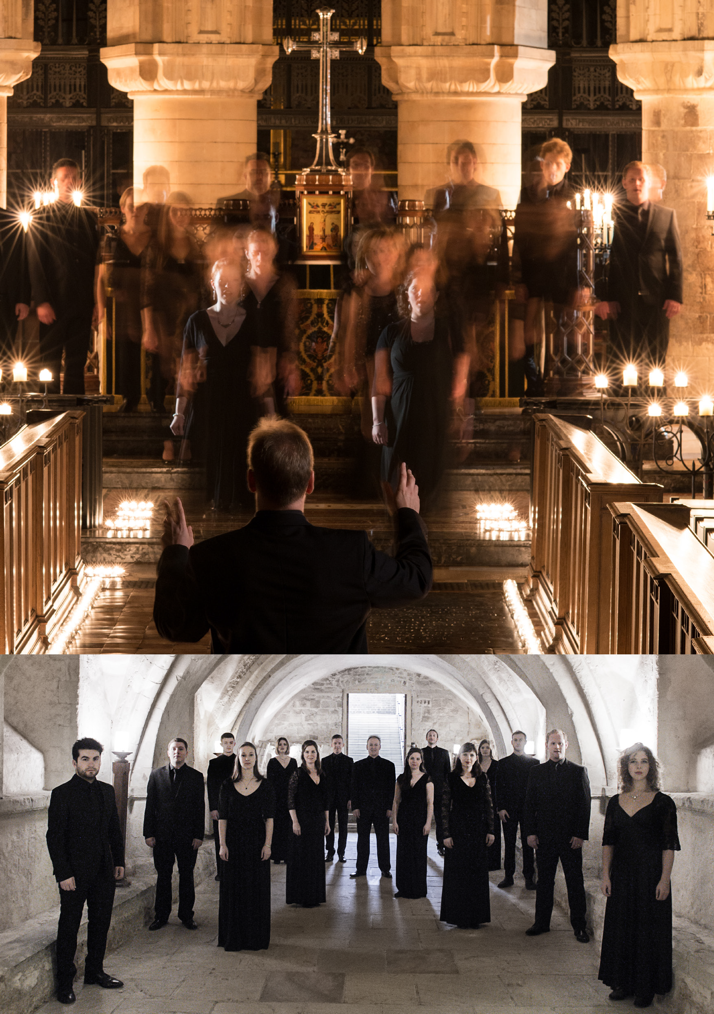

TENEBRAE
MASTERWORKS OF THE RENAISSANCE
TENEBRAE CHOIR AND NIGEL SHORT | UK
Photos: Sim Canetty-Clarke, Chris O’Donovan

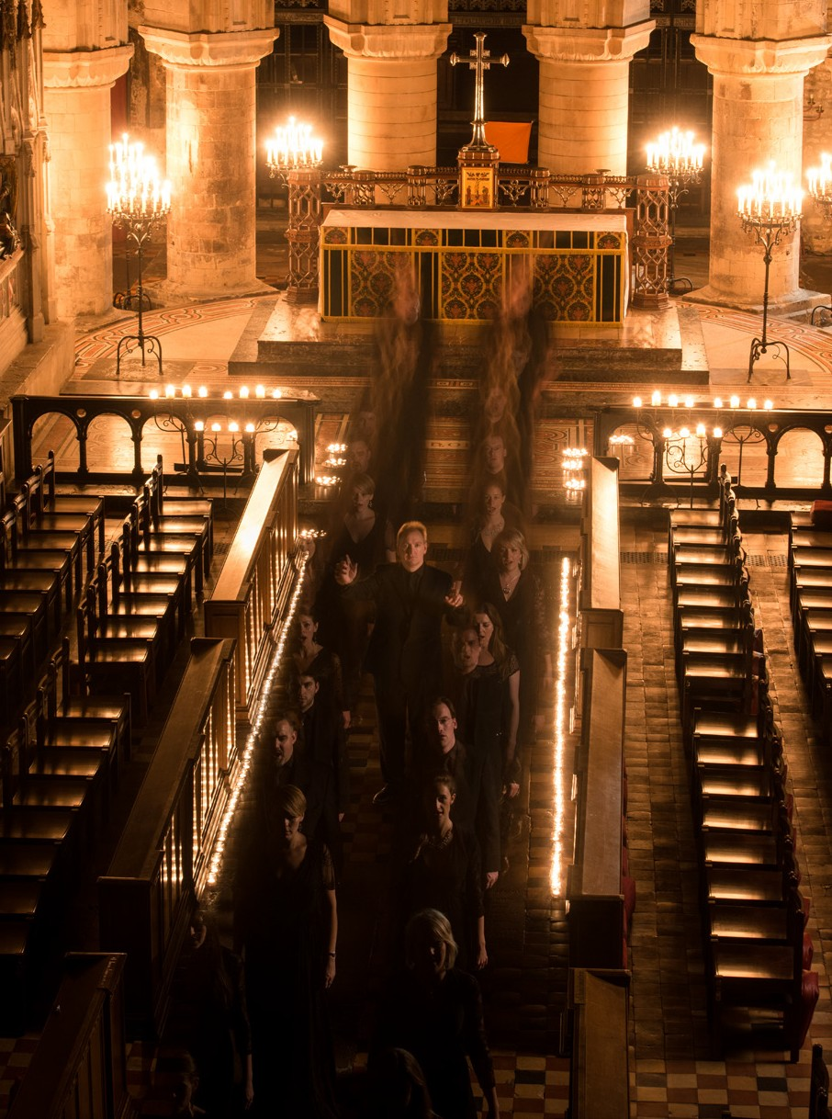TENEBRAE
MASTERWORKS OF THE RENAISSANCE
TENEBRAE CHOIR AND NIGEL SHORT | UK

CITY RECITAL HALL 21 JANUARY
95 MINS

Conductor Nigel Short

SOPRANO
Victoria Meteyard Anita Monserrat Elisabeth Paul Katie Trethewey

ALTO
Mark Chambers Hannah Cooke Martha McLorinan

TENOR
David de Winter Nicholas Madden Chris Watson

BASS
Benedict Flinn Tom Flint
Tom Herring Oliver Hunt

REPERTOIRE
Tenebrae performs some of the greatest jewels of the Golden Age, including Victoria’s stunning requiem of 1605 and Allegri’s celebrated Miserere, mei Deus.

Alfonso Lobo – Versa est in luctum
Tomás Luis de Victoria - Highlights from the Tenebrae Responsories and Lamentations
Gregorio Allegri – Miserere, mei Deus
Victoria - requiem (1605)

TENEBRAE
British choir Tenebrae is renowned for its interpretations of choral repertoire from the Renaissance to the present day, and for its core values of passion and precision. Under the direction of Nigel Short (a former King’s Singer), Tenebrae has twice secured the award for Best Choral Performance in the BBC Music Magazine Awards, and in 2018 it received its first Grammy nomination. Alongside a busy international schedule, Tenebrae runs a thriving outreach programme in its home city of London.

