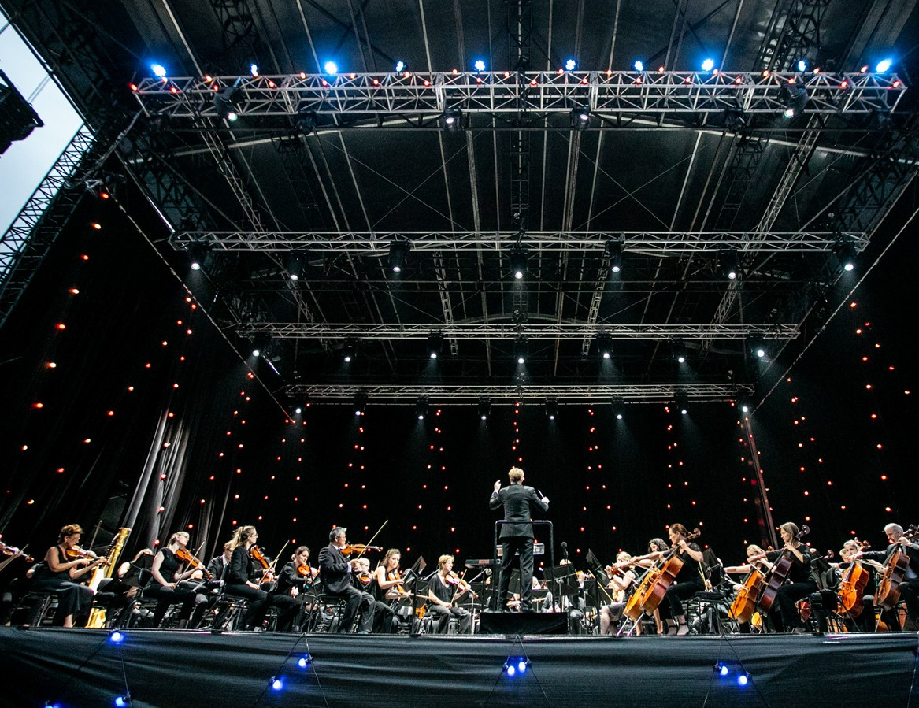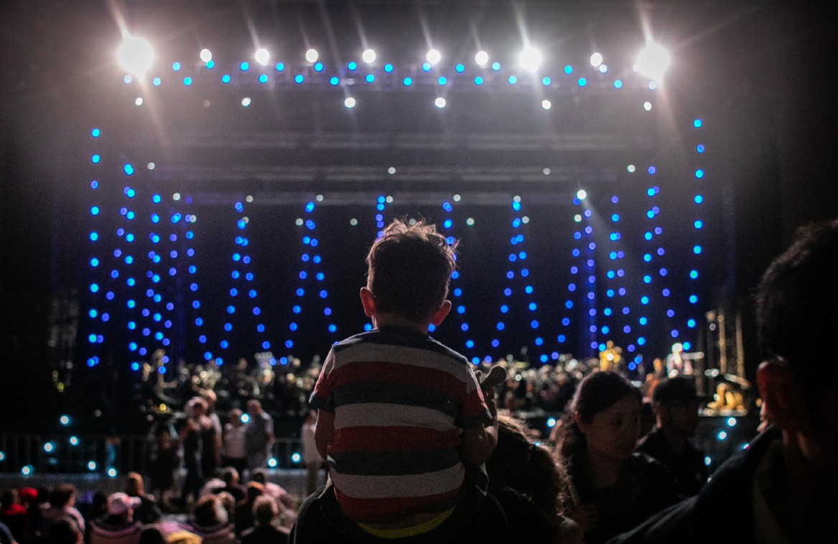

SYDNEY SYMPHONY UNDER THE STARS
Photos: Victor Frankowski
SYDNEY SYMPHONY ORCHESTRA I AUSTRALIA

SYDNEY SYMPHONY UNDER THE STARS
SYDNEY SYMPHONY ORCHESTRA AND
PARRAMATTA PARK TRUST | AUSTRALIA

THE CRESCENT PARRAMATTA PARK 18 JANUARY
120 MINS

Benjamin Northey conductor
Sun Yi violin
Leah Lynn cello
Sydney Symphony Orchestra

PROGRAM

Ludwig van Beethoven (German, 1770–1827)

Fidelio: Overture

Bedřich Smetana (Czech, 1824–1884)

Má Vlast: Vltava (The Moldau)

John Williams (American, born 1932)
Theme from Schindler's List
Sun Yi, violin

Piotr Ilyich Tchaikovsky (Russian, 1840–1893)

The Nutcracker: Three Dances

Alexander Borodin (Russian, 1833–1887)

Prince Igor: Polovtsian Dances

INTERVAL

Giuseppe Verdi (Italian, 1813–1901)

The Force of Destiny: Overture

Aram Khachaturian (Armenian, 1903–1978)

Spartacus: Adagio of Spartacus and Phrygia

Camille Saint-Saëns (French, 1835–1921) (orch. Vidal)
Carnival of the Animals: The Swan
Leah Lynn, cello

Jacques Offenbach (German-French, 1819–1880) (arr. Binder)

Orpheus in the Underworld: Can-Can

Piotr Ilyich Tchaikovsky (Russian, 1840–1893)

1812 – Festival Overture

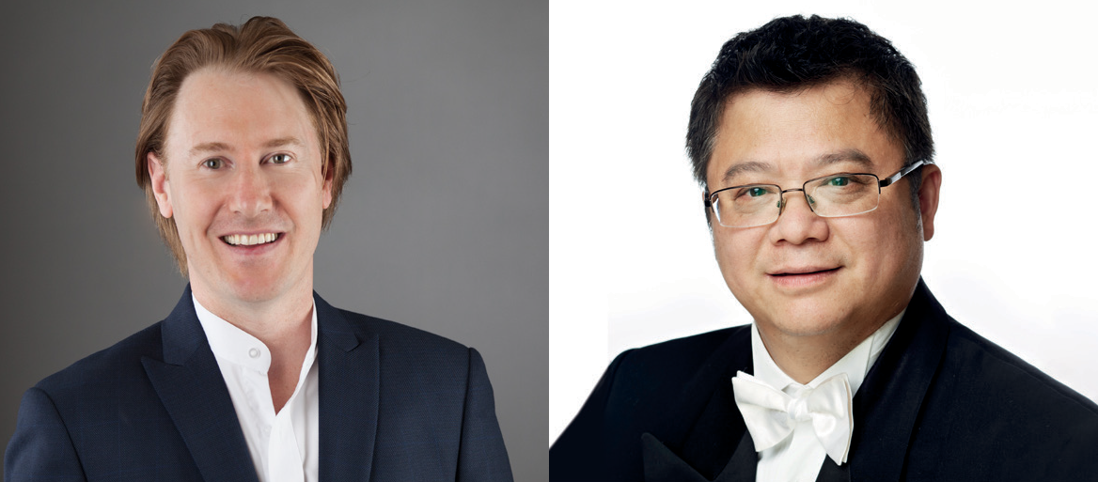
BENJAMIN NORTHEY
CONDUCTOR

Benjamin Northey is Chief Conductor of the Christchurch Symphony Orchestra and Associate Conductor of the Melbourne Symphony Orchestra. He was previously Resident Guest Conductor of the Australia Pro Arte Chamber Orchestra (2002–2006) and Principal Conductor of the Melbourne Chamber Orchestra (2007– 2010). He also appears regularly as a guest conductor with all the major Australian symphony orchestras, as well as Opera Australia, Victorian Opera and State Opera of South Australia.
His international appearances include concerts with the London Philharmonic Orchestra, Tokyo Philharmonic Orchestra, Mozarteum Orchestra Salzburg, Hong Kong Philharmonic, National Symphony Orchestra of Colombia, Malaysian Philharmonic, Auckland Philharmonia and New Zealand Symphony Orchestra.
Benjamin Northey studied conducting with John Hopkins at the University of Melbourne Conservatorium of Music, with Leif Segerstam and Atso Almila at the Sibelius Academy, and with Jorma Panula at the Stockholm Royal College of Music.
With a progressive and diverse approach to repertoire, he has collaborated with a broad range of artists, including Maxim Vengerov, Julian Rachlin, Karen Gomyo, Piers Lane, Alban Gerhardt, Johannes Moser, Amy Dickson, Slava Grigoryan and Marc-André Hamelin.
He is a regular guest of the Sydney Symphony Orchestra; recent engagements have included an
all-Rautavaara program in the 2016 Sydney Festival as well as the 2018 and 2019 Sydney Symphony Under the Stars concerts in Parramatta Park, and concerts featuring Simon Tedeschi, Kate Miller-Heidke and Megan Washington.

SUN YI
VIOLIN
Associate Concertmaster
Sun Yi was born in Hunan, China. He attended the Shanghai Conservatory of Music from 1988 to 1993 where he was the Concertmaster for the Youth Orchestra and Chamber Orchestra. In 1990, he won the third
prize for the senior section in the China National Violin Competition, and also participated in the International Chamber Music Competition in Melbourne, Australia.
After graduating with a Bachelor of Music degree from the Shanghai Conservatory, Sun Yi was engaged as the Associate Concertmaster of the Shanghai Symphony Orchestra.
He also became the leader of the Orient String Quartet, which toured Japan and France and won the special nomination prize in the 3rd Borciani International String Quartet Competition in Italy. The quartet studied with the Amadeus String Quartet at the International Summer
Camp in London. As a soloist he performed The Butterfly Lovers concerto in Taiwan with the Shanghai Symphony Orchestra in 1994. He has also performed Vivaldi's Four Seasons for the televised Shanghai New Year concert, and with the Shanghai Symphony Orchestra on their 1996 tour to Thailand.
From 2002 to 2007, Sun Yi held the position of Associate Concertmaster of the Australian Opera and Ballet Orchestra. He was appointed Associate
Concertmaster with the Sydney Symphony Orchestra in 2007 and has appeared as soloist with the orchestra in Saint-Saëns' Introduction and Rondo Capriccioso.
He is also the founding member of the Whiteley Trio and Nexus-2MBS Virtuosi.

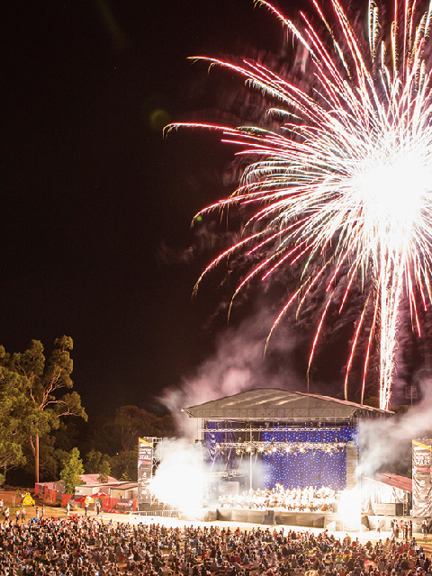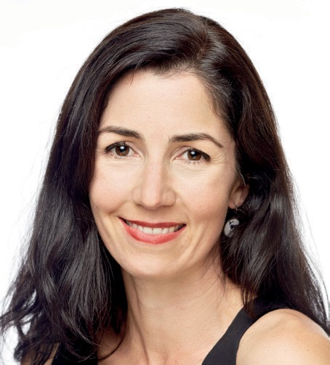
Parramatta Park is delighted to welcome back the Sydney Symphony Orchestra for the 14th year in The Crescent – our beautiful natural outdoor amphitheatre alongside the Parramatta River.
We’re equally pleased to be partnering again with Sydney Festival, bringing this wonderful concert to audiences both regular and new.
Sydney Symphony Under the Stars is a highlight of the annual Crescent Summer Series. It’s one of four free concerts for everyone to enjoy. To find out more about how you can see and hear the stars in The Crescent across the coming months, see crescentsummerseries.com.au
We hope you have a truly wonderful evening. And don’t forget to tag us @parrapark #TheCrescent.
AND WIN
We want to hear from you! Our short survey will only take a few minutes and you’ll go into the draw to win a $200 Westfield voucher.
Click here for the survey or go to http://bit.ly/parra-park-survey
TELL US ABOUT YOUR EVENING...
A SEASON
OF LIVE MUSIC IN PARRAMATTA PARK

LEAH LYNN
CELLO
Acting Associate Principal, Sydney Symphony Orchestra Vanguard Chair

Leah Lynn was born in Adelaide where she completed her Bachelor of Music degree, studying with Janis Laurs. She was involved in various Youth Music and National Academy activities and undertook tours with the Australian Youth Orchestra, with whom she performed as Principal Cello. She travelled to Europe while in her 20s and studied with a number of distinguished cellists, including Georg Faust and Maria Kliegel.
Leah Lynn has worked with the Adelaide and Tasmanian symphony orchestras, and has toured extensively with the Australian Chamber Orchestra. She joined the Sydney
Symphony Orchestra in 1997. In 2001 she took part in an exchange with the BBC Philharmonic as part of the Sydney Symphony's Friends scholarship. While in the UK, she studied with Hannah Roberts at the Royal Northern College of Music.
In addition to her orchestral career, Leah Lynn has been a member of numerous chamber ensembles including the Sydney Soloists, Australia Ensemble, Song Company
and the Australian and Seraphim trios. She has performed in several Government House series concerts as well as performing in ABC Classic FM's Sunday Live broadcasts.

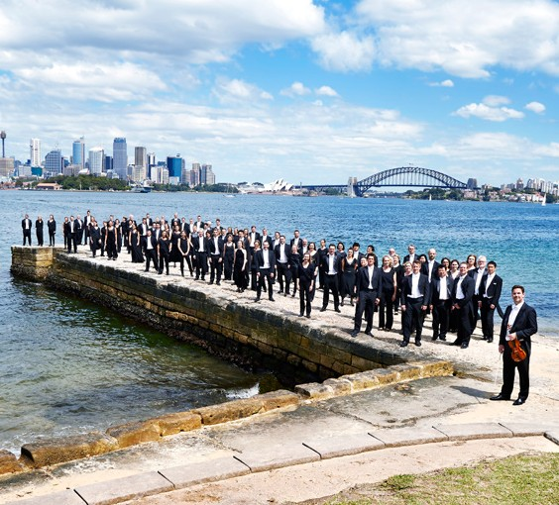
SYDNEY SYMPHONY ORCHESTRA
PATRON Her Excellency The Honourable Margaret Beazley AO QC
Founded in 1932 by the Australian Broadcasting Commission, the Sydney Symphony Orchestra has evolved into one of the world’s finest orchestras as Sydney has become one of the world’s great cities. Resident at
the iconic Sydney Opera House, the Sydney Symphony Orchestra also performs in venues throughout Sydney and regional New South Wales, and international tours to Europe, Asia and the USA have earned the Orchestra worldwide recognition for artistic excellence.
Well on its way to becoming the premier orchestra of the Asia Pacific region, the Sydney Symphony Orchestra has toured China on five occasions, and in 2014 won the arts category in the Australian Government’s inaugural Australia-China Achievement Awards, recognising
ground-breaking work in nurturing the cultural and artistic relationship between the two nations.
The Orchestra’s first chief conductor was Sir Eugene Goossens, appointed in 1947; he was followed by Nicolai Malko, Dean Dixon, Moshe Atzmon, Willem van Otterloo, Louis Frémaux, Sir Charles Mackerras, Zdeněk Mácal, Stuart Challender, Edo de Waart and Gianluigi Gelmetti. Vladimir Ashkenazy was Principal Conductor from 2009 to 2013, followed by David Robertson as Chief Conductor from 2014 to 2019. The Orchestra’s history also boasts collaborations with legendary figures such as George Szell, Sir Thomas Beecham, Otto Klemperer and
Igor Stravinsky.
The Sydney Symphony Orchestra's concerts encompass masterpieces from the classical repertoire, music by some of the finest living composers, and collaborations with guest artists from all genres, reflecting the Orchestra's versatility and diverse appeal. Its award-winning education program is central to its commitment to the future of live symphonic music, developing audiences and engaging the participation of young people, and the Orchestra promotes the work of Australian composers through performances, recordings and its commissioning program.
In 2020, the Orchestra embarks on an exciting partnership with the Sydney Coliseum Theatre, West HQ, bringing live symphonic music to music-lovers in Greater Western Sydney.

SYDNEY SYMPHONY ORCHESTRA

Benjamin Northey, conductor Saturday 18 January 2020

FIRST VIOLINS
Sun Yi Associate Concertmaster
Lerida Delbridge Assistant Concertmaster
Jenny Booth Claire Herrick Georges Lentz Nicola Lewis Emily Long Alexandra Mitchell Alexander Norton Anna Skálová Léone Ziegler Brian Hong†

SECOND VIOLINS
Marina Marsden Principal
Marianne Edwards Associate Principal
Alice Bartsch Rebecca Gill Emma Hayes Shuti Huang Monique Irik Wendy Kong Maja Verunica Tim Yu†

VIOLAS
Justin Williams Acting Associate Principal
Rosemary Curtin Graham Hennings Stuart Johnson Justine Marsden Amanda Verner Leonid Volovelsky Dana Lee†

CELLOS
Leah Lynn Acting Associate Principal
Kristy Conrau Elizabeth Neville Christopher Pidcock Adrian Wallis
Paul Stender*

DOUBLE BASSES
David Campbell Steven Larson Richard Lynn Jaan Pallandi

FLUTES
Joshua Batty Principal
Carolyn Harris
Katie Zagorski# Acting Principal Piccolo

OBOES
Shefali Pryor Associate Principal
Eve Osborn#
Alexandre Oguey Principal Cor Anglais

CLARINETS
James Burke Principal
Christopher Tingay
Alexei Dupressoir* Guest Principal Bass Clarinet

BASSOONS
Matthew Wilkie Principal Emeritus
Fiona McNamara
Noriko Shimada Principal Contrabassoon

HORNS
Samuel Jacobs* Guest Principal
Euan Harvey Marnie Sebire Rachel Silver Emily Newham†

TRUMPETS
Brent Grapes* Guest Principal
Anthony Heinrichs David Johnson# Fletcher Cox†

TROMBONES
Scott Kinmont Associate Principal
Nick Byrne
Christopher Harris Principal Bass Trombone

TUBA
Steve Rossé Principal

TIMPANI
Adam Jeffrey* Guest Principal

PERCUSSION
Rebecca Lagos Principal
Timothy Constable Tim Brigden*
Adam Cooper-Stanbury* Chiron Meller*

HARP
Genevieve Lang* Guest Principal

Bold = Principal
* = Guest Musician
# = Contract Musician
† = Sydney Symphony Fellow

