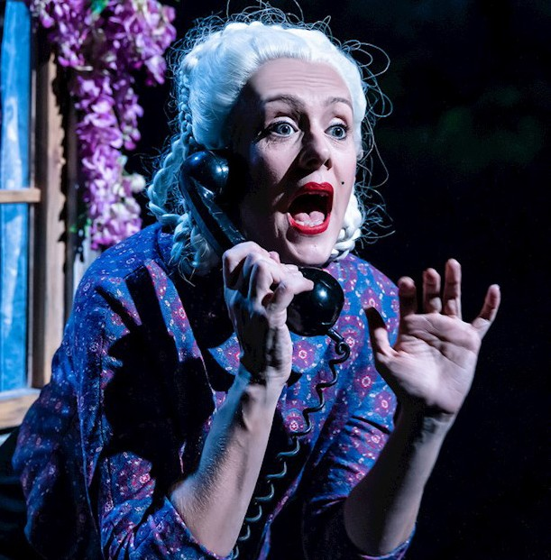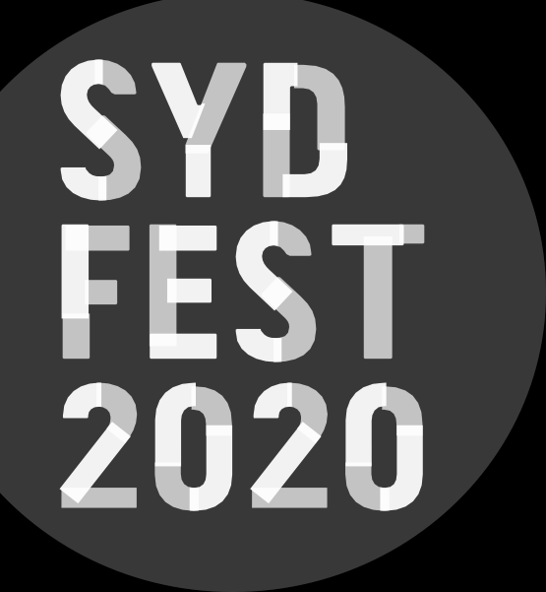

I’M A PHOENIX, BITCH
Photos: Christa Holka
BRYONY KIMMINGS | UK

I’M A PHOENIX, BITCH

BRYONY KIMMINGS | UK

DRAMA THEATRE SYDNEY OPERA HOUSE 14–17 JANUARY
80 MINS

Conceived, written and performed by
Bryony Kimmings
Directors Kirsty Housley and Bryony Kimmings
Producer Philippa Barr
Art Director David Curtis-Ring
Projection Designer Will Duke
Projection Design Associate Hayley Egan
Composer Tom Parkinson
Sound Designer Lewis Gibson Lighting Designer Johanne Jensen Dramaturgical Support Nina Steiger Creative Associate Michal Keyamo
Choreography & Rehearsal Direction Sarah Blanc
Makeup Design Guy Common
Design Assistants Katherine Millar, Alice Winzar, Abel Oberon and Ian Cy
Costume Assistant Alan Meggs
Senior Producer Consultant Judith Dimant
Production Manager Helen Mugridge

Technical Stage Manager/Video & Sound Operator
Froud
Additional Video & Sound 0peration Mike Bignell
Assistant Producer Becky Plotnek Additional Technical Support Beth O’Leary Lighting Operator James Smellie
Lighting Programmer Emma Henderson

ABOUT THE SHOW
Following an extended run at Battersea Arts Centre, a sell-out run at the 2019 Edinburgh Festival Fringe
and an Offies 2019 Award win, Bryony Kimmings brings the critically acclaimed I’m a Phoenix, Bitch to
Sydney Opera House.
Kimmings weaves a powerful, dark and joyful masterpiece about motherhood, heartbreak and finding inner strength. I’m a Phoenix, Bitch combines ethereal music, personal stories, epic film and feats of human strength.
Ever sunk so deep you felt like you might never make it up for air?
In 2016, Bryony nearly drowned. Postnatal breakdowns, an imploding relationship and an extremely sick child left her sitting beneath the waves hoping she could slowly turn to shell.
Four years later and she is able to deal with life again, but wears the scars of that year like a dark and heavy cloak. Who do we become after trauma? How do we turn pain into power? How do we fly instead of drown?
We will need new myths to survive the end of existence as we know it. Tonight a new legend will be created; that of the invincible and fearless woman; a tale Bryony wishes she had known from birth.

BRYONY KIMMINGS
Inspired by the taboos, stigmas, anomalies and social injustices around her, Kimmings creates mind-blowing, multi-platform art works to provoke change.
The work centres around outlandish ‘social experiments’ that Kimmings conducts with genuine genius, intrigue and wholehearted fearless gusto. The artist sets her sights
on the impossible and unconquerable, and turns the unspeakable into the year’s hottest topic.

THANKS
Co-commissioned by Battersea Arts Centre, Arts Centre Melbourne, Attenborough Centre for the Creative Arts and supported by Latitude Festival. Supported by the British Council and supported by Arts Council England using public funding. In association with Avalon.

