OPENING NIGHT
Photos: Simon Gosselin
CYRIL TESTE | FRANCE | AUSTRALIAN EXCLUSIVE

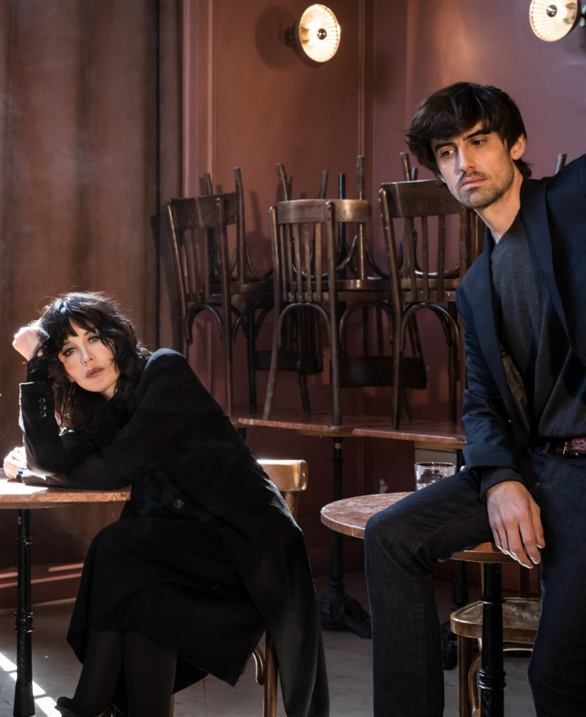
OPENING NIGHT
CYRIL TESTE | FRANCE | AUSTRALIAN EXCLUSIVE
DRAMA THEATRE SYDNEY OPERA HOUSE 21–26 JANUARY
80 MINS
Adapted from the screenplay by John Cassavetes Directed by Cyril Teste
Starring ISABELLE ADJANI, MORGAN LLOYD SICARD,
CYRIL TESTE and the participation of ZOÉ ADJANI

Translation Daniel Loayza
Artistic Collaborator Valérie Six
Dramaturgical Advisor Daniel Loayza, Marion Pellissier
Scenography Ramy Fischler Lighting Design Julien Boizard Original Soundtrack Nihil Bordures
Video Nicolas Doremus, Mehdi Toutain-Lopez Camera Operator Christophe Gaultier Sound Engineer Thibault Lamy
Costumes Agnès b.
Costume Collaboration Katia Ferreira Makeup & Hair [Kelly] Laurence Azouvy Stage Director Assistant Céline Gaudier Technical Manager Simon André
Stage Manager [Leo] Guillaume Allory
Sound Manager Jérôme Castel
Light & Olfactory Manager Rodolphe Villevieille
Video Manager Mehdi Toutain-Lopez
Assistant Eva Jarriau
Executive Producer Nicolas Roux Producer & International Distributor Julie Le Gall - Bureau Colot

ABOUT THE SHOW
Iconic French actress Isabelle Adjani makes her long- awaited Sydney theatrical debut with Morgan Lloyd Sicard and Cyril Teste in a riveting adaption of John Cassavetes’ Opening Night, directed by Cyril Teste, who is recognised as one of France’s most exciting new voices for his signature performance-filmique technique.
In her first major return to the stage, Adjani portrays a famous actress confronting age in a brave performance that mirrors her own life. Teste creates a powerful experiment where he changes stage directions every night to dig deeper into Cassavetes’ brilliant screenplay, and the actors are challenged with each performance.
THANKS
Production Le Quai Centre Dramatique National Angers Pays de la Loire. Coproduction Collectif MxM; Les Célestins – Theatre de Lyon; Bonlieu Scene nationale Annecy; Theatre du Gymnase – Bernardines, Marseille; Theatre de St-Quentin-en-Yvelines, Scene national; Theatre- Senart, Scène nationale; Festival Romaeuropa; Theatre de Namur, La Coop and Shelter Prod with the support of Taxshelter. be, ING and of Tax-shelter of the Belgian federal government. Corealisation C.I.C.T. Théâtre des Bouffes du Nord. With the support of Agnès b., Maison Francis Kurkdjian and Salon Messieurs-Dames.

