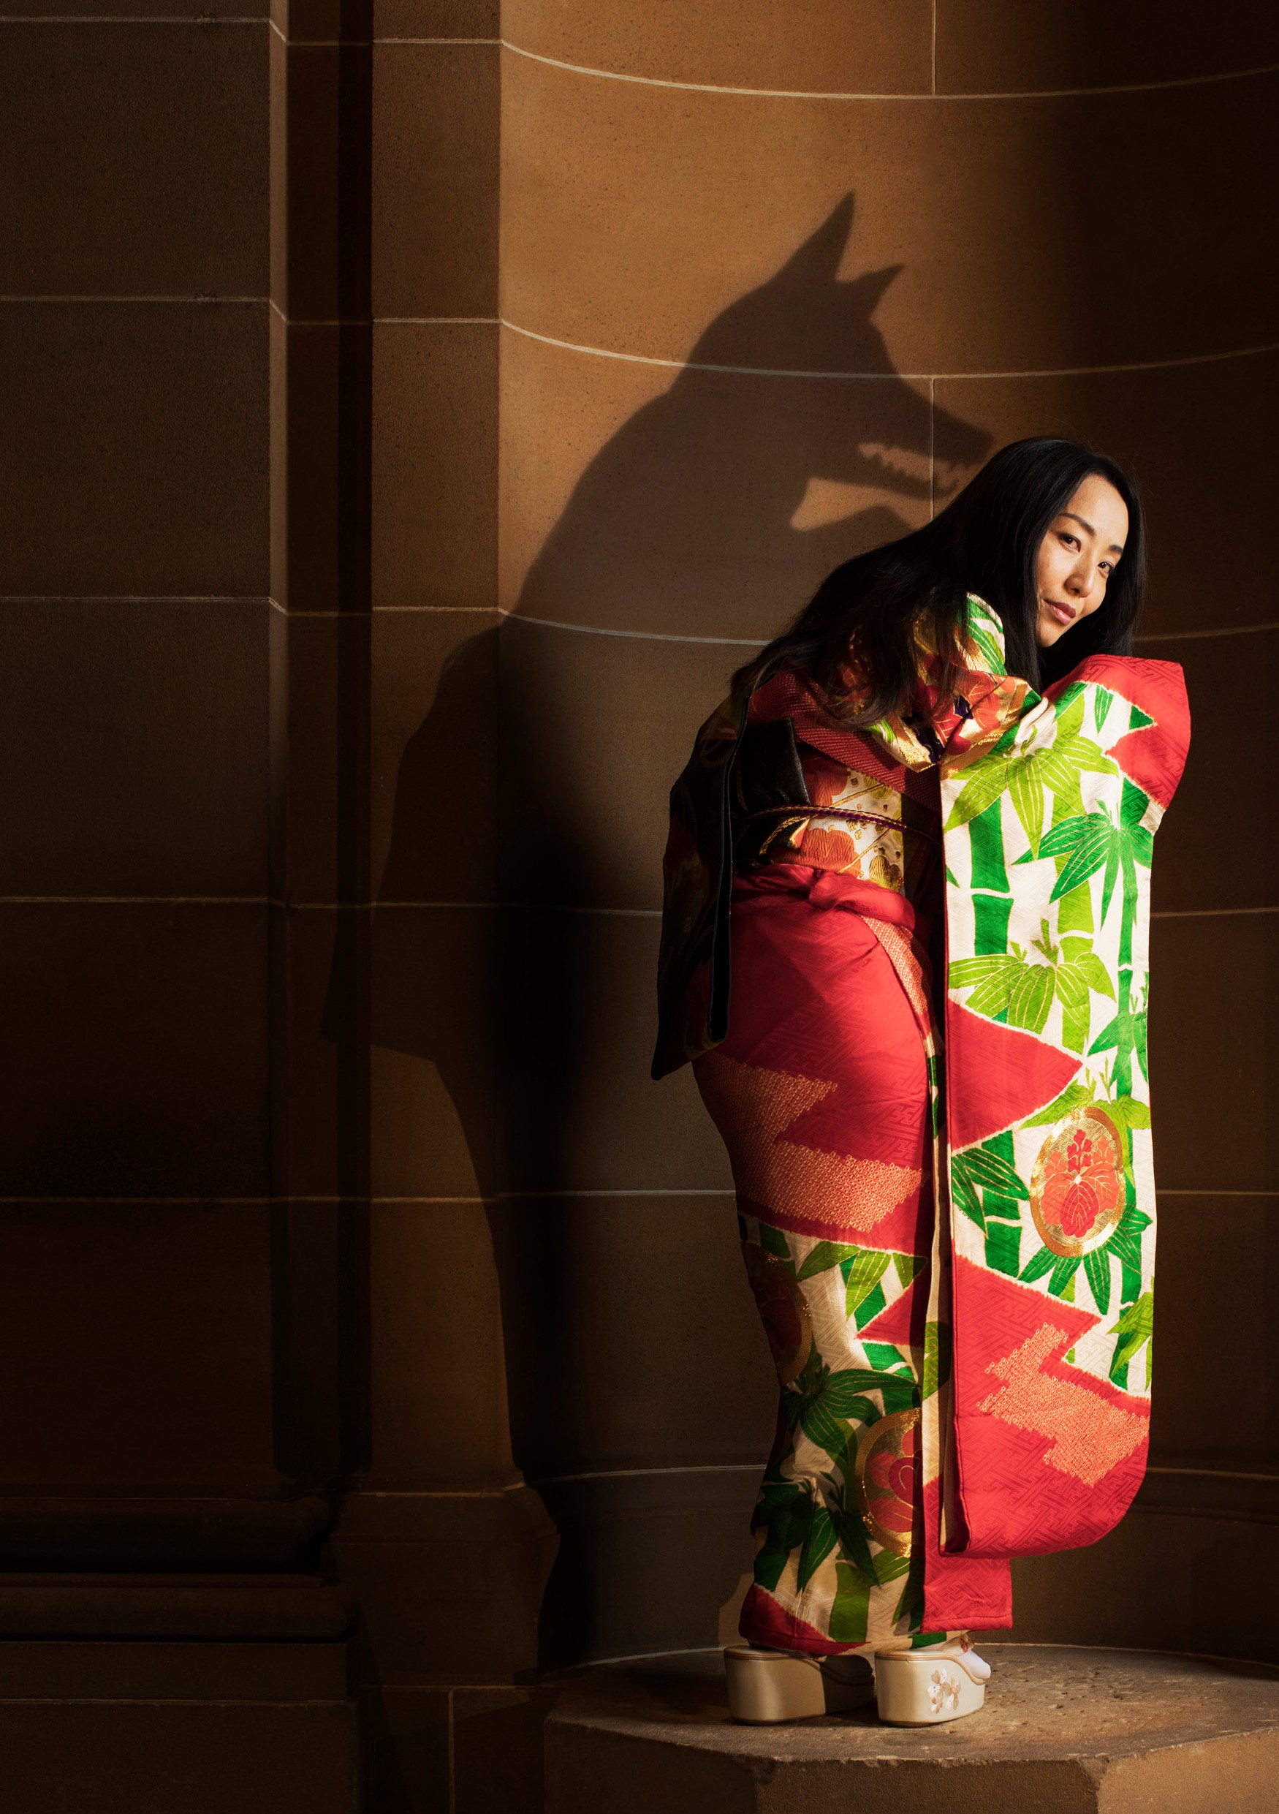

NIGHT PARADE 0F ONE HUNDRED GOBLINS
ART GALLERY OF NSW AND CLOCKFIRE THEATRE COMPANY AUSTRALIA
Photo: Geoff Magee, Brodie Kals

NIGHT PARADE OF ONE HUNDRED GOBLINS

ART GALLERY OF NSW
AND CLOCKFIRE THEATRE COMPANY AUSTRALIA

ART GALLERY OF NSW 16-25 JANUARY
80 MINS

CLOCKFIRE THEATRE COMPANY
Co-Directors/Performers Emily Ayoub, Arisa Yura Devisors/Performers Madeline Baghurst, Ryuichi Fujimura, Alicia Gonzalez
Musician Masae Ikegawa Designer/Devisor Tobhiyah Stone Feller Sound Designer Ben Pierpoint Lighting Designer Martin Kinnane Stage Manager Laura Turner
Makeup Design Natalia Ladyko

ART GALLERY OF NEW SOUTH WALES
Executive Producer Josephine Touma
Creative Producer Yuki Kawakami
Audio Production Steve McMillan, Charles Lawler
Exhibition Curator Melanie Eastburn
In-exhibition Soundtrack Eiko Ishibashi

THANKS AND ACKNOWLEDGEMENTS

This production is made possible by the
generous support of Carole Lamerton, Kiera Grant and Robyn Martin-Weber.
Costume elements kindly provided by MUJI.

Exhibition strategic sponsors

Principal patron and public programs patron

CREATORS’ NOTES
Night parade of one hundred goblins takes its name
from folklore illustrated in scroll paintings by Toriyama Sekien (1712-88) and Itaya Hiroharu (1831-82), two of the first artworks you’ll encounter in our exhibition Japan supernatural.
The story has its origins in a legendary riot of yokai
(shape-shifting creatures) that swarmed the streets of Kyoto after dark. Some versions of the story are playful, some are more ominous – and yokai continue to haunt many aspects
of Japanese cultural life, from Studio Ghibli films to playground games. Clockfire Theatre Company and composer Eiko Ishibashi have created an astonishing contemporary iteration of the Night parade in this production – and it has been
a singular pleasure to bring it to life with them.

Art Gallery of New South Wales

Yokai dwell between realms, a liminal space that is as intriguing as it is unnerving. Night parade of one hundred goblins vividly depicts these creatures of an ‘otherworld’ whose shapeshifting abilities allow for phenomenal transformation. This performance has been crafted in response to artworks that depict yokai and the folktales in which they mischievously parade through the streets after dark.
Artistically, we have sought the existence of yokai in contemporary culture. Their forms shadow our own grotesqueries and absurdities. They include the masterful kitsune (fox), trickster tanuki (racoon-dog), vivid tsukumogami (object monsters) and cucumber-craving kappa (water goblins). This cross-cultural performance draws on elements of Japanese no and European theatre-making practices –
and the in-exhibition component takes its cue from the heady soundtrack composed by Eiko Ishibashi.

Clockfire Theatre Company

ABOUT THE CREATORS
Clockfire Theatre Company creates innovative, highly physical theatre experiences based in the Jacques Lecoq method. Recent works include The natural conservatorium of wise women (Sydney Fringe Festival, 2019) and The grief parlour (Riverside Theatres, Parramatta).
Eiko Ishibashi is a Japanese composer, producer and
singer-songwriter whose work has ranged from acclaimed solo albums to scores for film and television to improvised music. Ishibashi has worked with celebrated local and international artists including Keiji Haino, Merzbow and Jim O’Rourke.

