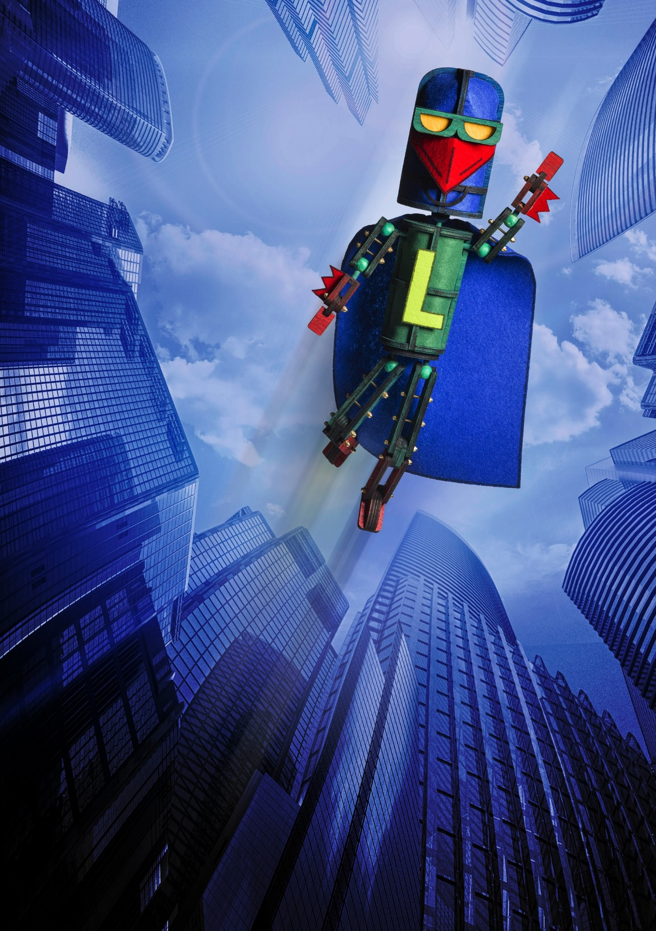

LASER BEAK MAN
DEAD PUPPET SOCIETY, TIM SHARP
& SAM CROMACK (BALL PARK MUSIC) AUSTRALIA
Photo: Dylan Evans

LASER BEAK MAN
DEAD PUPPET SOCIETY, TIM SHARP & SAM CROMACK
(BALL PARK MUSIC) | AUSTRALIA

DRAMA THEATRE SYDNEY OPERA HOUSE 8−12 JANUARY
85 MINS
Writer, Director & Designer David Morton Writer & Creative Producer Nicholas Paine Writer & Original Artwork Tim Sharp Composer Sam Cromack
Designer Jonathon Oxlade Projection Designer Justin Harrison Sound Designer Tony Brumpton Lighting Designer Jason Glenwright
Puppet Fabricators Jennifer Livingstone and Matt Seery Dramaturgs Louise Gough and Todd MacDonald Associate Producer Judy Sharp
Technical Manager Wesley Bluff
Stage Manager Nicole Neil

Assistant Stage Manager and Props Master
Jennifer Livingstone
Sound Engineer Benn Sargood
Head of Lighting Timothy Gawne

Peter Bartman Nathaniel P. Claridad Amazing Grace & Barbie Ellen Bailey Laser Beak Man Drew Wilson
Black Sheep, Ram & Tomato Man Jonathan Riddleberger
Mayor & Chicken Betsy Rosen Leigh Sales Herself (Voiceover) Laser Beak Man & Boar Matt Seery Evil Emily Maren Searle
Vocals, Guitar & Piano Sam Cromack
Drums Daniel Hanson
Guitar, Bass & Vocals Dean Hanson

ABOUT THE SHOW
Ever since we first met him, we’ve been fans of Laser Beak Man: his creator Tim Sharp is a genius. The quirky humour and unrestrained joy in his work offers a unique insight into what it means to be in the world. The adventure we’ve been on together over the last six years has been straight out of a superhero movie: from developments in NYC looking out over Times Square, to assembling a world class team of performers and creatives. The input from all involved has been marked
by constant generosity; from Tim and Judy in sharing their world with us, to the incredible cast and creatives who have brought it to life, and the amazing crew who have made it all a reality. We can’t thank you all enough.

DEAD PUPPET SOCIETY
Dead Puppet Society is a visual theatre and design company working across Australia, London and New York City. They are best known for their works The Wider
Earth (Sydney Festival 2018), Laser Beak Man, Argus and The Harbinger. They have been nominated for a slew of Helpmann Awards and an Olivier Award.

THANKS
A Dead Puppet Society, La Boite and Brisbane Festival production in association with PowerArts.
Original development partners: The New Victory Theater, Queensland Performing Arts Centre, Sydney Opera House, Arts Centre Melbourne, Casula Powerhouse, Australian Government – Department of Communication and the Arts and Australia Council for the Arts, Arts Queensland, Brisbane City Council and Jim Henson Foundation.
Thanks to the Hunt Family Foundation for their support.

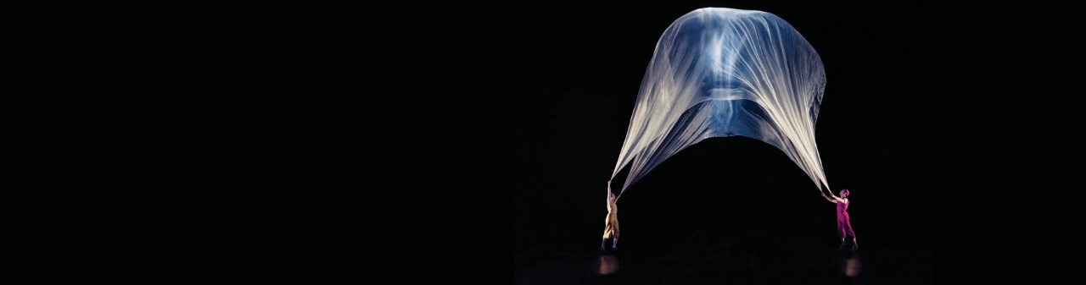
AIR PLAY

21–25 JANUARY
ROSLYN PACKER THEATRE, WALSH BAY
MORE INFO AT SYDNEYFESTIVAL.ORG.AU
“A JOY FROM START TO FINISH”
THE SYDNEY MORNING HERALD
VISUALLY-DAZZLING FAMILY ADVENTURE MAKING PLAYTHINGS OF AIR AND GRAVITY

