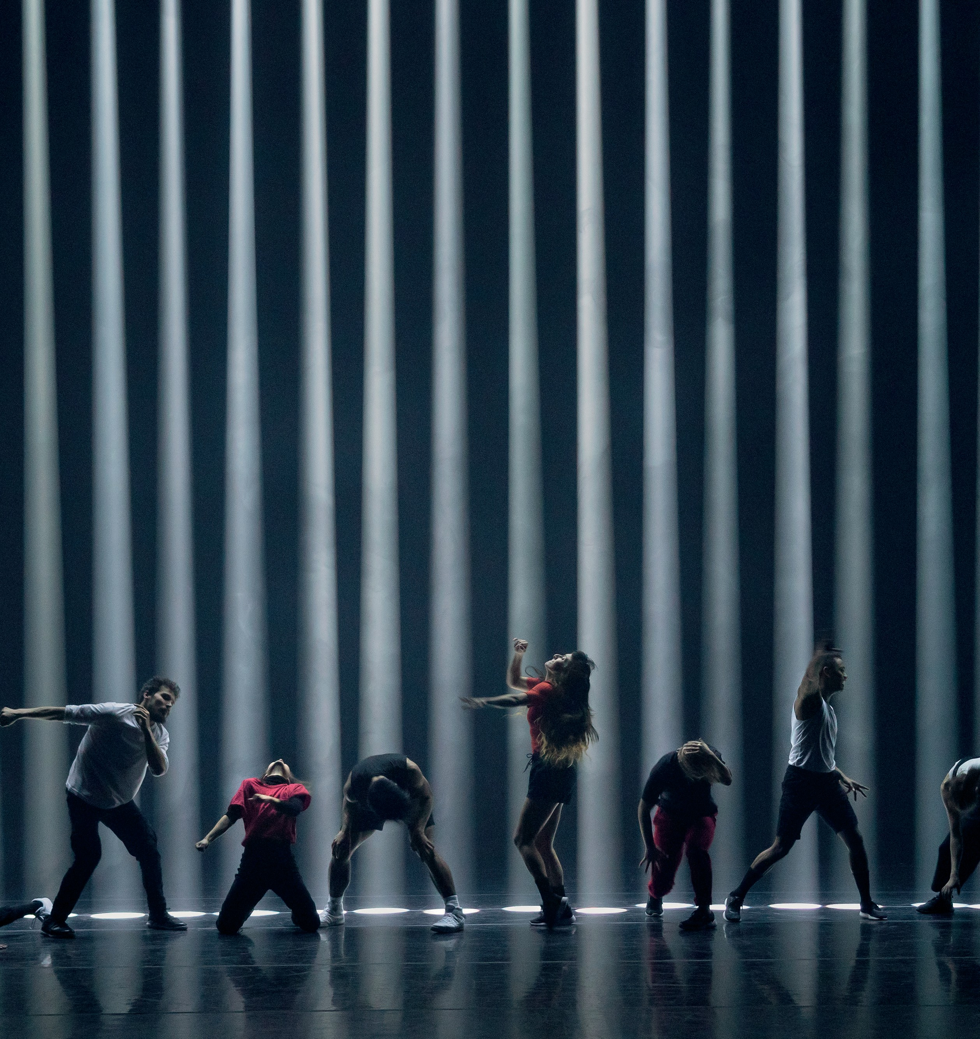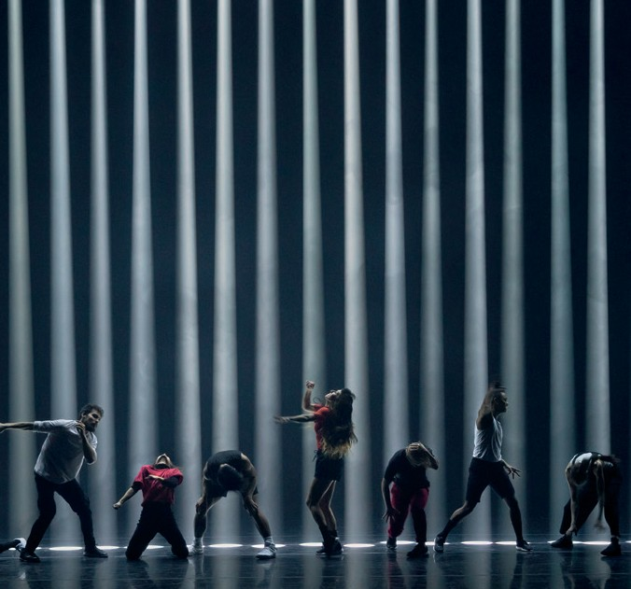

FRONTERA
Photos: Yannick Grandmont
DANA GINGRAS AND ANIMALS OF DISTINCTION CANADA | AUSTRALIAN PREMIERE

FRONTERA

DANA GINGRAS AND ANIMALS OF DISTINCTION CANADA | AUSTRALIAN PREMIERE

CARRIAGEWORKS 8–12 JANUARY
75 MINS

Choreography and Direction Dana Gingras Executive Producer Centre de Création O Vertigo In coproduction with Animals of Distinction

Created with and performed by Robert Abubo, Léna Demnati, Stacey Désilier, Caroline Gravel, Louise Michel Jackson, Justin de Luna, Mark Medrano, Sovann Rochon- Prom Tep, Koliane Rochon-Prom Tep, Lexi Vajda

Visual concept and scenography United Visual Artists
Live Music Fly Pan Am
Field Recordings and Interviews Dave Bryant
Dramaturge Ruth Little
Assistant to the Choreographer and Rehearsal Director Sarah Williams
Costumes Sandra Richefort Producer and Agent Sarah Rogers Stage Manager Annie-Kim Déry
Technical Director Jean-François Piché
Sound Technician Yann Dupuis

Touring crew
Stage Manager Annie-Kim Déry
Tour Manager Dominique Sarrazin Technical Director Jean-François Piché Sound Technician Radwan Ghazi Moumneh

Developed with support from The National Arts Centre’s National Creation Fund

Co-producers Danse Danse (Montréal), Sydney Festival, CTM Festival (Berlin) & PuSh International Performing Arts Festival (Vancouver)
Creation Residencies Centre de Création

O Vertigo (Montréal), Place des Arts (Montréal),
Salle Pierre-Mercure du Centre Pierre-Péladeau (Montréal)
“Borders run across land but through people. On maps they appear as fine one-dimensional lines, whereas on the ground they have many dimensions. Borderlands are boundaries in depth, space around a line, the place where state meets society, and where no one ever feels at home.”
(Zartman, I William, ed. Understanding Life in the Borderlands: Boundaries in Depth and in Motion)

ANIMALS OF DISTINCTION
Animals of Distinction (AOD) is the multimedia dance company of renowned choreographer and dancer Dana Gingras. Through
AOD, Gingras has fostered the creation of numerous cutting-edge works that have involved innovative collaborations across diverse mediums and artistic practices, all shaped by the possibilities of new technologies and cultural shifts.
At the centre of the work is a belief that we can obtain critical knowledge from engaging with the physical and emotional risks inherent to dance and movement. It is through the body and choreography that this element of risk can be employed to explore a vision of the world that is larger than our individual isolated experiences. The goal is to stimulate audiences to become more aware of the elements of complexity, connectivity, and complicity within our physical, social, and emotional lives.
Artistic Direction Dana Gingras Producer Sarah Rogers Administration Stephanie Murphy
Board of Directors Suzanne Hawkes, Patty Jones, Dianne Kennedy, Patricia Kim, Mike Magee, Marie Brassard, Daniel Canty, Karine Denault, Line Nault, Sonya Stefan

animalsofdistinction.org

ACKNOWLEDGEMENTS
Thank you to the following for their openness, generosity and willingness to be interviewed:
- Klavdij Sluban (Slovenian photographer)
- Gabriel Acuna (activist from El Paso, TX)
- Alexis Ipatovtsev (radio journalist from Saint Petersburg)
- Werner Hampl (built one of the first tunnels between East and West Berlin)
- Kate Nolan (photographer from Dublin, Ireland)
- François Le Blond (writer from Paris, active in gay liberation movement in the 1970s)
- Alex Piero (former doctor of psychoanalysis from Rome)
- Cande Andrade (video editor and media designer born and raised in México. He lives in Canada)

THANK YOU
Justin Evans, Beryl and Lionel Gingras, Matthew Clark, Maximo Recio, Lee Sampson, Karine Denault, Claudia Fancello, Laurie-Anne Langis, Sonya Stefan, Cathy Levy, Pierre Des Marais, Caroline Ohrt, Wesley Enoch, Oliver Baurhenn, Joyce Rosario, Clothilde Cardinal, Francine Bernier, Constellation Records, Canada Council for the Arts and the Conseil des Arts et des Lettres du Québec.
A special thank you to dancers Ellen Furey, Esther Rousseau Morin and Paige Culley, who were an integral part of the creation process.

