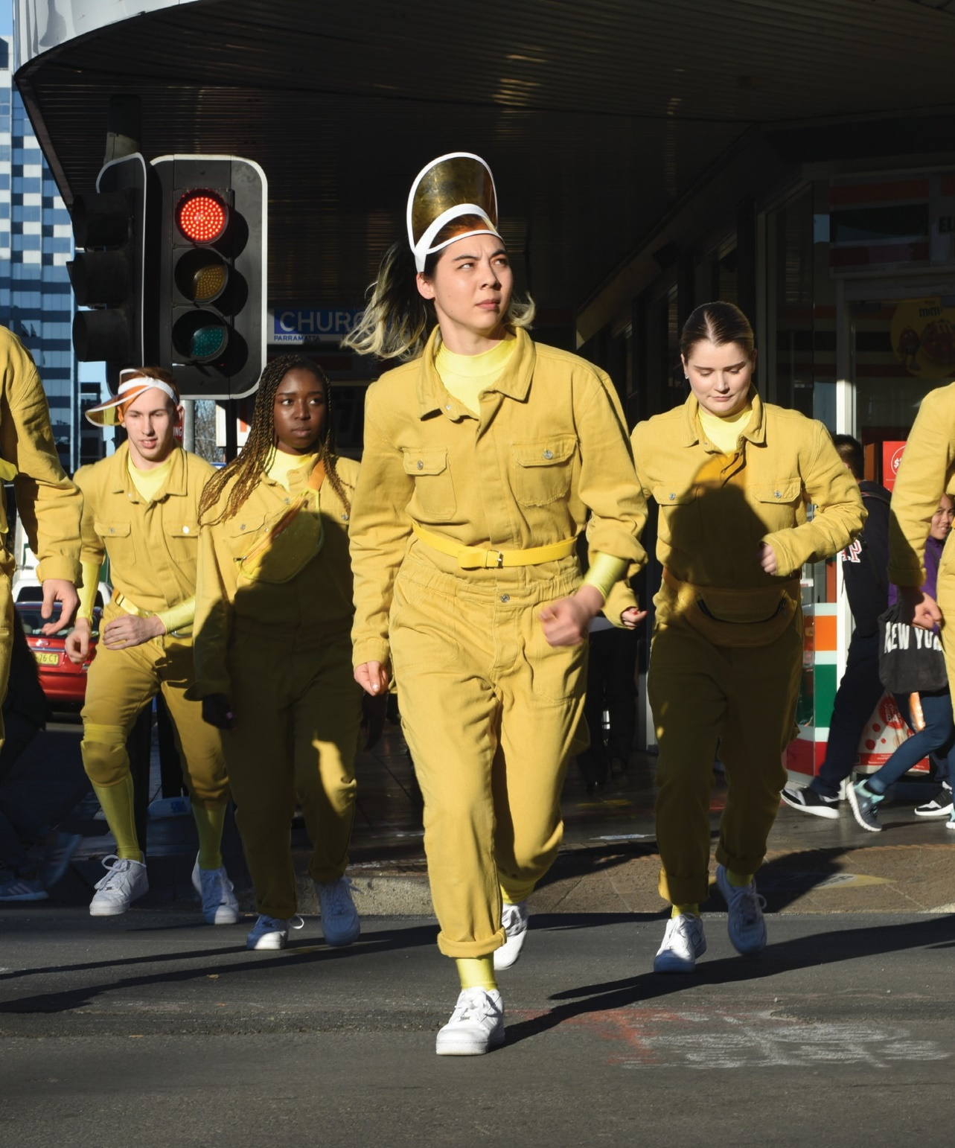
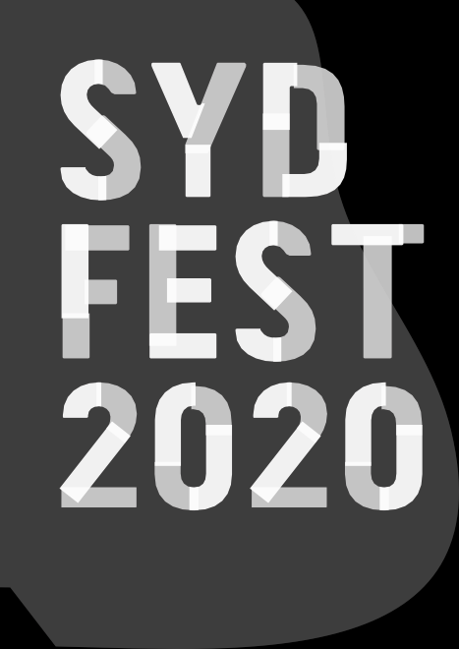

ENCOUNTER

FORM DANCE PROJECTS/SYDNEY YOUTH ORCHESTRAS/
FLING PHYSICAL THEATRE I AUSTRALIA WORLD PREMIERE
Photos: Heidrun Lohr

ENCOUNTER
FORM DANCE PROJECTS/SYDNEY YOUTH ORCHESTRAS/ FLING PHYSICAL THEATRE I AUSTRALIA
WORLD PREMIERE

PRINCE ALFRED SQUARE, PARRAMATTA 10–12 JANUARY
135 MINS

PARK OPENS: 5PM
PRELUDE: 6PM–7PM
ENCOUNTER: 7.10PM–8.10PM

Director Emma Saunders
Choreography In collaboration with dancers Associate Artist Rob McCredie Composers Amanda Brown & Jodi Phillis Orchestrator Jessica Wells
Conductor James Pensini Writer Felicity Castagna Visual Artist David Capra
Western Sydney Dancers Sarah Kalule, Lawrencea Mateariki, Sabrina Muszynski,
Joshua O’Connor, Naomi Reichardt, Feras Shaheen, Caylan Spendlove, Xara Zaineddine
The Fling Company Esme Barker, Ebony Constable, Gabriela Green Olea, Ebony Ryan-Miners, Lara Scrivens, Bodhi Turner, Rory Warne, Luca Yi
Orchestra Western Sydney Youth Orchestra
Spoken Word Pola Fanous
Photography Heidrun Lohr
Video & Trailer Dominic O’Donnell
Production Manager Bec Poulter
Form Executive Producer Annette McLernon
SYO General Manager Mia Patoulios
SYO Artistic Program Manager Katie Garman

ABOUT THE SHOW
You are here in this place where the eels lay down and the cars light up and the McDonald’s M is the biggest moon in the sky.
Parramatta. Summertime. Early in the evening. ENCOUNTER is your invitation to the neighbourhood.
In this en masse, site-specific work of joy, directed by the “formidable” Emma Saunders, ENCOUNTER explores the indomitable spirit of youth and the world they find themselves in. ENCOUNTER was created in collaboration
with award-winning artists and 67 young performers including a 50-piece live orchestra, 16 dancers and a slam poet.
Bring a picnic blanket to the park and warm up with PRELUDE, a rotating showcase of short performances by local dance revolutionaries and community dance leaders. Artists include flamenco diva Pepa Molina; Bharatanatyam dancer Aruna Gandhi; Polynesian Cook Islanders Pacific Dreams; Feras Shaheen and his Dabke dancing mother, Diane Busuttil’s Feisty Femmes; Forge Tap Quartet; the rocking contemporary Dance Makers Collective; and international Sharp Short Dance alumnus Billy Keohavong.

CREATOR’S NOTE
ENCOUNTER explores the simplicity of dance and the complexity of choreography. It’s trying to reflect who’s in it, rather than just my own vision. I have steered our creative process to be respectful to the breadth of each of our lives, ages, backgrounds and dancing experiences. We have responded, merged and created new ways of moving that reflect, at times, a communal body, and at other times the individual nuances we bring to our dancing. Dance is an abstract art form and ENCOUNTER positions itself front and centre on the spectrum of densely choreographed movement sequences through to open-ended, installation-based passages that open our senses to the site we find ourselves in. This outdoor business is something to behold – it’s yours, it’s mine, it’s free and it’s ours to revel in. Enjoy!
Emma Saunders, Director

COMPANIES
FORM Dance Projects is a dynamic presenter and producer of dance, based in Parramatta, Western Sydney, rigorously supporting independent dance artists and developing audiences for Australian contemporary dance. ENCOUNTER is commissioned and produced by FORM Dance Projects and supported by Sydney Youth Orchestras, offering orchestral
training excellence to young musicians living locally, and FLING Physical Theatre, a youth dance organisation based in Bega, NSW, empowering young regional artists.

