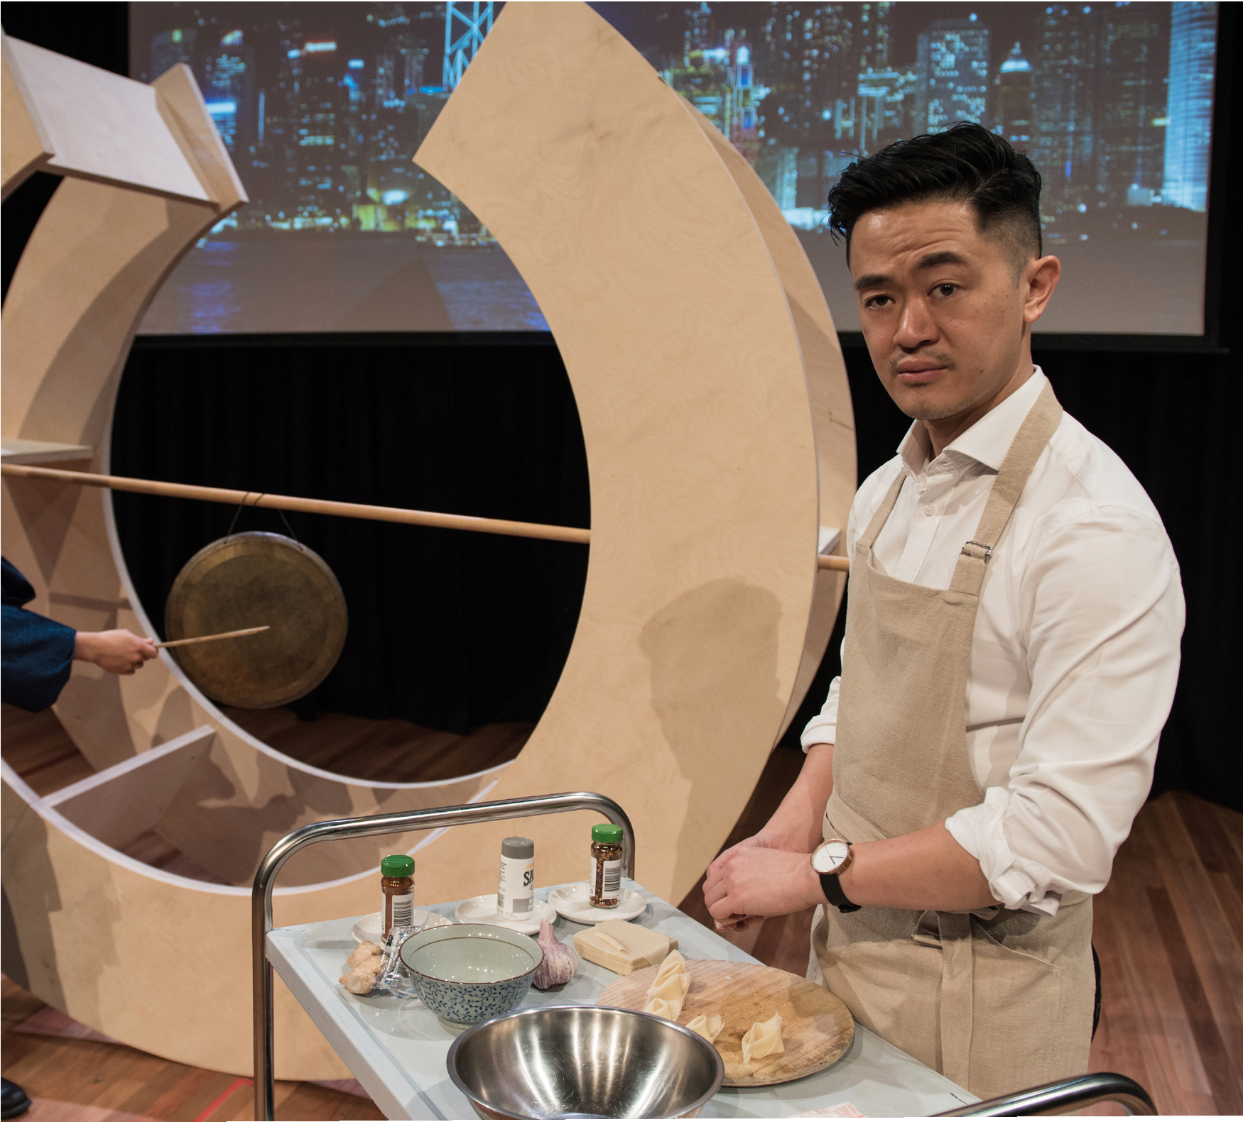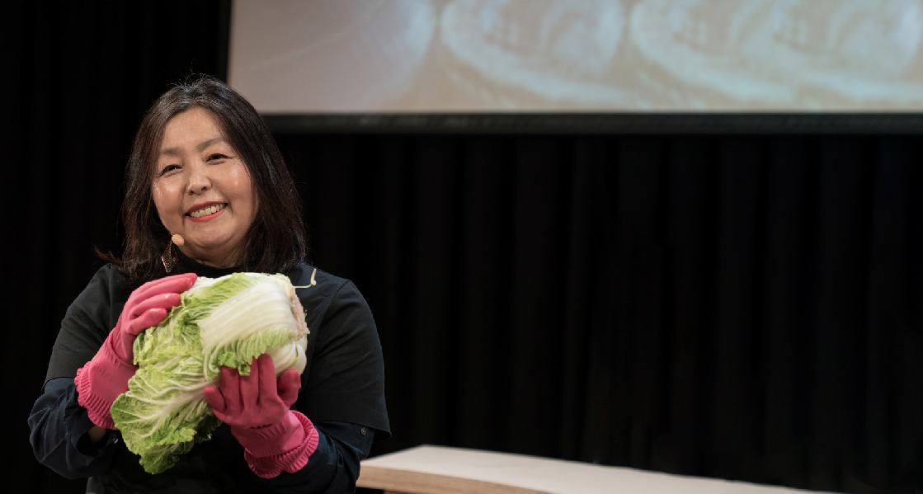

DOUBLE DELICIOUS
Photos: Courtney Stewart, Ashley de Prazer & Alison Laird.
CONTEMPORARY ASIAN AUSTRALIAN PERFORMANCE AUSTRALIA | WORLD PREMIERE

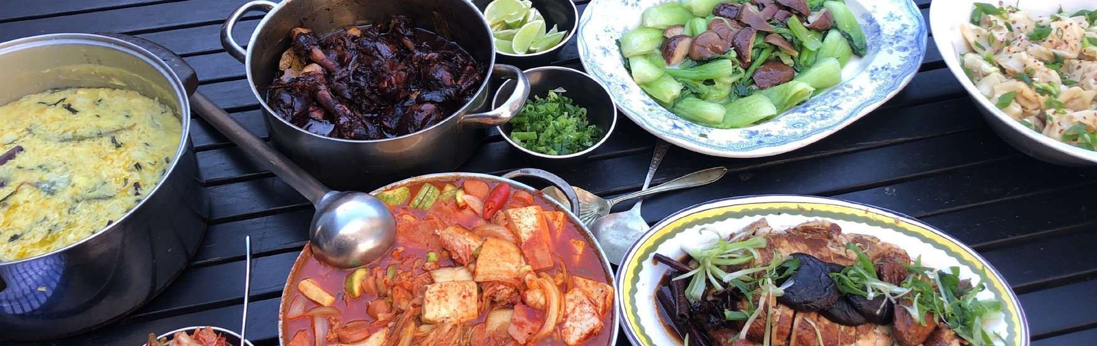DOUBLE DELICIOUS

CONTEMPORARY ASIAN AUSTRALIAN PERFORMANCE AUSTRALIA | WORLD PREMIERE

CARRIAGEWORKS 8–12 JANUARY
100 MINUTES. NO INTERVAL.

STORYTELLERS
Valerie Berry Elizabeth Chong Raghav Handa Heather Jeong Benjamin Law

CREATIVE TEAM
Director Darren Yap
Original Concept & Dramaturge Annette Shun Wah
Assistant Director Courtney Stewart
Set & Costume Designer Leocampo Yuen Hon-Wai Sound Designer/Composer & Musician Nicholas Ng Lighting & Projection Designer Verity Hampson Production Manager Neil Simpson
Stage Manager Patrick Howard
Chef Christine Ware

CONTEMPORARY ASIAN AUSTRALIAN PERFORMANCE
Executive Producer Annette Shun Wah
Administration Co-ordinator Jules Orcullo
CAAP Committee Elaine Chia, Ien Ang, Karilyn Brown, Gary Williams, Simon Chan, Linly Goh, Courtney Stewart and William Yang

ABOUT THE SHOW
Food is central to so many important moments in our lives – it’s a natural entrée to stories that are enthralling, insightful, and illuminating. In a stimulating experience for the senses, stellar storyteller-cooks Benjamin Law, Elizabeth Chong, Valerie Berry, Raghav Handa and Heather Jeong reveal their stories and the secrets of their dishes. Listen as they tell intimate, affecting tales while slicing, stirring and serving personally
and culturally significant cuisine.

CONTEMPORARY ASIAN AUSTRALIAN PERFORMANCE
Contemporary Asian Australian Performance (CAAP) is the only professional arts company dedicated to making exceptional contemporary Asian Australian work for all audiences. They engender greater cultural diversity in Australian performing arts by producing cross artform theatrical works of the
highest quality, in partnership with major festivals and flagship companies. CAAP is committed to developing, nurturing and championing Asian Australian artists to take their place on main stages nationally and internationally.

THANKS
Thanks to Flour Drum for catering advice and support.
Image of Elizabeth Chong as Black Satin Chicken courtesy of Darren Centofanti.
Double Delicious is supported by the Carriageworks 2019 In Development Program and assisted by the Australian
Government through the Australia Council for the Arts, its arts funding and advisory body. CAAP is supported by the NSW Government through Create NSW.

