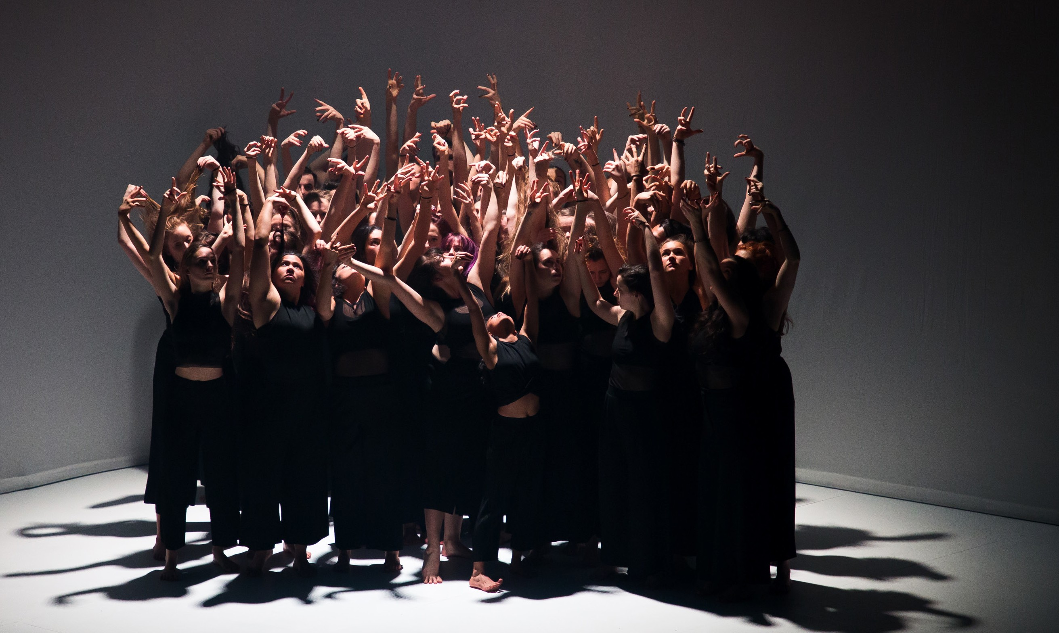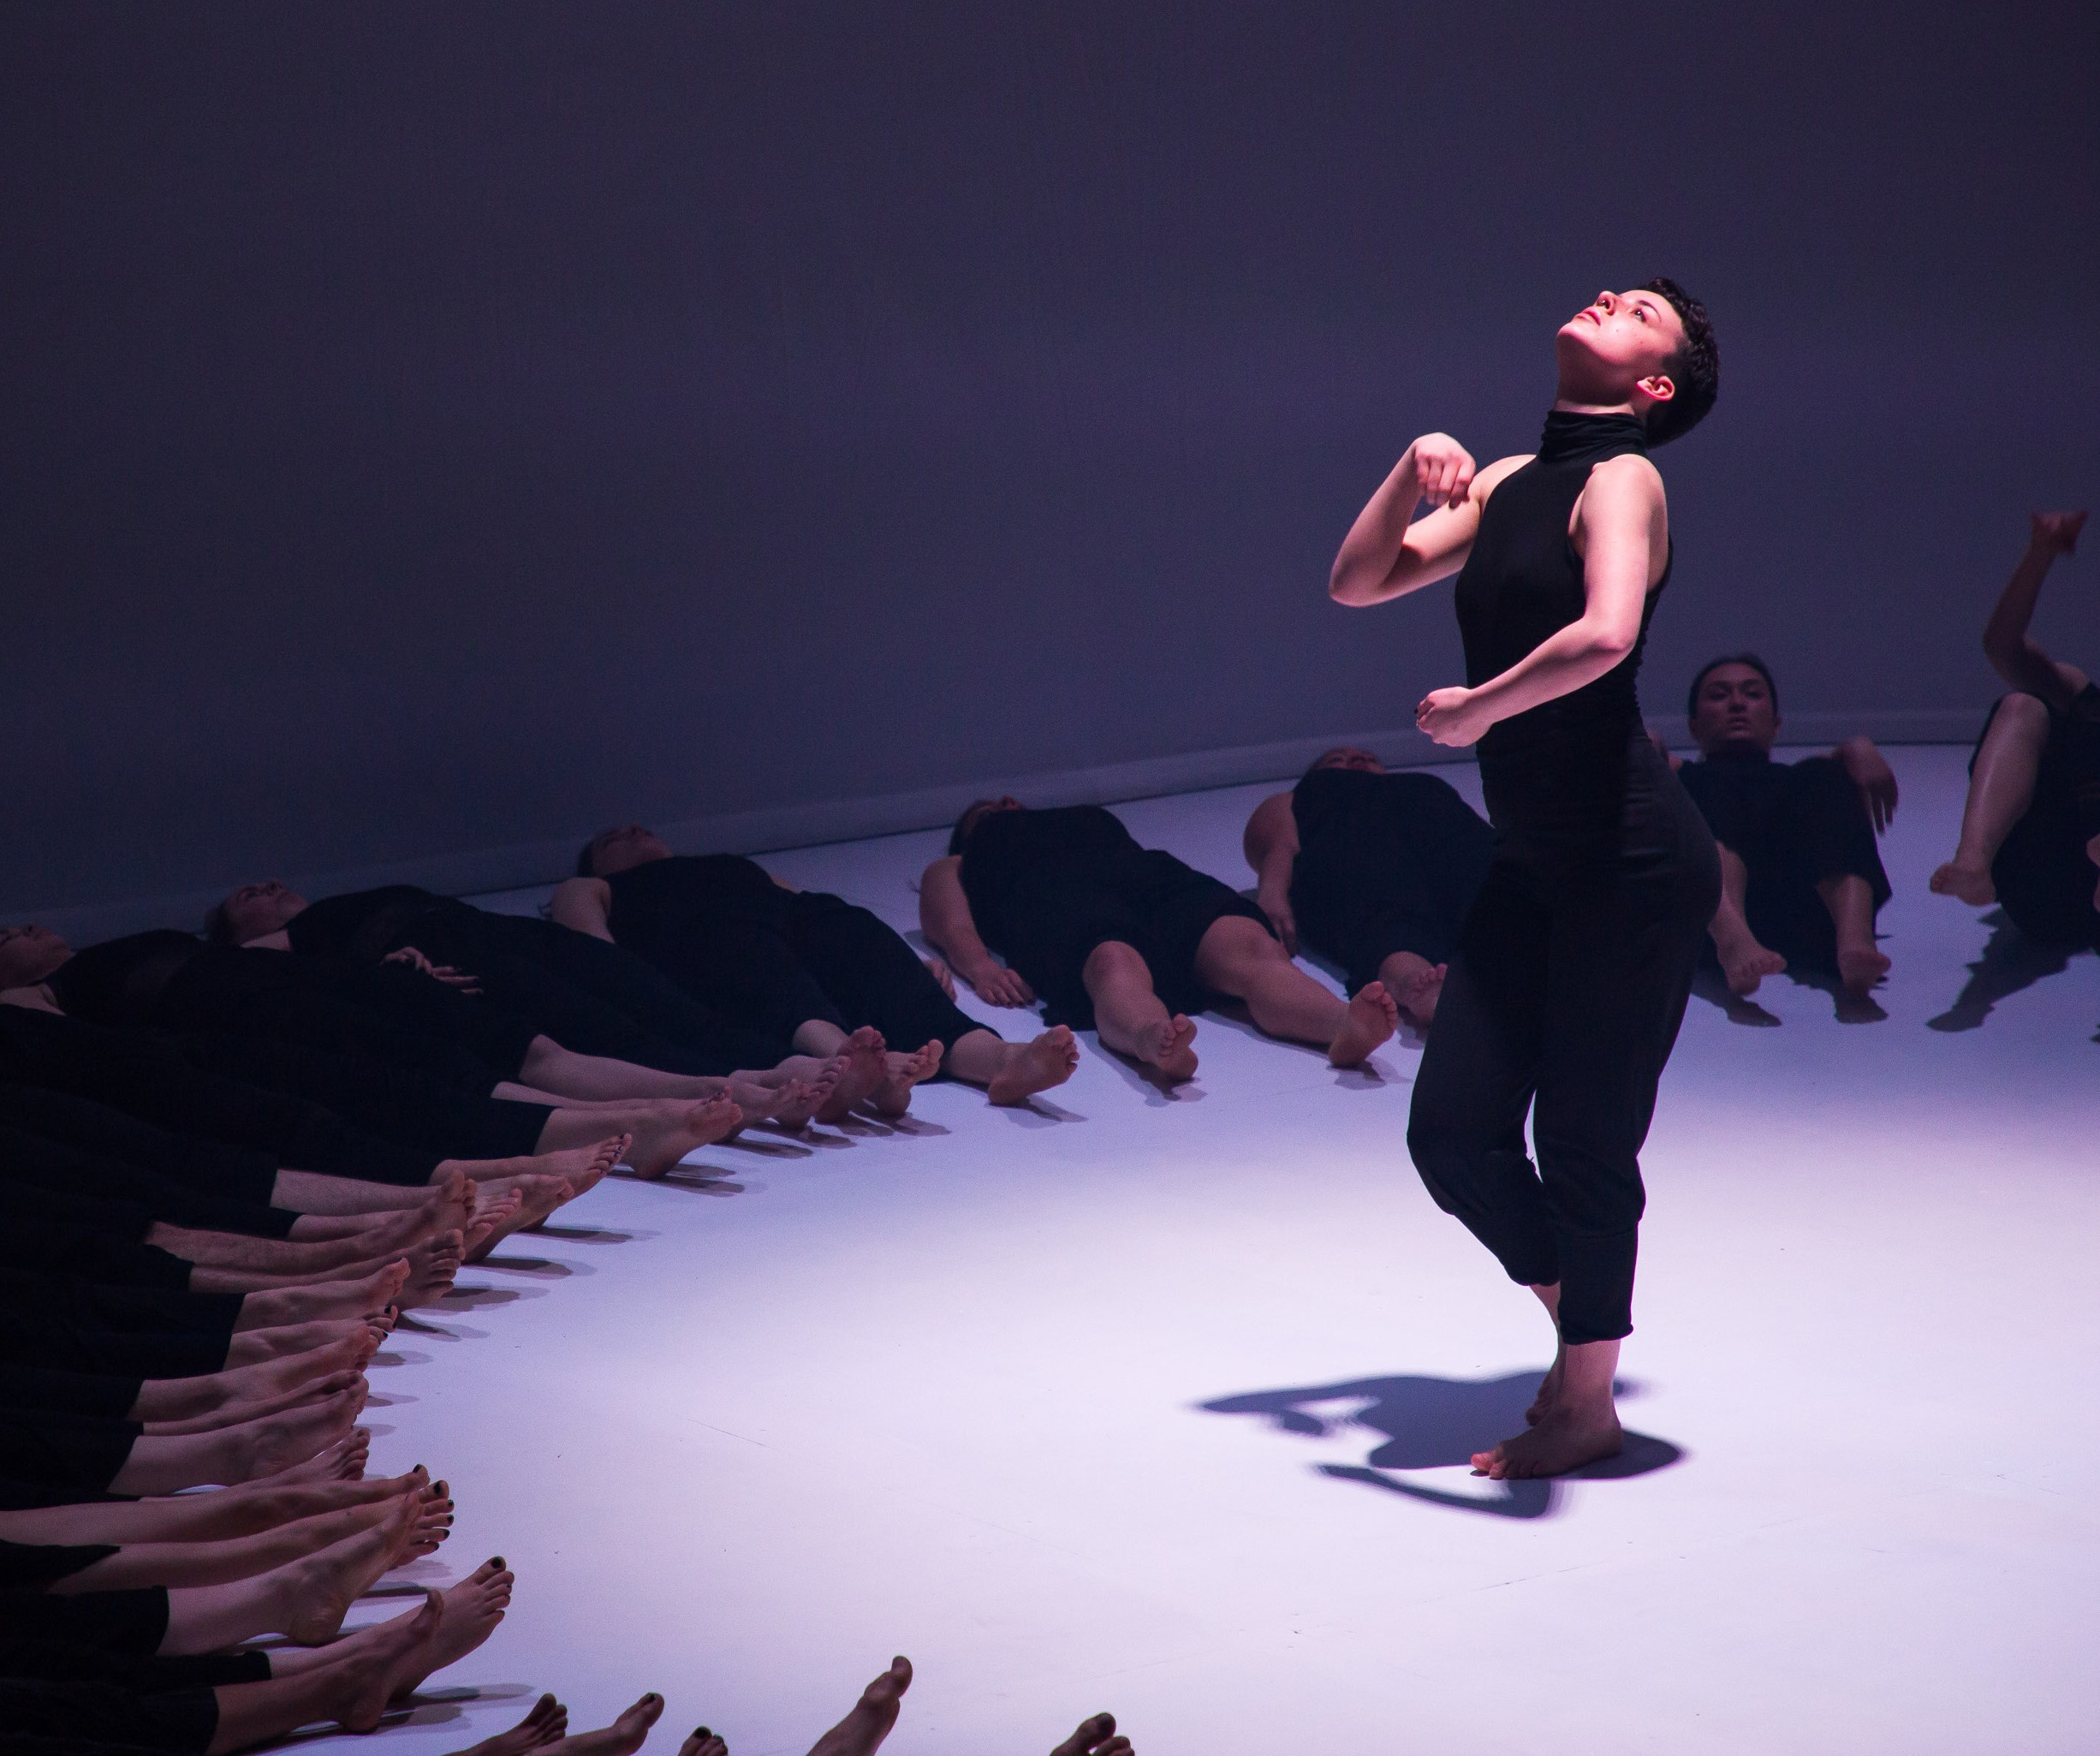
Photos: Mark Gambino

COLOSSUS
STEPHANIE LAKE COMPANY | AUSTRALIA

COLOSSUS

STEPHANIE LAKE COMPANY | AUSTRALIA

CARRIAGEWORKS 16–19 JANUARY
50 MINS

Choreographer Stephanie Lake Composer & Sound Designer Robin Fox Lighting Designer Bosco Shaw Costume Designer Harriet Oxley
Dance Assistants Marni Green, Sarah McCrorie
Technical Manager Robert Larsen Production Manager Glenn Dulihanty Production Consultant Emily O’Brien Executive Producer Claire Bradley Duke

Dancers

ABOUT THE SHOW
Are our societies, crowds and social networks more than simply collections of individuals? Colossus demonstrates the power of many. It fills the theatre with a heaving throng of fifty dancers, moving in intricate unison and wild individuality. Colossus presents a mass of human bodies, but its epic scale also extends beyond the human, with its movements echoing the patterns and systems of nature. Exploring both the beauty and ugliness of the collective experience, Colossus builds and rebuilds towards a united, dizzying finale.

STEPHANIE LAKE COMPANY
Stephanie Lake Company is a multi-award-winning contemporary dance company based in Melbourne. Known for a gutsy, original choreographic style and striking visual aesthetic,
Stephanie Lake Company strives to create performances that are affecting and relevant. Working in collaboration with Australia’s leading dancers and designers, the company has
been presented in major festivals and venues around Australia and has toured internationally to France, Germany, Hong Kong, Denmark, Singapore and the UK.
Artistic Director Stephanie Lake won the Australian Dance Award in 2018 (Pile of Bones) and 2014 (AORTA) for Most Outstanding Choreography, the Helpmann Award for Outstanding

Bjorn Aslund Alessia Augello Grace Baird David Biondi-Odo Kirsty Campbell Olivia Castagna Imogen Chen
Chase Clegg Robinson Sabine Crompton-Ward Holli Di Nardo
Lucy Doherty Franky Drousioti Eugénie English Poppy Geldart Lillian Grant Olivia Hadley Soleil Harvey
Tegan Jeffrey-Rushton Amy Jordan
Alec Katsourakis Bree Kelly
Tom Kennedy Emalyn Knight
Hosken MacFarlane Daniel Mateo Elayna Moens Callum Mooney Anja Mujic Maddison Paluch Angus Parent Candy Park Roselyn Pasia
Neve Pierce Kristie Pike Remy Rochester Opal Russell Brianna Shahin
Lucianna Spackman Maycie Spry Jasmine Susic Jessica Tonkin Rachel Trent
Emma-Jane Tuck Georgia Van Gils Laura Vlasic Claudia Willimann
Choreography in 2014 (A Small Prometheus) and the Green Room Award for Best Choreography (Mix Tape) in 2011. She is currently the recipient of the Australia Council Fellowship for Dance and a past recipient of the Sidney Myer Creative
Fellowship and the Peggy Van Praagh Choreographic Fellowship. The company collaborates across theatre, film, music and visual art and has created several large-scale projects for over one thousand participants.
Stephanie Lake’s work is supported by the Australia Council for the Arts, Creative Victoria, City of Melbourne and the Sidney Myer Foundation and by generous individual donors. stephanielake.com.au

THANKS AND ACKNOWLEDGEMENTS
Stephanie Lake Company would like to thank the following people for their valued contribution to the work: the brilliant cast of dancers and the entire creative and production team; Sydney Dance Company for a generous studio residency; Linda
Gamblin, Rafael Bonachela, Dominic Chang, Lisa Bowmer, Sarah Boulter, Paula Steeds-Huston and Craig Bary; huge thanks to our Colossus Champions Circle of major donors - Linda Herd, Michael and Silvia Kantor and Anonymous; also to our valued donors Barry and Deborah Conyngham, Colin and Christine
Fox, Chloe Munro and Anonymous; Arts Centre Melbourne and Melbourne Fringe for commissioning Colossus through the Take Over Program, 2018; Monica Lim and Konfir Kabo, and John and Lorraine Bates, for their generous donations to Take Over 2018; Daniel Clarke, Simon Abrahams, Michaela Coventry and Gideon Obarzanek for their support of the original production; the entire original Melbourne cast of Colossus, Transit Dance and the Victorian College of the Arts; the Australian Cultural Fund; Creative Partnerships Australia; Wesley Enoch, Vivia Hickman and the entire Sydney Festival team.

