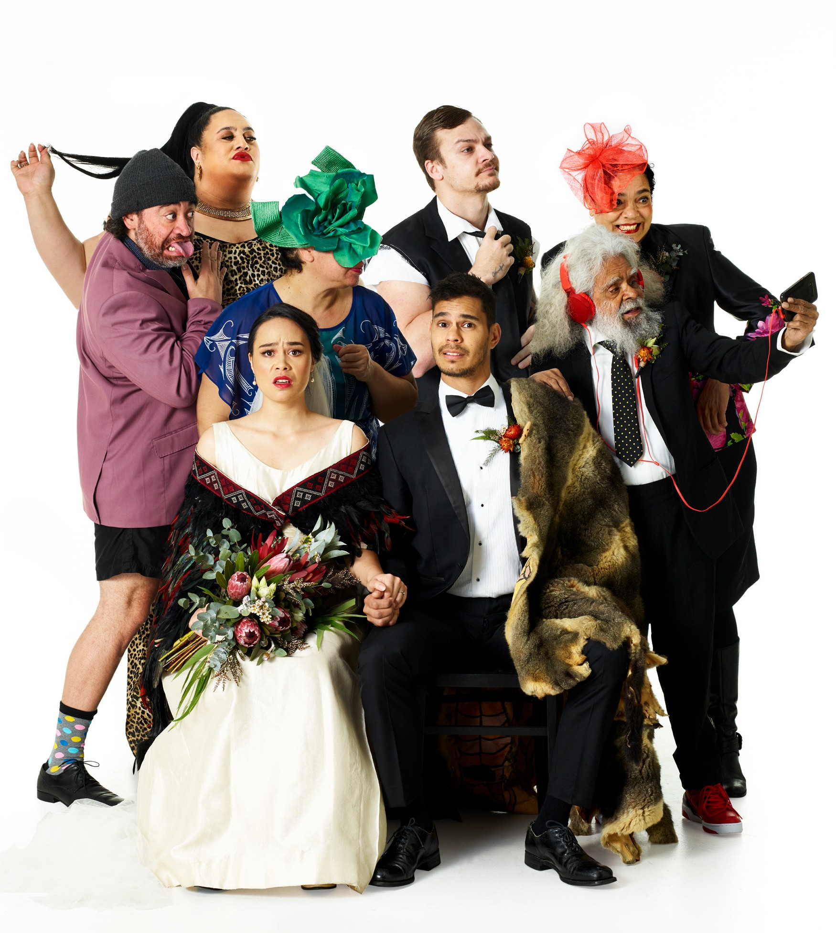

BLACK TIES

ILBIJERRI THEATRE COMPANY AND
TE RE-HIA THEATRE | AUSTRALIA
AND AOTEAROA/NEW ZEALAND WORLD PREMIERE SEASON
Photo: Garth Oriander

BLACK TIES
ILBIJERRI THEATRE COMPANY AND TE RĒHIA THEATRE | AUSTRALIA AND AOTEAROA/NEW ZEALAND WORLD PREMIERE SEASON
SYDNEY TOWN HALL 10–18 JANUARY
150 MINS INCLUDING INTERVAL

Written by John Harvey & Tainui Tukiwaho Directed by Rachael Maza & Tainui Tukiwaho

Set Design Jacob Nash
Composition & Musical Direction Brendon Boney
Lighting Design Jane Hakaraia AV Design James Henry Sound Design Laughton Kora
Costume Design Te Ura Hoskins

PERFORMERS
Jack Charles Mark Coles Smith Lana Garland
Tawhirangi Macpherson Lisa Maza
Tuakoi Ohia Brady Peeti Tainui Tukiwaho Dalara Williams Dion Williams

BAND
Brendon Boney Mayella Dewis Laughton Kora
Producers Nina Bonacci, Amber Curreen, Laila Thaker
Production Manager Nick Glen
AV Mentor Sean Bacon
Audio Engineer Jake Luther
AV Operator Sean Bacon, James Henry
Stage Manager Casey Norton
Assistant Stage Manager Nazaree Dickerson
Company Manager Jamara Maza Technical Consultant Paul Lim Design Assistant Hannah Murphy

ABOUT THE SHOW
Two families, two cultures... too much!
For Maori corporate hotshot Hera and Aboriginal consultancy entrepreneur Kane, it was love at first sight. Ambitious and career focused, Kane and Hera have their perfect future all mapped out. But there is one thing they can’t control… their families!
As the biggest mob get worked up for the blackest wedding ever, reality is sinking in. Fast! Will this international love story bring two strong cultures together? Or will it blow Hera and Kane’s world apart?

ILBIJERRI THEATRE COMPANY
ILBIJERRI Theatre Company is Australia’s longest established First Nations theatre company. ILBIJERRI creates, presents and tours powerful and engaging theatre creatively controlled by First Nations artists that gives voice to culture.

TE RE–HIA THEATRES
Established in 2012, Te Re-hia Theatre is a proudly
Ma-ori theatre company, championing Ma-ori playwrights, tikanga Ma-ori arts practice and the presentation of
diverse stories.

THANKS AND ACKNOWLEDGEMENTS
Original concept developed by: Kamarra Bell Wykes, Albert Belz, Amber Curreen, John Harvey, Rachael Maza & Tainui Tukiwaho.
Special thanks to the Turnbull Foundation for their support, and to the following collaborators who contributed to the creative developments for BLACK TIES: Nelson Baker, Suri Bin Saad, Mark Coles Smith, Erina Daniels, Kristel Kickett, Miriama McDowell, Jennifer Medway, Ngaire Pigram, Jarod Rawiri, Melodie Reynolds, Rickylee Russell-Waipuka, Iain Sinclair, Regan Taylor, Maria Walker & Tyler Wilson-Kokiri.
Special thanks also to: Stephen Armstrong from AsiaTOPA for his faith and support from the very beginning; Wesley Enoch for his unwavering guidance and support; Louise Gough, Laura Milke-Garner, Tame Iti, Toi Iti and
Te Rewarewa Marae.

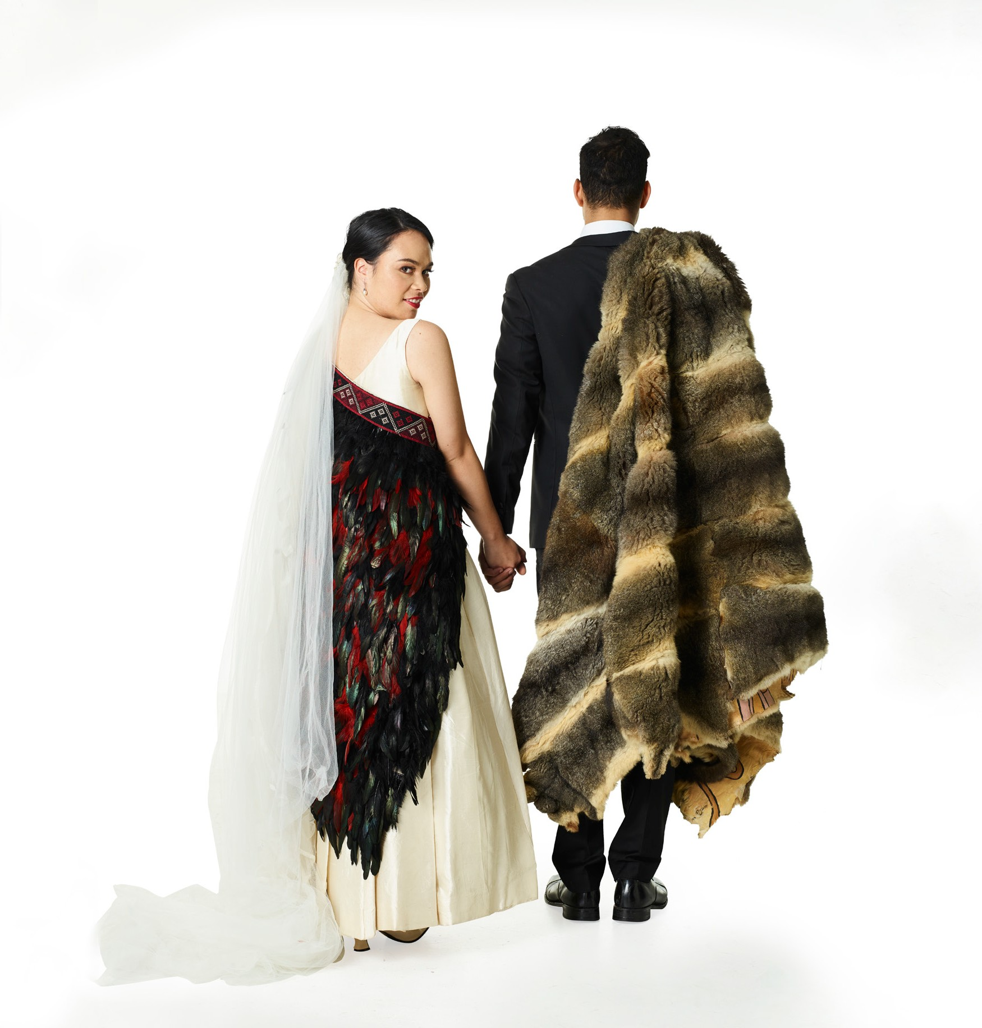
BLACK TIES was commissioned by AsiaTOPA, a joint initiative of the Sidney Myer Fund and Arts Centre Melbourne; and has been assisted by the Australian Government’s Major Festivals Initiative, managed by the Australia Council, its arts funding and advisory body, in association with the Confederation of Australian International Arts Festivals Inc., Sydney Festival, Perth Festival, New Zealand Festival of the Arts, Auckland Arts Festival, AsiaTOPA Festival and Brisbane Festival. BLACK TIES is also supported by Creative New Zealand and The Wilin Centre for Indigenous Arts & Cultural Development. ILBIJERRI Theatre Company is assisted by the Australian Government through the Australia Council, its arts funding and advisory body, and by Creative Victoria and City of Melbourne.
ILBIJERRI Theatre Company and Te Re-hia Theatre Company acknowledge and pay respect to the Country that we travel through and share stories on. We acknowledge and pay our respects to the Traditional Owners, Elders, Ancestors, and young leaders. We acknowledge, with full respect,
the strength of First Nations people and communities, continuing to practice culture, and connection to Country. We acknowledge, with full respect, the power and excellence of First Nations people and communities fighting to protect and look after Country, Community, Language and Lore, in the face of ongoing colonial interruptions
and cultural genocide. Always was, always will be, sacred Indigenous land.

ALSO A
T

THEATRE

OPENING
NIGHT
CYRIL TESTE | FRANCE | AUSTRALIAN EXCLUSIVE

DRAMA THEATRE SYDNEY OPERA HOUSE 21–26 JANUARY
FROM $49 + BOOKING FEE
“AN ELEGANT, STREAMLINED STAGE REMIX”
THE NEW YORK TIMES

BOOK NOW SYDNEYFESTIVAL.ORG.AU

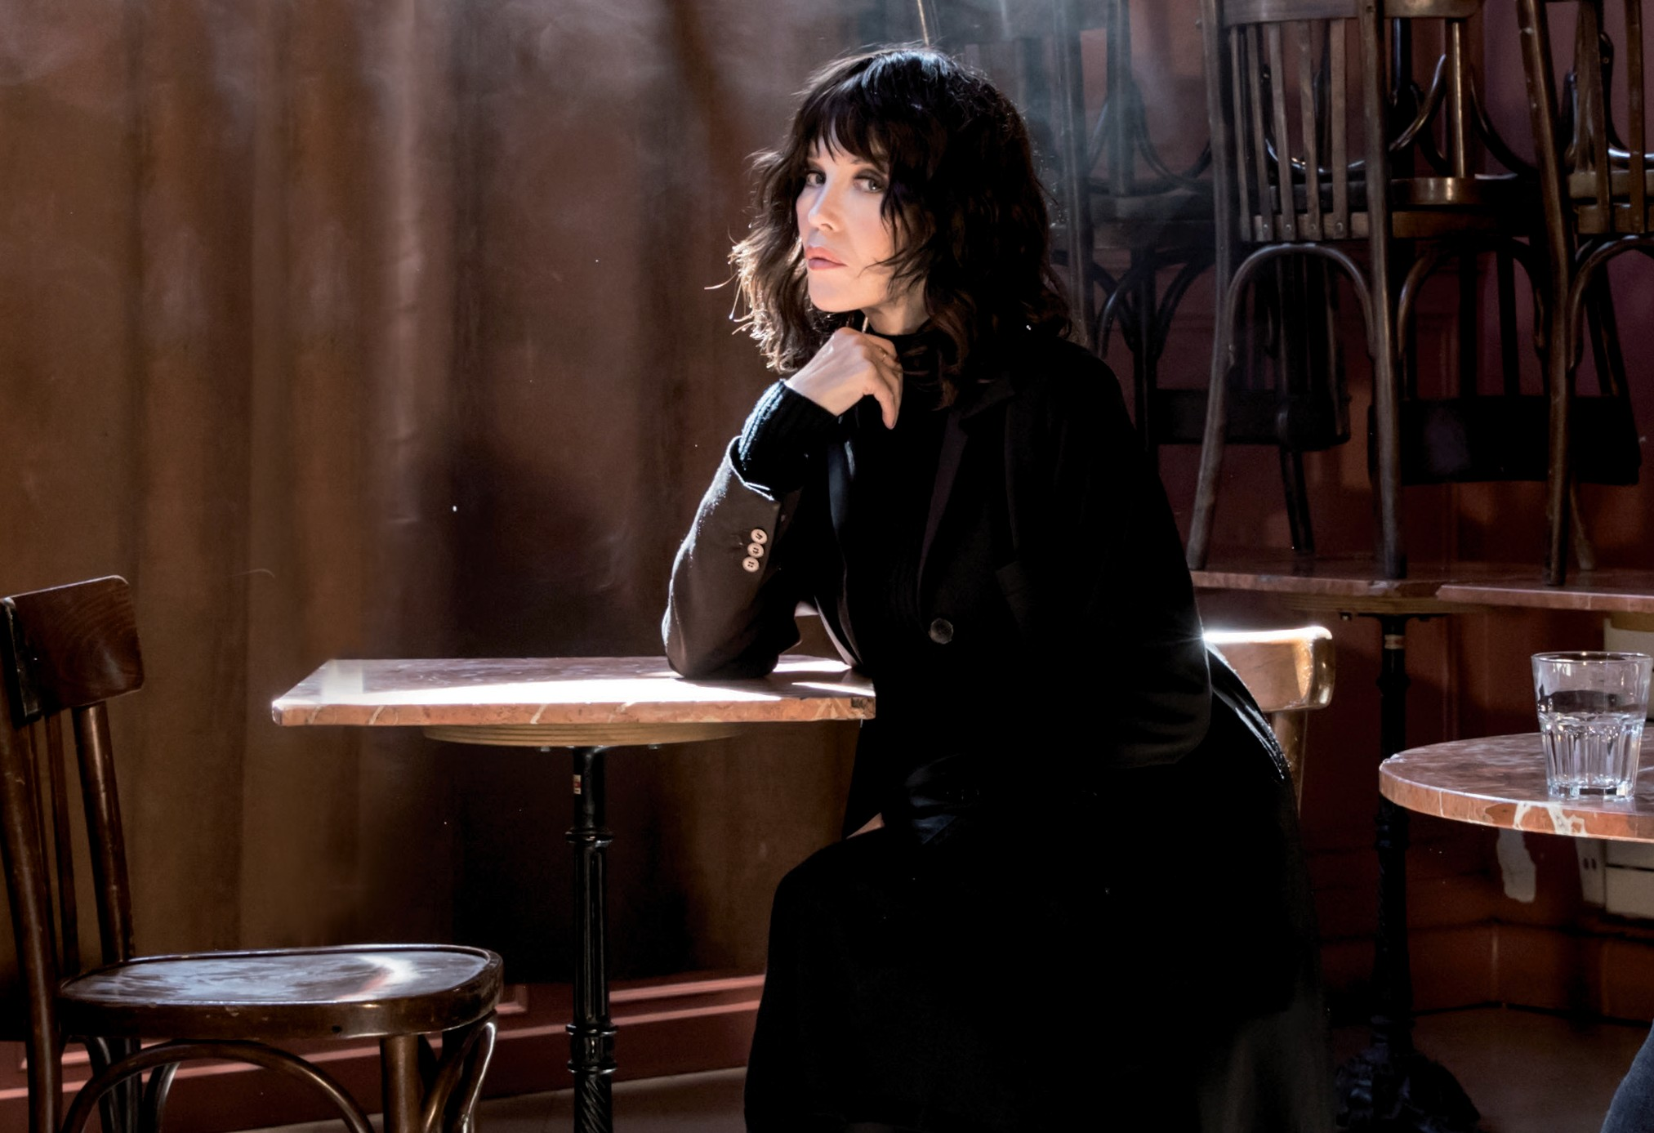CABARET
“NOTHING SHORT OF STUPENDOUS”

COURIER MAIL

LIFE –
THE SHOW
STRUT & FRET PRODUCTION HOUSE | AUSTRALIA

MAGIC MIRRORS SPIEGELTENT HYDE PARK
8–26 JANUARY
FROM $70 + BOOKING FEE

