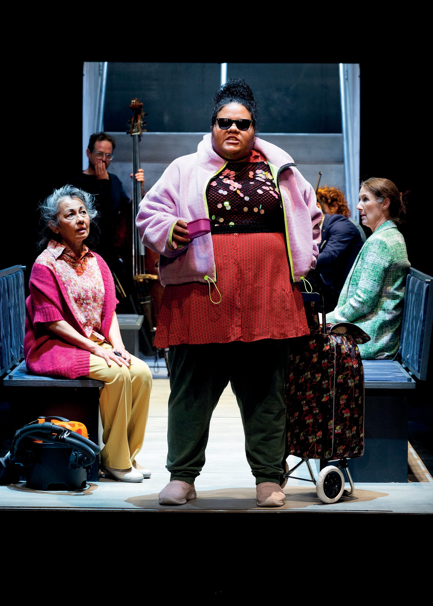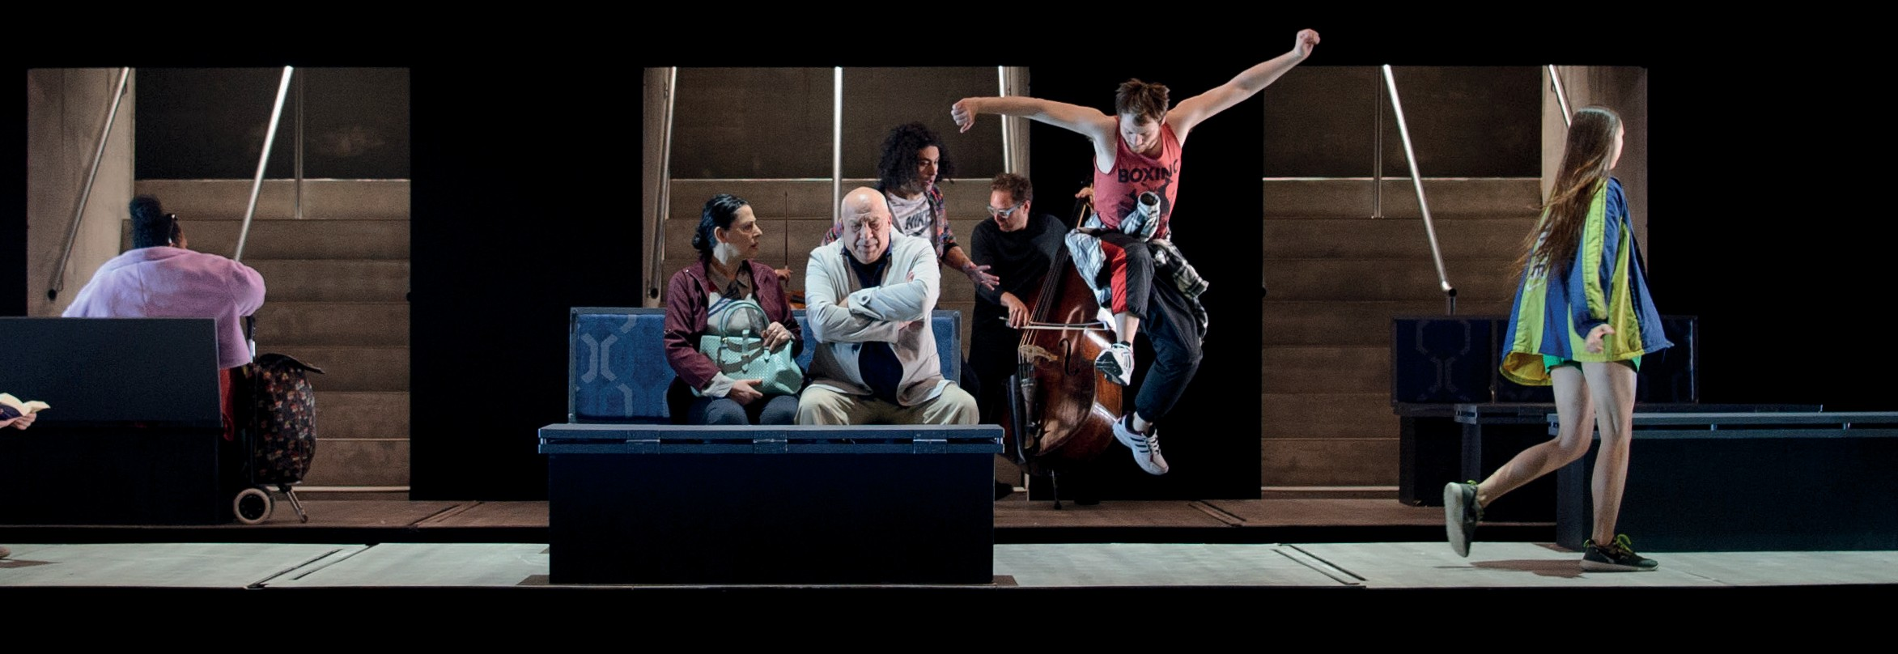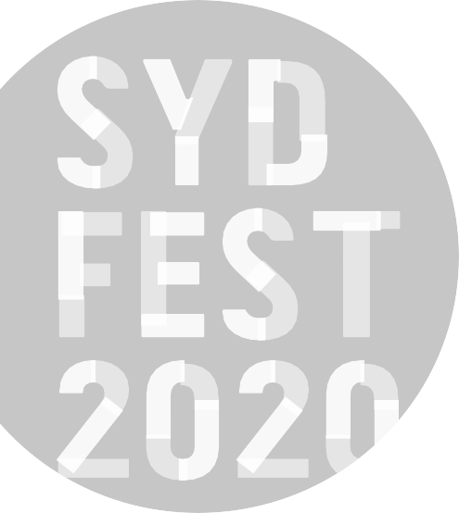

ANTHEM
Photo: Pia Johnson
ARTS CENTRE MELBOURNE AND PERFORMING LINES AUSTRALIA | WORLD PREMIERE SEASON
Photo: Sarah Walker

ANTHEM
ARTS CENTRE MELBOURNE AND PERFORMING LINES AUSTRALIA | WORLD PREMIERE SEASON

ROSLYN PACKER THEATRE WALSH BAY
15–19 JANUARY
150 MINS

Writers Andrew Bovell, Patricia Cornelius, Melissa Reeves, Christos Tsiolkas & Irine Vela Director Susie Dee
Designer Marg Horwell
Lighting Designer Paul Jackson

Composer, Music Director and Sound Designer
Irine Vela
Movement Consultant Natalie Cursio Assistant Director Sapidah Kian Aboriginal Cultural Dramaturg Bryan Andy
Creative Producer (2016-March 2019) Daniel Clarke
Cast Maude Davey, Reef Ireland, Ruci Kaisila, Thuso Lekwape, Amanda Ma, Maria Mercedes, Tony Nikolakopoulos, Eryn Jean Norvill, Sahil Saluja, Osamah Sami, Eva Seymour, Carly Sheppard, Jenny M. Thomas, Dan Witton

Production Team
Production Manager Tony Harding
Stage Manager Meg Deyell
Assistant Stage Manager Cassandra Fumi
Sound Engineer Jim Atkins
Lighting Design Associate Trent Barclay
Producer, Performing Lines Annette Vieusseux

ABOUT THE SHOW
Twenty-one years ago, four playwrights and a composer came together to create Who’s Afraid of the Working Class?, a powerful, critically-acclaimed portrait of Australia in the Howard era. Now, six prime ministers later, writers Andrew Bovell, Patricia Cornelius, Melissa Reeves, Christos Tsiolkas and Irine Vela reunite to take the national pulse and ask if the advance of Australia is truly fair.
Who’s Afraid of the Working Class? amplified the voices of ordinary people so we all could hear them. Now, Anthem turns up the volume on the everyday injustices we
choose to ignore; colliding voices that may not always be in harmony but cannot be silenced.

WRITERS’ NOTE
We first came together in 1998 to create a work to mark the ten-year anniversary of Melbourne Workers Theatre. The company was not expected to last beyond its first project at the Jolimont Train Maintenance Yards, so there was truly something to celebrate. Who’s Afraid of the Working Class? told the story of a group of characters whose lives were impacted upon by the rise of economic rationalism. It caught the zeitgeist and articulated the shared anxieties of the end of the 20th century.
Twenty years later we have come together again to try and capture the mood of our times. As in the earlier work we sat around the table and thrashed out our ideas. We argued and yelled and laughed and when we got sick of the sound of our own voices we ventured out into the city.
It was winter in Melbourne. It was bleak. The world seemed tough. We caught trains out to the end of the lines and into the city again and brought the stories of what we’d seen back into the room. Slowly, we began to build a picture of a city, a place, a country, a time of fractured identities, racial tensions and economic hardship.
Our play is set largely in the public domain, particularly on trains where our conflicting identities around class and race and gender and sexuality clash and compete for ascendency, or simply for space and the right to be seen. What became apparent is that we are not one nation brought together by
a single anthem. Our country is not “fair” in any meaning of the word as our Anthem proclaims. We are riven by
difference and disagreement and the arguments around our national identity are acrimonious and dangerous. Our political leadership has failed to provide a vision that could unify us and instead, seems only to entrench our differences. The nation’s a powder keg waiting to blow. “The Fire Next Time,” says a character in the play quoting James Baldwin.
As in the earlier work, class remains our shared and urgent theme.
In Uncensored Andrew creates a chorus of commuters caught on the endless cycle of having to make ends meet. In 7-11, A Chemist Warehouse… A Love Story, Melissa tells the story of two low paid workers who set out on a Bonnie and Clyde-like mission to take on capitalism. In Terror, Patricia tells the story of three women who face increasing economic uncertainty. Here, it is not only class that places these women in jeopardy but their gender. In Brothers and Sisters, Christos tells the story of a successful man returning to Australia from Europe, hoping to transform the lives of his three siblings who never escaped their tough upbringing. As in the earlier play, the individual stories are interwoven and held together by Irine’s score, Resistance. She also riffs on some of Christos’s characters, including an elderly Greek

woman on the train, reminding us that political struggle has a history and that those histories are a part of our ongoing national narrative.
In Who’s Afraid… we softened the blow of its tough stories by finding moments of connection and intimacy between strangers, which reminded us of our shared
humanity. Anthem is a tougher work. There are no moments of redemption or reassurance. It is unrelenting in the conclusions it draws. But it is a true account of what we found the state of things to be.
We’d like to thank Daniel Clarke for bringing us back together. We all said it probably couldn’t be done. He didn’t listen and just made sure that it did. And we’d like to thank Bryan Andy who has joined us as a sixth voice as dramaturg and consultant. He has provided a wise and encouraging presence throughout the process.
– Andrew Bovell, Patricia Cornelius, Melissa Reeves, Christos Tsiolkas and Irine Vela.

THANKS AND ACKNOWLEDGEMENTS
This project was initiated by Arts Centre Melbourne. Produced by Performing Lines in association with Arts Centre Melbourne.
Script commissioned by Arts Centre Melbourne and generously supported by Linda Herd, Mr Derek Young AM and Mrs Caroline Young.
The Anthem company would like to thank Courtney Barnett, Katie Besgrove, Peta Brady, Melanie Burge, Mark Burlace, Pier Carthew, Linda Cropper, Jessica Darlow, Renee Dudfield, Wesley Enoch, Tahlee Fereday, Emma Fishwick, Emily Goad, Iain Grandage, David Geoffrey Hall, Jonathan Holloway, Pia Johnson, Darcy Kent, Takeshi Kondo, Katerina Kotsonis, Wayne Macauley, Kath Mainland, Tehyali Malone, Brett McCallum, David McDonald, Rohan Mirchandaney, Kevin Nugara, Deon Nuku, Nick O’Byrne, Gideon Obarzanek, Gerard Pigg, Playwriting Australia, Marion Potts, Megan Roberts, Anne Samson, Damian Seddon, Tatia Sloley (TS Publicity), Deanna Smart, Francesca Smith, Thom Smyth, Demi Sorono, Claire Spencer, Natalie Stewart, Sarah Walker, Kate Williams and Terry Yeboah.

ARTS CENTRE MELBOURNE
At Arts Centre Melbourne, we bring people together for remarkable experiences. Sitting beneath our iconic Spire, we’re Australia’s largest and busiest performing arts centre. In 2018–19, we staged nearly 3,000 performances and events and welcomed 3.35 million people through our doors. In fact, as a cultural and architectural landmark in our nation’s cultural capital, we’ve showcased the best of Australian and international performing arts for nearly 40 years.

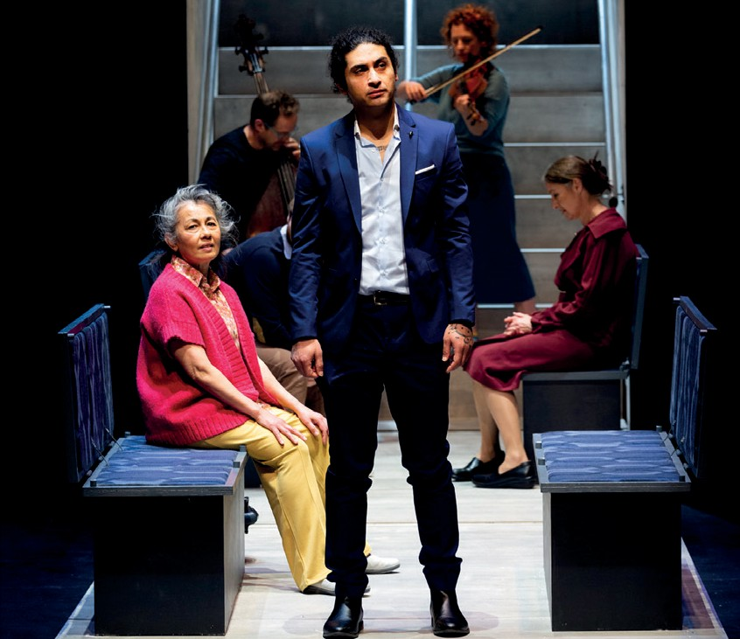
ARTS CENTRE MELBOURNE
Photo: Pia Johnson
Executive Director, Performing Arts
Melanie Smith

Director of Programming
Edwina Lunn

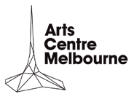
Head of Contemporary Performance
David Anderson artscentremelbourne.com.au

PERFORMING LINES
Performing Lines produces provocative contemporary performance by Australia’s most audacious independent artists. We curate a portfolio of work that is propelled by pressing questions and new ways of seeing the world. We champion the unconventional, the marginal, the rebellious and the new.

Executive Producer
Marion Potts

General Manager
Megan Roberts
performinglines.org.au

This project has been assisted by the Australian Government’s Major Festivals Initiative, managed by the Australia Council, its arts funding and advisory body, in association with the Confederation of Australian International Arts Festivals Inc., commissioned by Melbourne International Arts Festival, Arts Centre Melbourne, Sydney Festival and Perth Festival.
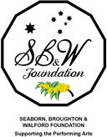

ALSO AT

THEATRE

BLACK TIES
ILBIJERRI THEATRE COMPANY AND
-
TE REHIA THEATRE AUSTRALIA/AOTEAROA/NEW ZEALAND WORLD PREMIERE SEASON

SYDNEY TOWN HALL 10–18 JANUARY
FROM $60 + BOOKING FEE

BOOK NOW SYDNEYFESTIVAL.ORG.AU

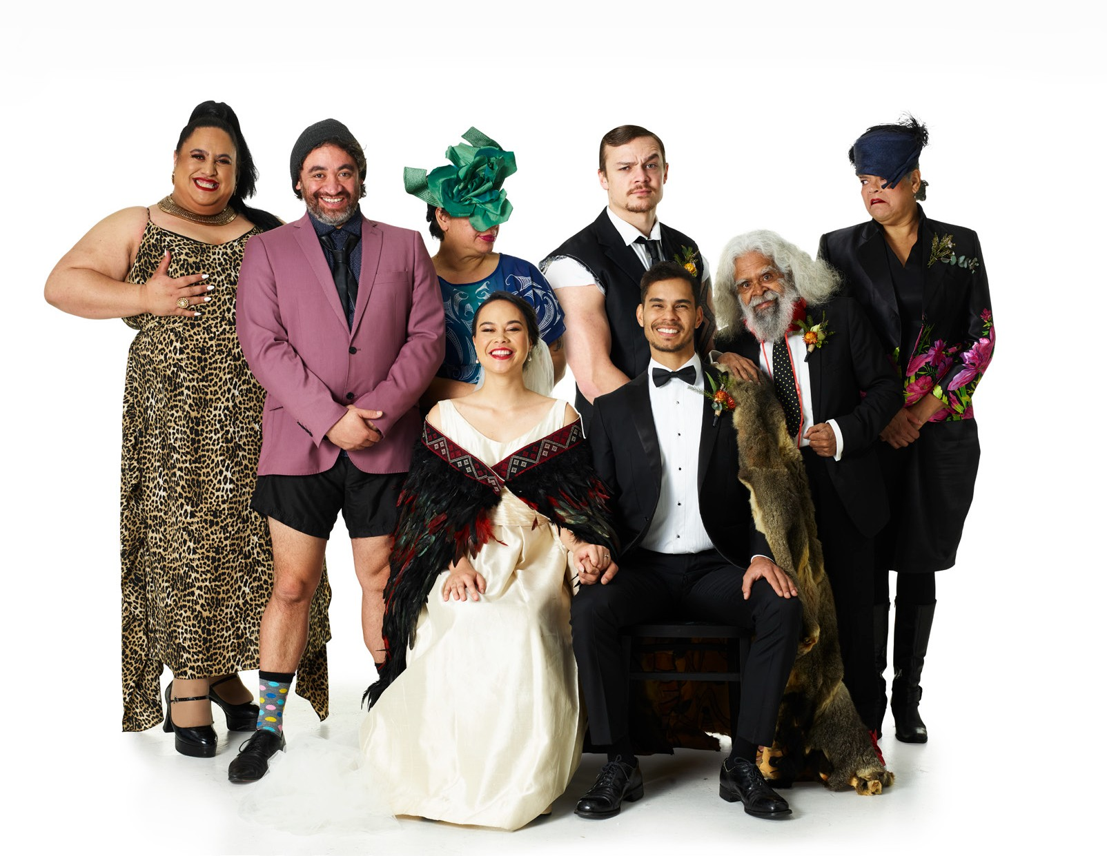“NOTHING SHORT OF STUPENDOUS”
COURIER MAIL

LIFE –
THE SHOW
STRUT & FRET PRODUCTION HOUSE | AUSTRALIA

MAGIC MIRRORS SPIEGELTENT HYDE PARK
8–26 JANUARY
FROM $70 + BOOKING FEE

CABARET

