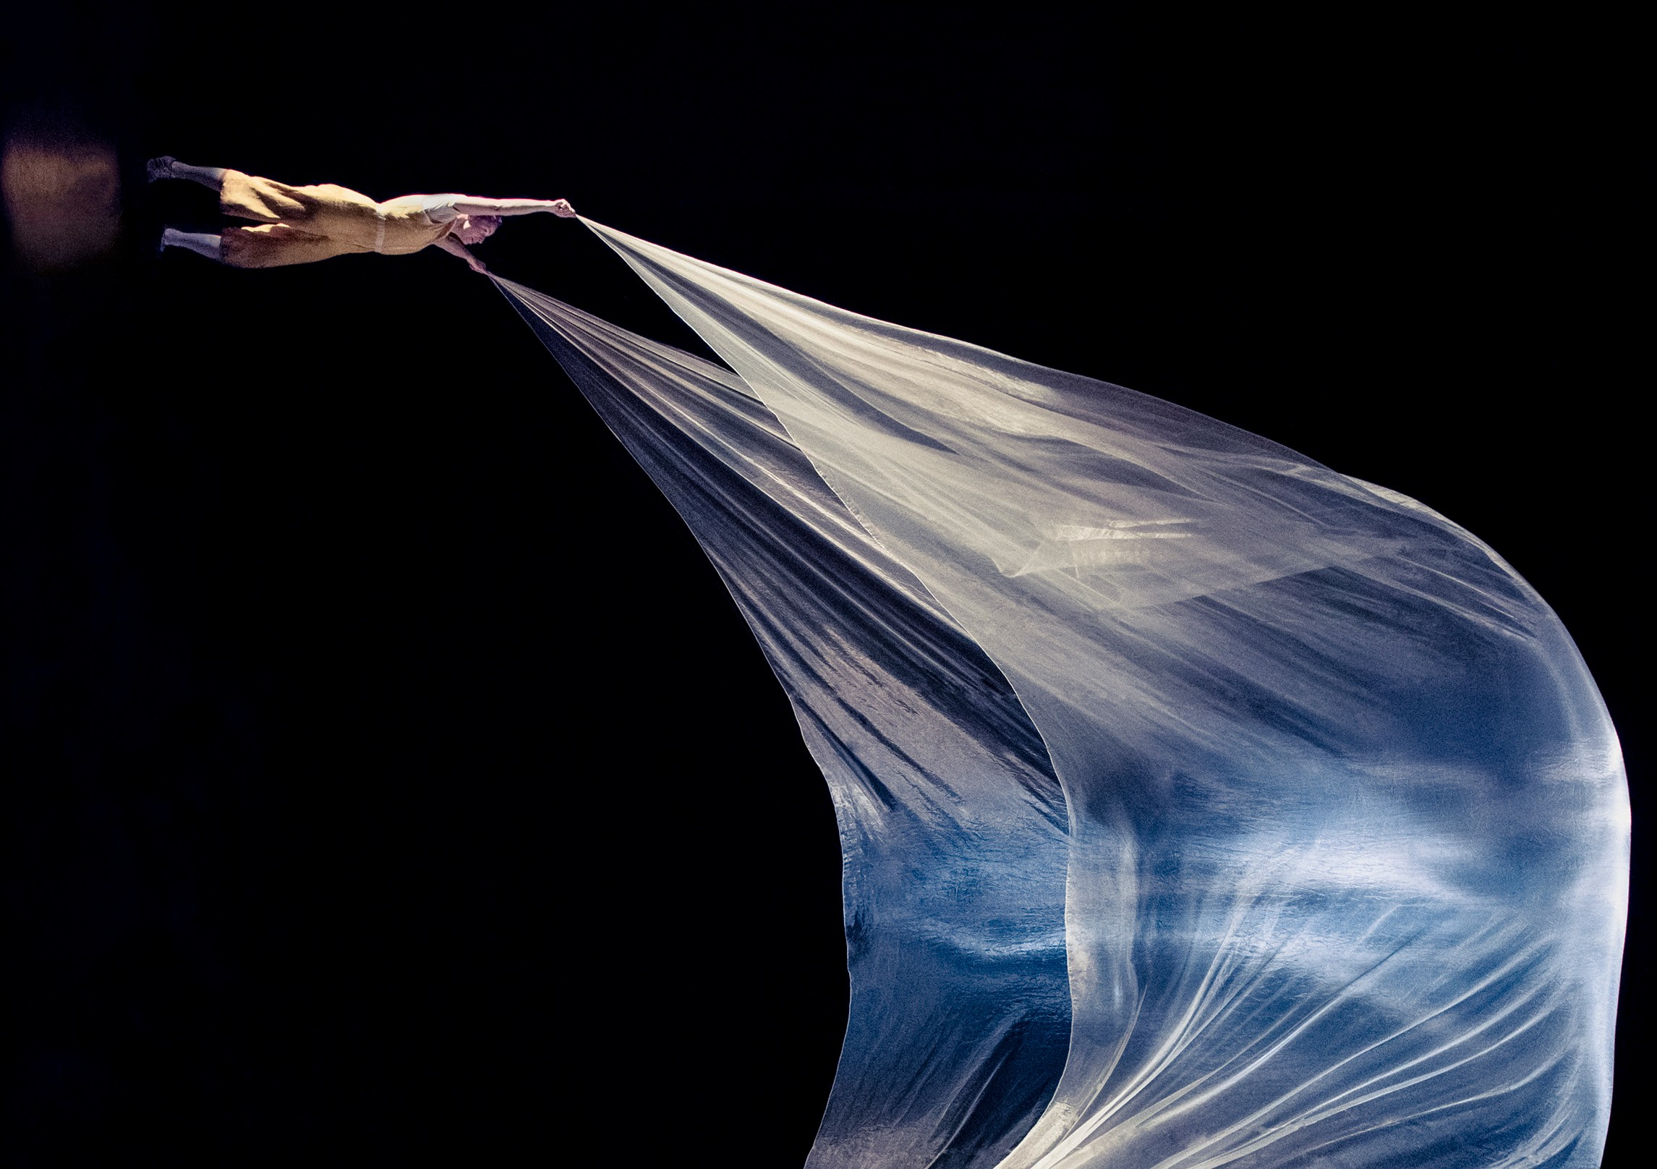Photos: Florence Montmare
AIR PLAY
ACROBUFFOS | USA

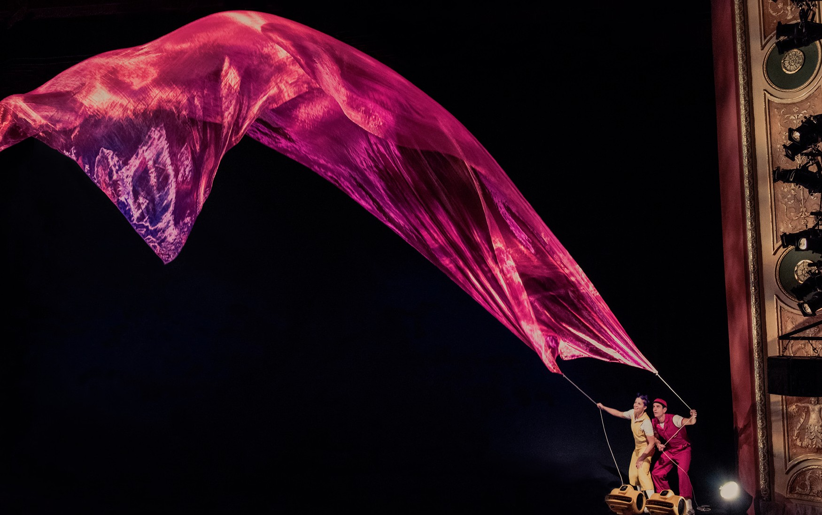AIR PLAY

ACROBUFFOS | USA
ROSLYN PACKER THEATRE WALSH BAY
21–25 JANUARY
60 MINS

Writers & Creators Seth Bloom and Christina Gelsone Performers Seth Bloom and Christina Gelsone Kinetic Sculptures Daniel Wurtzel
Director West Hyler
Technical Director Todd Alan Little Stage Manager Flora Vassar Lighting Design Jeanne Koenig
Costume Design Ashley Dunn Gatterdam Sound Design Seth Bloom and Christina Gelsone Additional Sound Design Phil Ingle
Props Seth Bloom and Christina Gelsone
Representation Aurora Nova and Boat Rocker Entertainment

ABOUT THE SHOW
Air Play is a visual poem, using no words. Umbrellas fly, fabrics soar over the audience, balloons swallow people, and snow swirls, filling the stage. Air Play lives on the edge of definition: part comedy, part sculpture, part circus, part theatre. Created by circus performers Seth Bloom and Christina Gelsone in collaboration with kinetic sculptor Daniel Wurtzel, Air Play was devised through years of experimentation with simple materials, movement, and technology.

THE ARTISTS
Acrobuffos are husband-and-wife silent comedy duo Seth Bloom and Christina Gelsone. They met at a circus in Afghanistan, married at a clown festival in China, and have performed their unique brand of visual comedy in 28 countries on six continents. See more at acrobuffos.com.
Daniel Wurtzel is known for his kinetic sculptures and installations using air and lightweight materials that fly. His work is featured on Broadway, in Cirque du Soleil, and in museums around the world. See more at danielwurtzel.com.

THANKS
Air Play has been made possible with support from Playhouse Square, New Victory Theater, Zoellner Arts Center and Flushing Town Hall.

