Forums
#UTSThinkBig
UTS is the proud knowledge partner of Sydney Festival. Together we’re building experiences to better understand society, culture and art.
Join us at one of our Big Thinking Forums
and become part of the conversation.
PROUD PARTNER OF
UTS CRICOS PROVIDER CODE: 00099F
uts.edu.au/bigthinking
23013

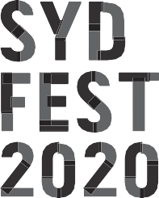

What defines an artistic project as a piece of First Nations work?
UTS BIG THINKING FORUM
WHAT DEFINES A PROJECT AS FIRST NATIONS?
UNIVERSITY OF TECHNOLOGY SYDNEY THE GREAT HALL
SATURDAY 18 JANUARY 2PM–3PM
In an environment of collaboration, what level of artistic control or representation is necessary for an artwork
or performance to be definitively considered as First Nations?
Hear from artists involved in cross-cultural collaborations across the 2020 Sydney Festival program.
Stay after the talk for Forums Unpacked,

a 30 minute opportunity for audience members to engage with the facilitator and panellists, reflect on the discussion and further explore its themes.
PROCLAMATION
8–26 JANUARY BARANGAROO RESERVE FREE
Visit Barangaroo Reserve during Sydney Festival to see Proclamation, a large-scale art installation flying 250 flags that explore Australians’ diverse ideas about land and country, belonging and possession.
MORE INFO AT SYDNEYFESTIVAL.ORG.AU

SPEAKERS

FORUMS UNPACKED
Stay after the talk for Forums Unpacked, a 30-minute opportunity for audience members to engage with the facilitator and panellists, reflect on the discussion and further explore its themes.
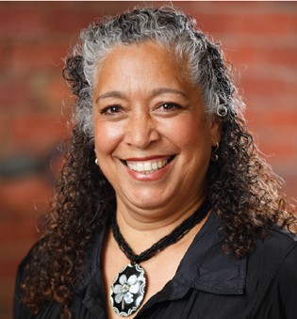
RACHAEL MAZA (BLACK TIES)
Rachael Maza is a Yidinji and Meriam woman and the current Artistic Director for ILBIJERRI Theatre Company (2008 – present). Her acting credits include The Dreamers (written by Jack Davis and directed by Wesley Enoch) and The Sapphires for MTC, Playbox Theatre &
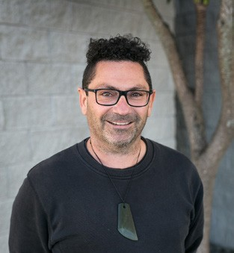
Belvoir St Theatre; and her directing credits include Jack Charles V the Crown (Ilbijerri); FOLEY (Ilbijerri); Which Way Home (Ilbijerri) and My URRWAI (Performing Lines/Belvoir/Ilbijerri). Rachael contributes to arts leadership in her many advisory roles, and currently sits on the Board of ACMI, as well as the Circus OZ Indigenous Advisory Panel and Australian Opera’s Indigenous Advisory panel. She has previously been a panellist for the Balnaves Indigenous Playwrights Award and is currently on the Greenroom Award ‘Theatre Company’ Panel.

DR JASON DE SANTOLO (UTS)
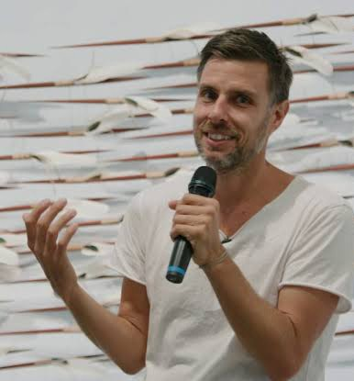
Dr Jason De Santolo is a researcher and creative producer. His tribal affiliations are Garrwa and Barunggam. Jason co-edited Decolonizing Research: Indigenous storywork as methodology (2019) with Jo-Ann Archibald and Jenny Lee-Morgan (Zed Books). His latest documentary Warburdar Bununu: Water Shield (2019) explores water contamination in his homelands and Borroloola, Northern Territory.

JONATHAN JONES
Jonathan Jones is a proud member of the Wiradjuri and Kamilaroi peoples of south-east Australia. He is a renowned Australian artist working across a range of media, utilising everyday objects to question cultural and historical relationships and ideas from an Indigenous perspective. Jonathan’s art is represented in major public collections both nationally and internationally.

MODERATOR
DISTINGUISHED PROFESSOR LARISSA BEHRENDT (UTS)
Distinguished Professor Larissa Behrendt holds the Chair of Indigenous Research at UTS, is a Board Director of Sydney Festival and the host of Speaking Out on the ABC Radio Network. She is an award-winning author and filmmaker.

FORUMS UNPACKED FACILITATOR
ASSOCIATE PROFESSOR PAULINE CLAGUE (UTS)
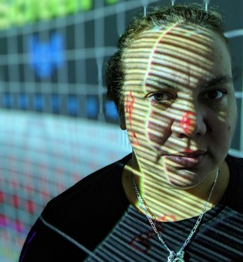
Pauline Clague is a Yaegl woman from North Coast NSW. She is founder and Artistic Director of Winda Film Festival in Sydney and co-creator of NativeSlam, a 72-hour Indigenous film challenge held at Maoriland Film Festival in New Zealand. Her work in communities teaches digital storytelling as a platform for community to keep oral history active utilising new technologies.
In 2015 she won the Stanley Hawes award for her contribution to Australian Documentaries.

