Forums
#UTSThinkBig
UTS is the proud knowledge partner of Sydney Festival. Together we’re building experiences to better understand society, culture and art.
Join us at one of our Big Thinking Forums
and become part of the conversation.
PROUD PARTNER OF
UTS CRICOS PROVIDER CODE: 00099F
uts.edu.au/bigthinking
23013

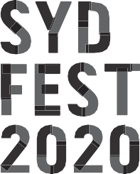

On the 250th year of Cook’s landing, artists and academics consider the structure of Australia’s accepted history, colonial institutions and “national identity”.
UTS BIG THINKING FORUM
RETHINKING NATIONALISM
THE GREAT HALL, UTS SATURDAY 25 JANUARY 4PM–5PM

Drawing on themes explored in Sydney Festival installations and performances Proclamation, The Visitors, The Future is Floating, Black Drop Effect, Procession and The Vigil, this forum explores positive new ways to consider Australian national identity.
Stay after the talk for Forums Unpacked,

a 30 minute opportunity for audience members to engage with the facilitator and panellists, reflect on the discussion and further explore its themes.
PROCLAMATION
8–26 JANUARY BARANGAROO RESERVE FREE
Visit Barangaroo Reserve during Sydney Festival to see Proclamation, a large-scale art installation flying 250 flags that explore Australians’ diverse ideas about land and country, belonging and possession.
MORE INFO AT SYDNEYFESTIVAL.ORG.AU

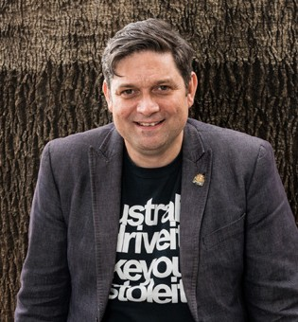
SPEAKERS
FORUMS UNPACKED
Stay after the talk for Forums Unpacked, a 30-minute opportunity for audience members to engage with the facilitator and panellists, reflect on the discussion and further explore its themes.
WESLEY ENOCH (SYDNEY FESTIVAL DIRECTOR)
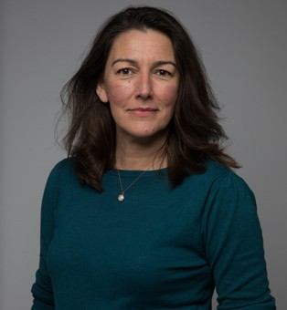
Wesley Enoch is the Director of Sydney Festival. He has been a theatre director/writer for over 25 years specialising in Aboriginal Theatre. Wesley was Artistic Director of Queensland Theatre Company 2010–15, Ilbijerri 2003–06 and Kooemba Jdarra 1994–97, and Resident Director at Sydney Theatre Company 2000–01, Associate Artistic Director of Company B Belvoir 2007–10, and worked on the Opening Ceremony of the 2006 Commonwealth Games. Wesley has worked with all the large theatre companies, arts centres and festivals in Australia and won multiple awards. Wesley was a Trustee of the Sydney Opera House 2006–13 and is the Chair of the ATSI Strategy Panel for the Australia Council.

LORENA ALLAM (THE GUARDIAN )
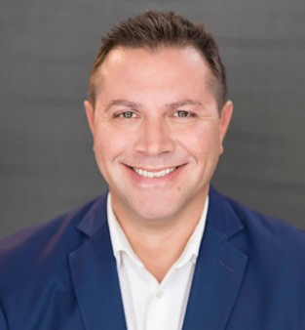
Lorena Allam is a Gamilaraay and Yuwalaraay woman whose country is in the Dhariwaa or Narran lakes area of far west NSW, and across the border into south-west Queensland. She is the Indigenous affairs editor for Guardian Australia and is a Walkley award winner for innovation in journalism for the Deaths Inside project. She has also won a Kennedy award for excellence in journalism and the NSW Premier's history award for the series called The Killing Times in partnership with the University of Newcastle.

PROFESSOR LINDON COOMBES
Professor Lindon Coombes is a descendant of the Yuallaraay people of north-west NSW. He is currently Industry Professor of Indigenous Policy at the Jumbunna Institute for Indigenous Education and Research where he is undertaking a range of projects looking at Treaty,
Indigenous self-determination and provision of policy advice and strategy. He is also Co-Chair of Reconciliation NSW.

MODERATOR
DISTINGUISHED PROFESSOR LARISSA BEHRENDT (UTS)
Distinguished Professor Larissa Behrendt holds the Chair of Indigenous Research at UTS, is a Board Director of Sydney Festival and the host of Speaking Out on the ABC Radio Network. She is an award-winning author and filmmaker.

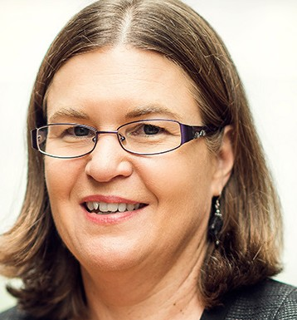
FORUMS UNPACKED FACILITATOR PROFESSOR SUSAN PAGE (UTS)
Professor Susan Page is an Aboriginal academic whose research focuses on Aboriginal and Torres Strait Islander peoples’ experience of learning and academic work in higher education and student learning in Indigenous Studies. In 2019 she led the UTS team awarded a National Australian Universities Teaching Award, the Neville Bonner award for Indigenous Education.
From 2015–2018 she was a Director of the National Aboriginal and Torres Strait Islander Higher Education Consortium (Aboriginal Corporation).

